Tackling unstructured problems

‘Do I stand back and watch, or intervene and tell them what to do?’

Handouts for teachers

Contents

1 Structured problems 2
1 Structured problems (continued) 3
1 Structured problems (continued) 4
2 Unstructured versions of the problems 5
3 Notes on the unstructured problems 6
3 Notes on the unstructured problems (continued) 7
4 Practical advice for teaching problem solving 8

1 Structured problems

Organising a table tennis tournament

You have the job of organising a table tennis tournament.

- 7 players will take part
- All matches are singles.
- Every player has to play each of the other players once.

1. Call the players A, B, C, D, E, F, G
Complete the list below to show all the matches that need to be played.
A v B B v C ....
A v C B v D ....
.... ....

2. There are four tables at the club and each game takes half an hour.
The first match will start at 1.00pm.

Copy and complete the poster below to show the order of play,
so that the tournament takes the shortest possible time.
Remember that a player cannot be in two places at once!
You may not need to use every row and column in the table!

Start Time | Table on which the game will be played
 | 1 | 2 | 3 | 4
1.00 | A v B
1.30
2.00
2.30
3.00
3.30
4.00
4.30

1 Structured problems (continued)

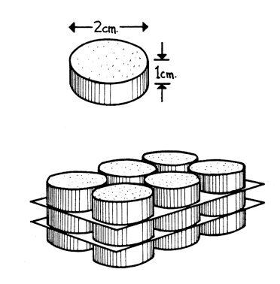
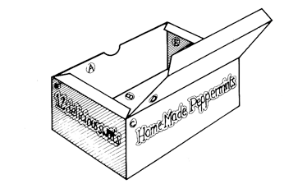
Designing a box for 18 sweets

You work for a design company and have been asked to design a box that will hold 18 mints.
Each mint is 2 cm in diameter and 1 cm thick.
The box must be made from a single sheet of A4 card with as little cutting as possible.

On the grid paper below, show clearly how the card can be folded up and glued together to make the box.

Make your box to check.

1 Structured problems (continued)

Calculating Body Mass Index

This calculator is used to help adults find out if they are overweight.

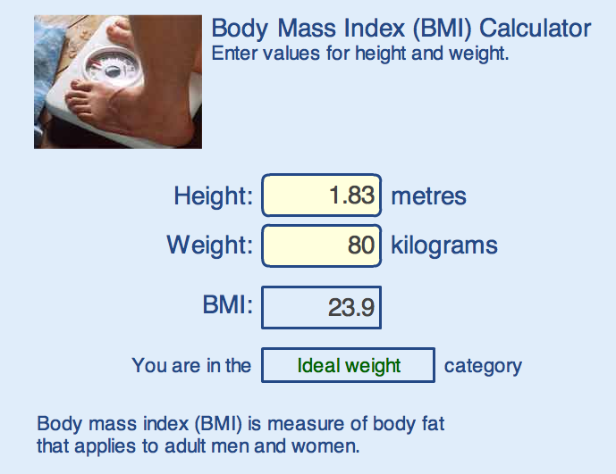

1. Fix the height at 2 metres - a very tall person!
Complete the table below and draw a graph to show your results.
Weight (kg) | 60 | 70 | 80 | 90 | 100 | 110 | 120 | 130 | 140
BMI

(a) What is the largest BMI for which someone is underweight?
(b) What is the smallest BMI for which someone is overweight?
(c) When you double the weight, what happens to the BMI?
(d) Can you find a rule for calculating BMI from the weight?
2. Fix the weight at 80 kilograms and try varying the height.
(a) When you double the height, what happens to the BMI?
(b) Can you find a rule for calculating BMI from the height?
(c) Draw a graph to show the relationship between the height and the BMI.

For more information on BMI visit:

http://www.nhsdirect.nhs.uk/magazine/interactive/bmi/index.aspx

Note for pupils: If you put your own details into this calculator, don’t take the results too seriously! It is designed for adults who have stopped growing and will give misleading results for children or teenagers!

2 Unstructured versions of the problems

Organising a table tennis tournament

You have the job of organising a table tennis league.

- 7 players will take part
- All matches are singles.
- Every player has to play each of the other players once.
- There are four tables at the club.
- Games will take up to half an hour.
- The first match will start at 1.00pm.

Plan how to organise the league, so that the tournament will take the shortest possible time. Put all the information on a poster so that the players can easily understand what to do.

Designing a box for 18 sweets

You work for a design company and have been asked to design a box that will hold 18 sweets.
Each sweet is 2 cm in diameter and 1 cm thick.
The box must be made from a single sheet of A4 card with as little cutting as possible.

Compare two possible designs for the box and say which is best and why.

Make your box.

Calculating Body Mass Index

This calculator shown is used on websites to help an adult decide if he or she is overweight.
What values of the BMI indicate
whether an adult is underweight,
overweight, obese, or very obese?

Investigate how the calculator works
out the BMI from the height and weight.

Note for pupils: If you put your own details into this calculator, don’t take the results too seriously! It is designed for adults who have stopped growing and will give misleading results for children or teenagers!

3 Notes on the unstructured problems

Organising a table tennis tournament
Pupils should quickly notice that it is impossible to use all four tables simultaneously as there are only seven players. On each occasion, therefore someone has to rest. One possible way of organising the matches is shown below.

Start time | Table 1 | Table 2 | Table 3
1.00 | AvB | CvD | EvF | G rests
1.30 | CvA | EvB | GvD | F rests
2.00 | EvC | GvA | FvB | D rests
2.30 | GvE | FvC | DvA | B rests
3.00 | FvG | DvE | BvC | A rests
3.30 | DvF | BvG | AvE | C rests
4.00 | BvD | AvF | CvG | E rests

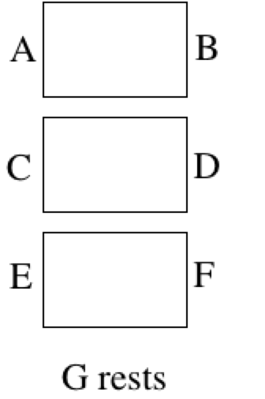
This solution was obtained by writing all the players' names on scraps of paper and placing them next to the three tables as shown. Every half an hour the players move one place clockwise. In this way each player plays against all the others once. It is also 'fair' in other ways; each player plays on each side of each table exactly once. Notice also that if there were 8 players, the matches would not take any longer. The additional player could play the resting player.

Designing a box for 18 sweets
18 sweets may be arranged in different ways. For example:
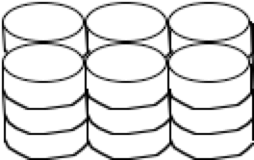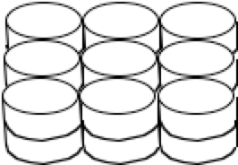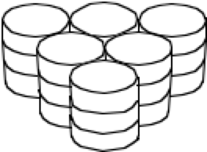

Each arrangement will lead to a different box design. Their dimensions may be calculated theoretically, or a more concrete approach may be adopted by drawing round sweets with appropriate dimensions. Furthermore any given design may be constructed from card in several different ways. Some possible box designs are illustrated below:

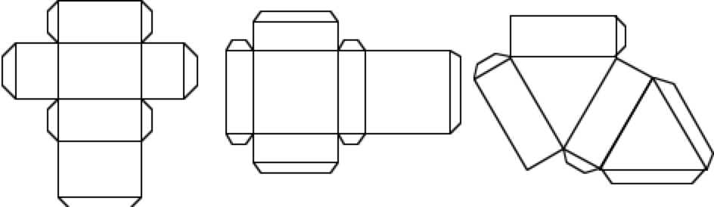

3 Notes on the unstructured problems (continued)

Calculating Body Mass Index
It is easy to find the boundaries at which someone becomes underweight/overweight/obese if one variable is held constant while the other is varied systematically. The boundaries occur at:

 | BMI
Underweight | Below 18.5
Ideal weight | 18.5 - 24.9
Overweight | 25.0 - 29.9
Obesity | 30.0 and Above

In order to find out how the calculator works, it is better to forget realistic values for height and weight and simply hold one variable constant while changing the other systematically. For example, if pupils hold the height constant at 2 metres (not worrying if this is realistic!), then they will obtain the following table and/or graph:

Weight (kg) | 60 | 70 | 80 | 90 | 100 | 110 | 120 | 130
BMI | 15 | 17.5 | 20 | 22.5 | 25 | 27.5 | 30 | 32.5
 | Underweight |  | Ideal weight |  | Overweight |  | Obese

From this it can be seen that there is a proportional relationship between weight and BMI. (If you double weight, you double BMI; Here BMI = Weight/4)

If they now hold the weight constant and double the height, they will see that the BMI decreases by a factor of 4. This is an inverse square law, which may be outside the experience of many pupils. They may be able to explore the relationship by graphing, however.
So, if the BMI is proportional to weight and inversely proportional to the square of the height, it makes sense to try the relationship BMI = k x (weight)/(height)². The result is that k = 1.

4 Practical advice for teaching problem solving
Allow pupils time to understand and engage with the problem  Discourage pupils from rushing in too quickly or from asking you to help too soon. | - Take you time, don't rush.  - What do you know?  - What are you trying to do?  - What is fixed? What can be changed?  - Don't ask for help too quickly - try to think it out between you.
Offer strategic rather than technical hints  Avoid simplifying problems for pupils by breaking it down into steps. | - How could you get started on this problem?  - What have you tried so far?  - Can you try a specific example?  - How can you be systematic here?  - Can you think of a helpful representation?
Encourage pupils to consider alternative methods and approaches  Encourage pupils to compare their own methods. | - Is there another way of doing this?  - Describe your method to the rest of the group  - Which of these two methods do you prefer and why?
Encourage explanation  Make pupils do the reasoning, and encourage them to explain to one another. | - Can you explain your method?  - Can you explain that again differently?  - Can you put what Sarah just said into your own words?  - Can you write that down?
Model thinking and powerful methods  When pupils have done all they can, they will learn from being shown a powerful, elegant approach. If this is done at the beginning, however, they will simply imitate the method and not appreciate why it was needed. | - Now I'm going to try this problem myself, thinking aloud.  - I might make some mistakes here - try to spot them for me.  - This is one way of improving the solution.

