Asking Questions that encourage Inquiry-based learning
How do we ask questions to develop scientific thinking and reasoning?

Introduction
This unit contains a selection of professional activities that are designed to help teachers to reflect on:
- characteristics of their questioning that encourage students to reflect, think and reason;
- ways in which teachers might encourage students to provide extended, thoughtful answers, without being afraid of making mistakes;
- the value of showing students what reasoning means by 'thinking aloud'.

The activities described below are given here as a 'menu' of suggestions to help the provider select and plan. They are presented in a logical order, building up knowledge and expertise.

Any planned professional development program should offer opportunities for teachers to try new pedagogies in the classroom and then report back and reflect on their experiences. Activity 4 is therefore essential in the program.

Activities
Activity A: Reflecting on the questions we ask 2
Activity B: What kinds of questions promote inquiry? 4
Activity C: Observing a lesson 6
Activity D: Plan a lesson, teach it and reflect on the outcomes 8
Activity E: Solve a problem, "thinking aloud" 10

Acknowledgement:
This material is adapted for PRIMAS from:
Swan, M; Pead, D (2008). Professional development resources. Bowland Maths Key Stage 3, Bowland Charitable Trust. Available online in the UK at: http://www.bowlandmaths.org.uk
It is used here by kind permission of the Bowland Charitable Trust.

Activity A: Reflect on the questions we ask

Time needed: 15 minutes.
Give teachers time to discuss the following questions in pairs or small groups.
Ask them to record their collective ideas on a copy of the handout.
Then hold a plenary discussion to collect and share ideas.
As teachers suggest different purposes, ask them to give particular examples.

Teachers ask many different types of questions and they serve many different purposes.
- What different types of questions are there?
- What different functions do these questions serve?
- Which types of questions do you use most frequently?
- What common mistakes do you tend to make when asking questions?
What are their effects?
We ask questions for many possible reasons, including the following eight:
- to interest, engage and challenge;
- to assess prior knowledge and understanding;
- to stimulate recall, in order to create new understanding and meaning;
- to focus thinking on the most important concepts and issues;
- to help students extend their thinking from the factual to the analytical;
- to promote reasoning, problem solving, evaluation and the formation of hypotheses;
- to promote students’ thinking about the way they have learned;
- to help students to see connections.

The following is a list of some of the more common mistakes that teachers make:
- Asking too many trivial or irrelevant questions.
- Asking a question and answering it yourself.
- Simplifying the question when students don't immediately respond.
- Asking questions of only the most able or likeable students.
- Asking several questions at once.
- Asking only closed questions that allow one right/wrong possible answer.
- Asking 'guess what is in my head' questions, where you know the answer you want to hear and you ignore or reject answers that are different.
- Judging every student response with 'well done', 'nearly there' 'not quite'. 'Well done' can discourage alternative ideas being offered.
- Not giving students time to think or discuss before responding.
- Ignoring incorrect answers and moving on.

Handout 1. Thinking about why we ask questions

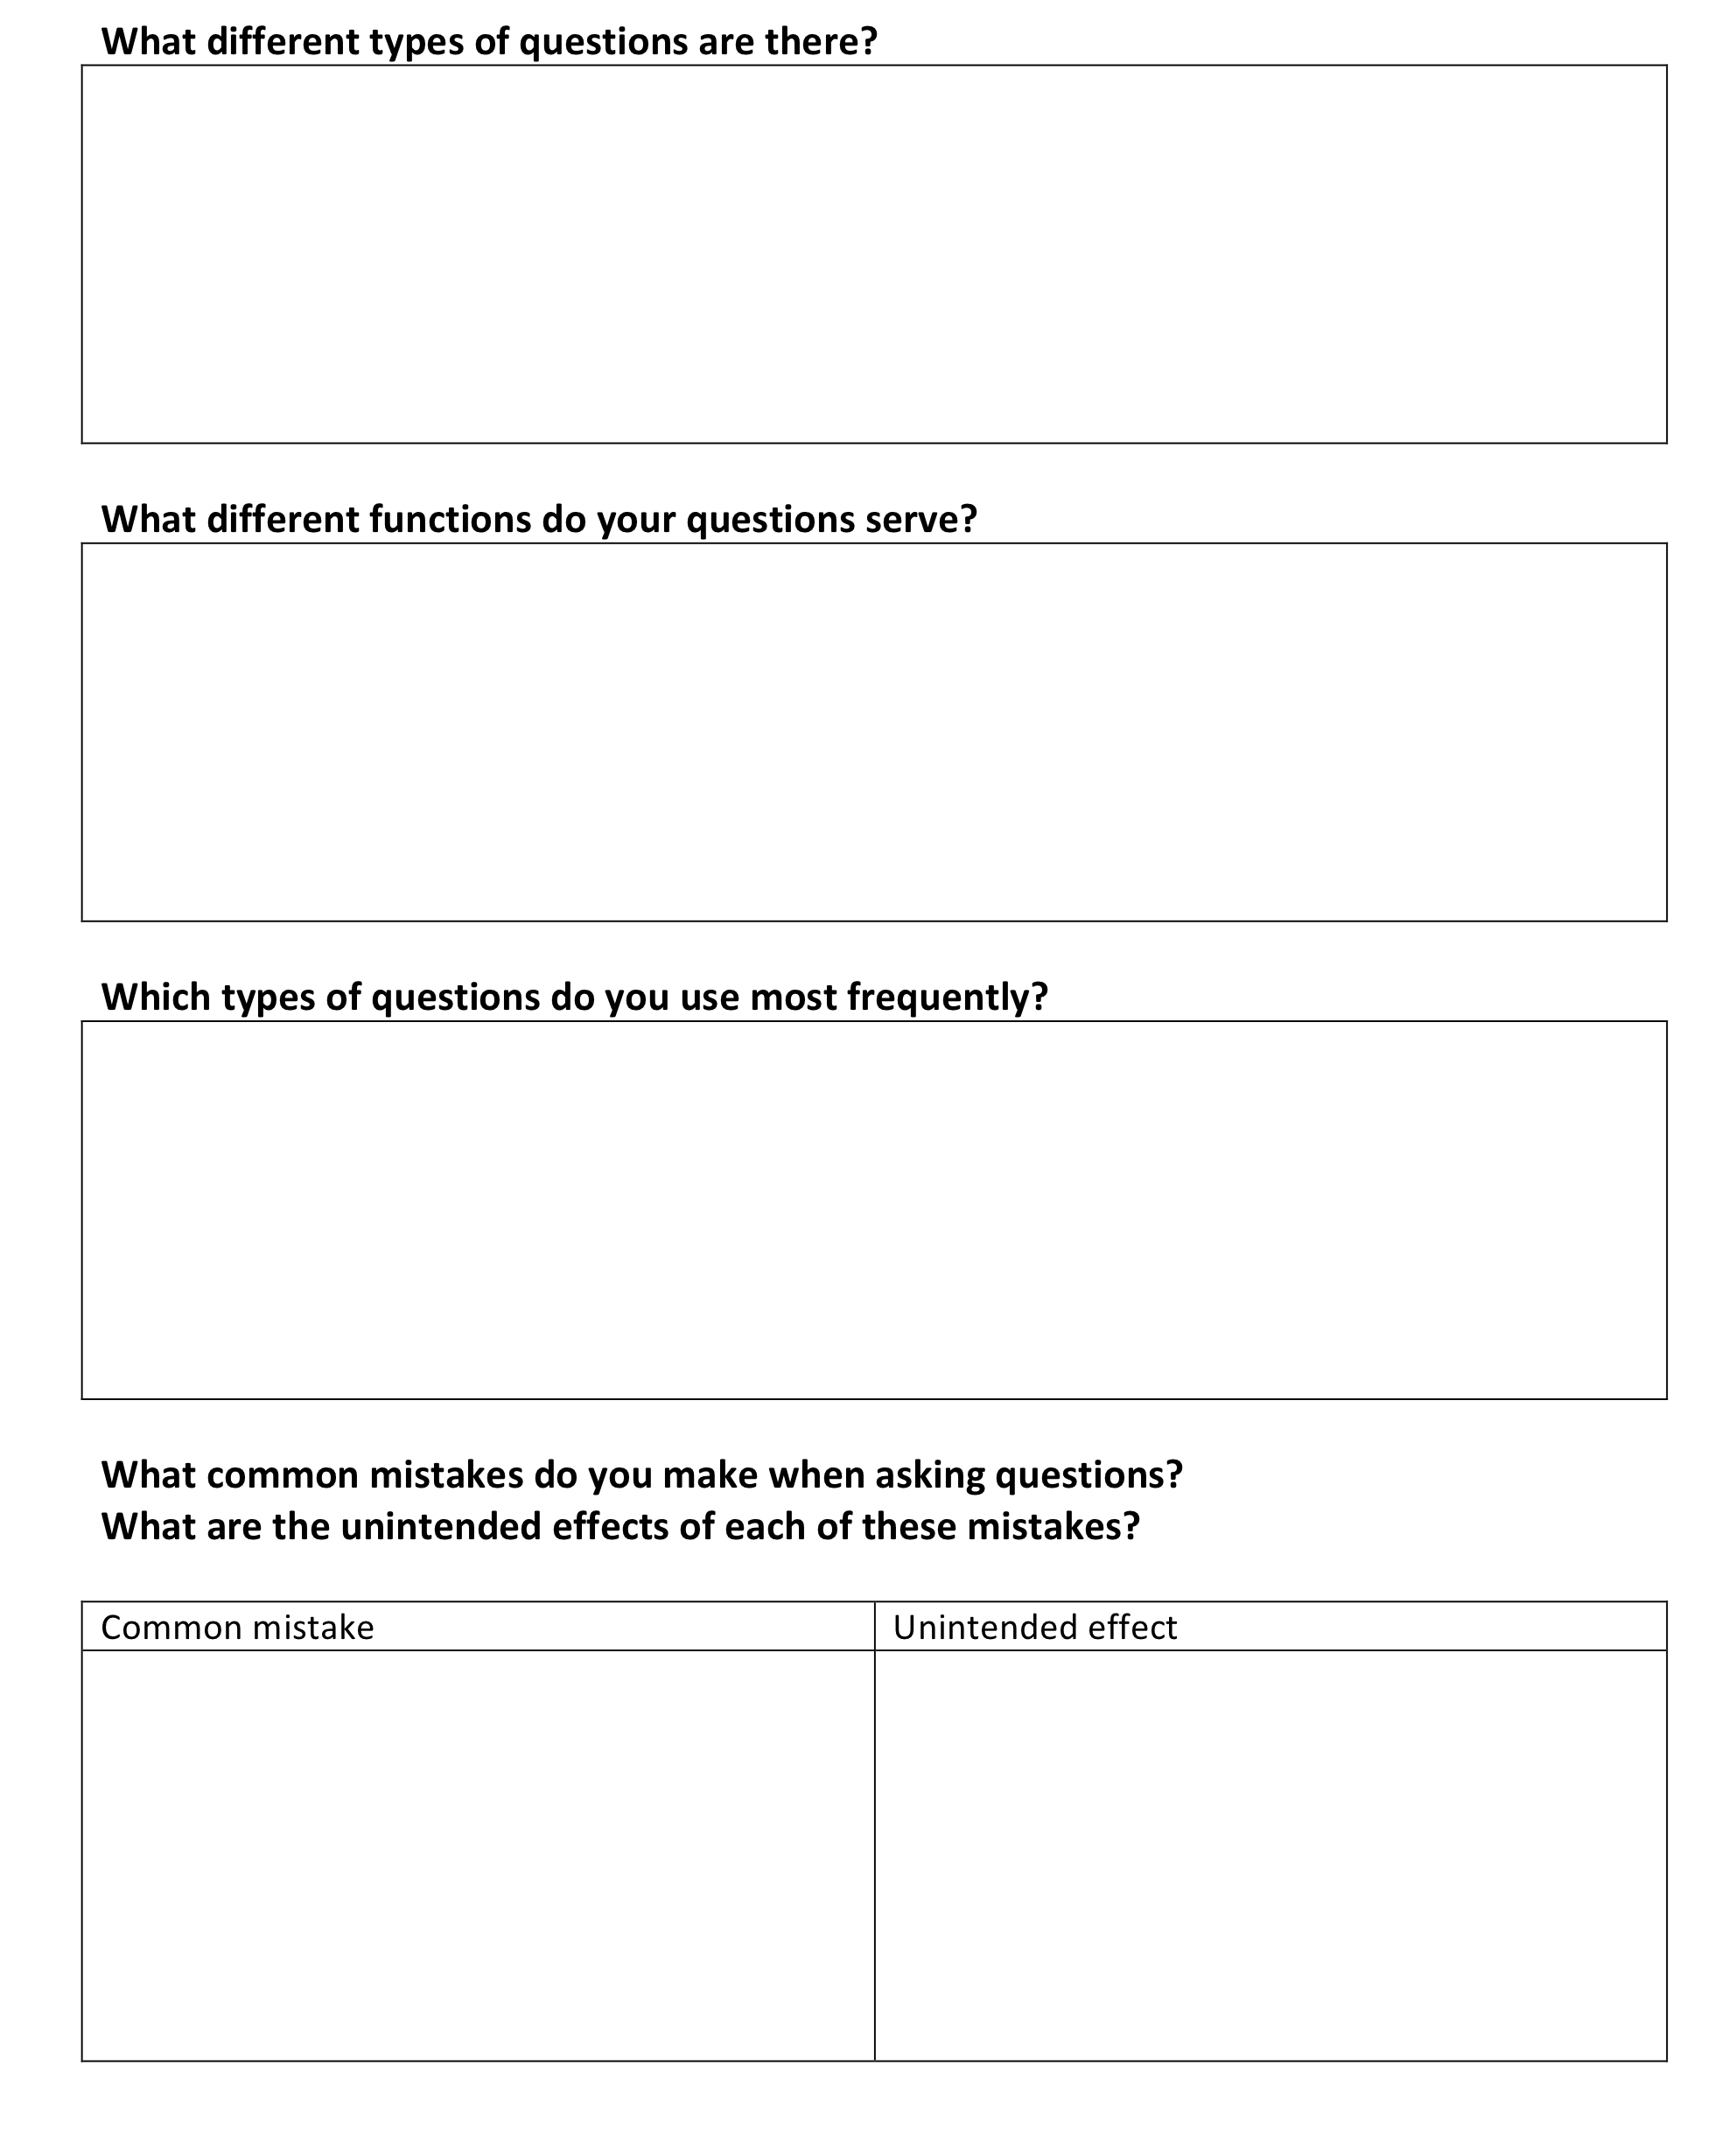

Activity B: What kinds of questions promote inquiry?

Time needed: 20 minutes.
Give teachers time to discuss the following issues.
Ask them to record their collective ideas on a copy of Handout 2 shown.

- What types of questions promote inquiry-based learning?
- Give some examples that you have recently used.
- Handout 3 describes some characteristics of effective questioning.
Reflect on the implications of these ideas for your own practice.

Afterwards give them copies of Handout 3. This contains a summary of some research findings into questioning. This shows that effective questioning displays the five characteristics:
- The teacher plans questions that encourage thinking and reasoning.
- Everyone is included.
- Students are given time to think.
- The teacher avoids judging students' responses.
- Students' responses are followed up in ways that encourage deeper thinking.
Invite teachers to discuss the research findings in small groups.

- Which of these principles do you usually implement in your own teaching?
- Which principles do you find it most difficult to implement? Why is this?

Handout 2. What kinds of questions promote inquiry-based learning?
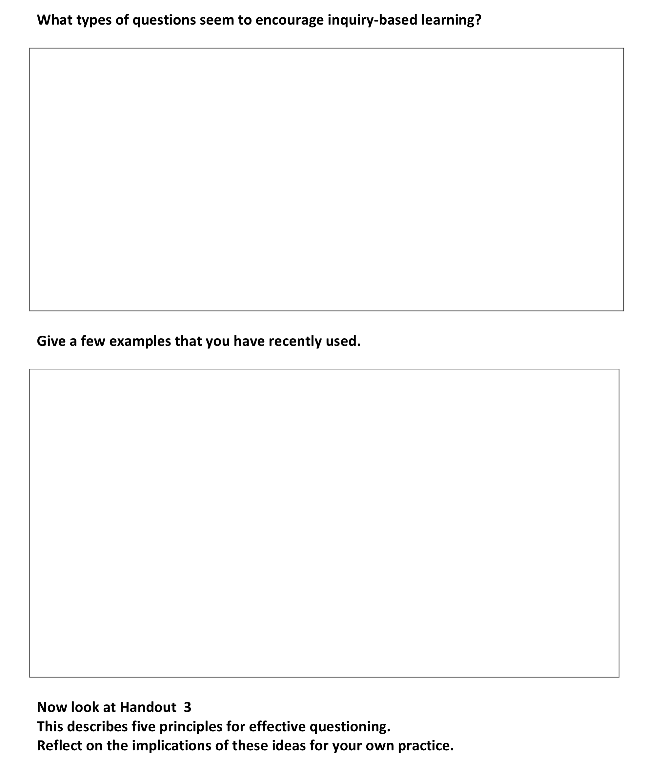

Handout 3. Five principles for effective questioning
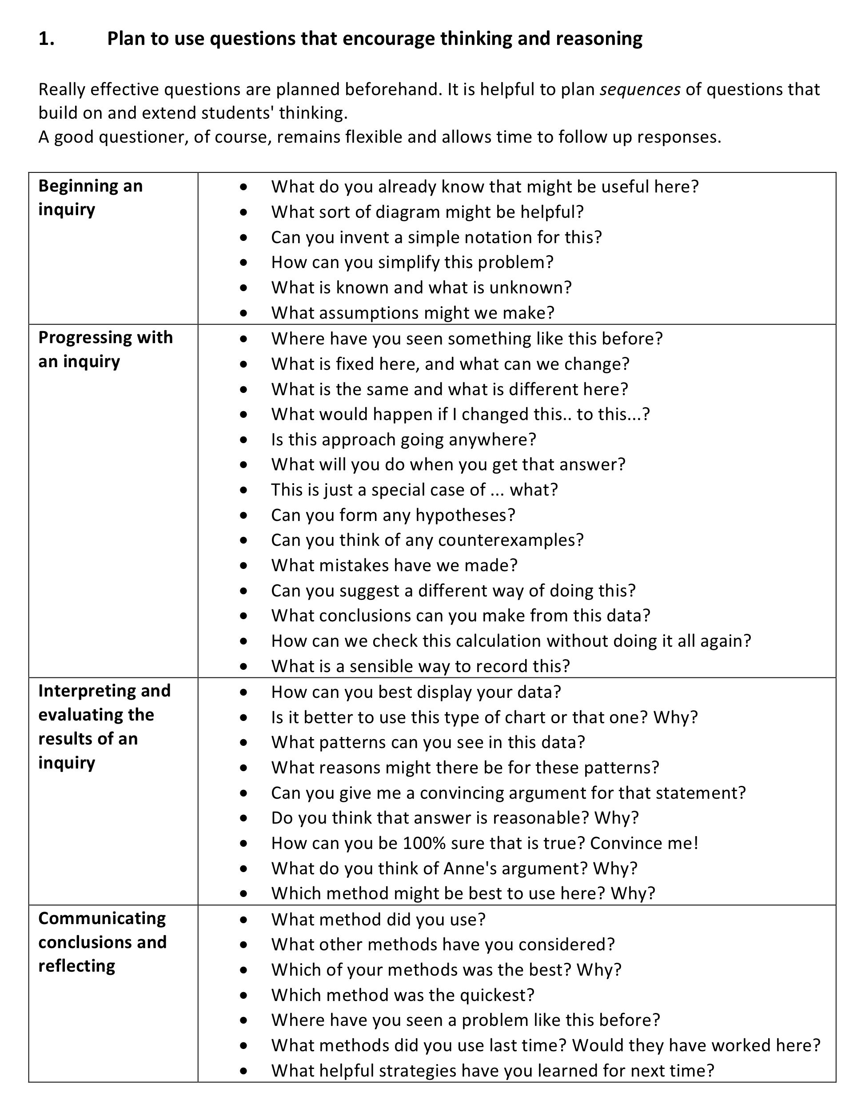 | 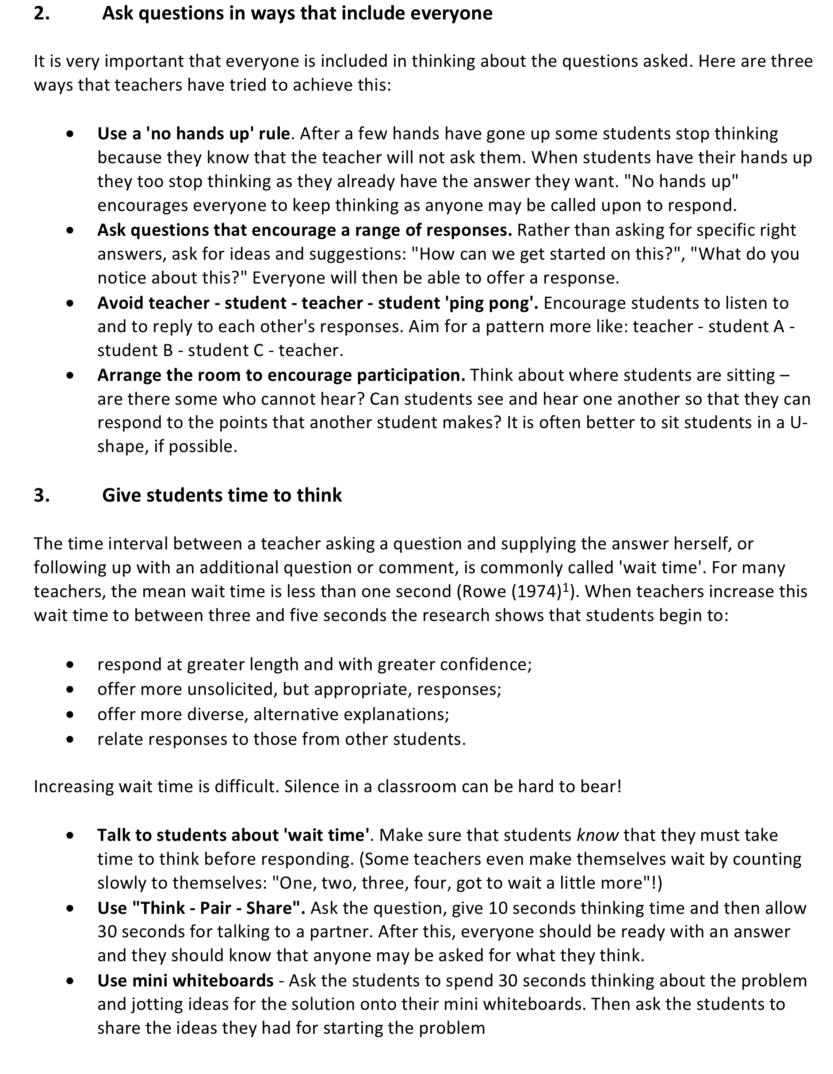 | 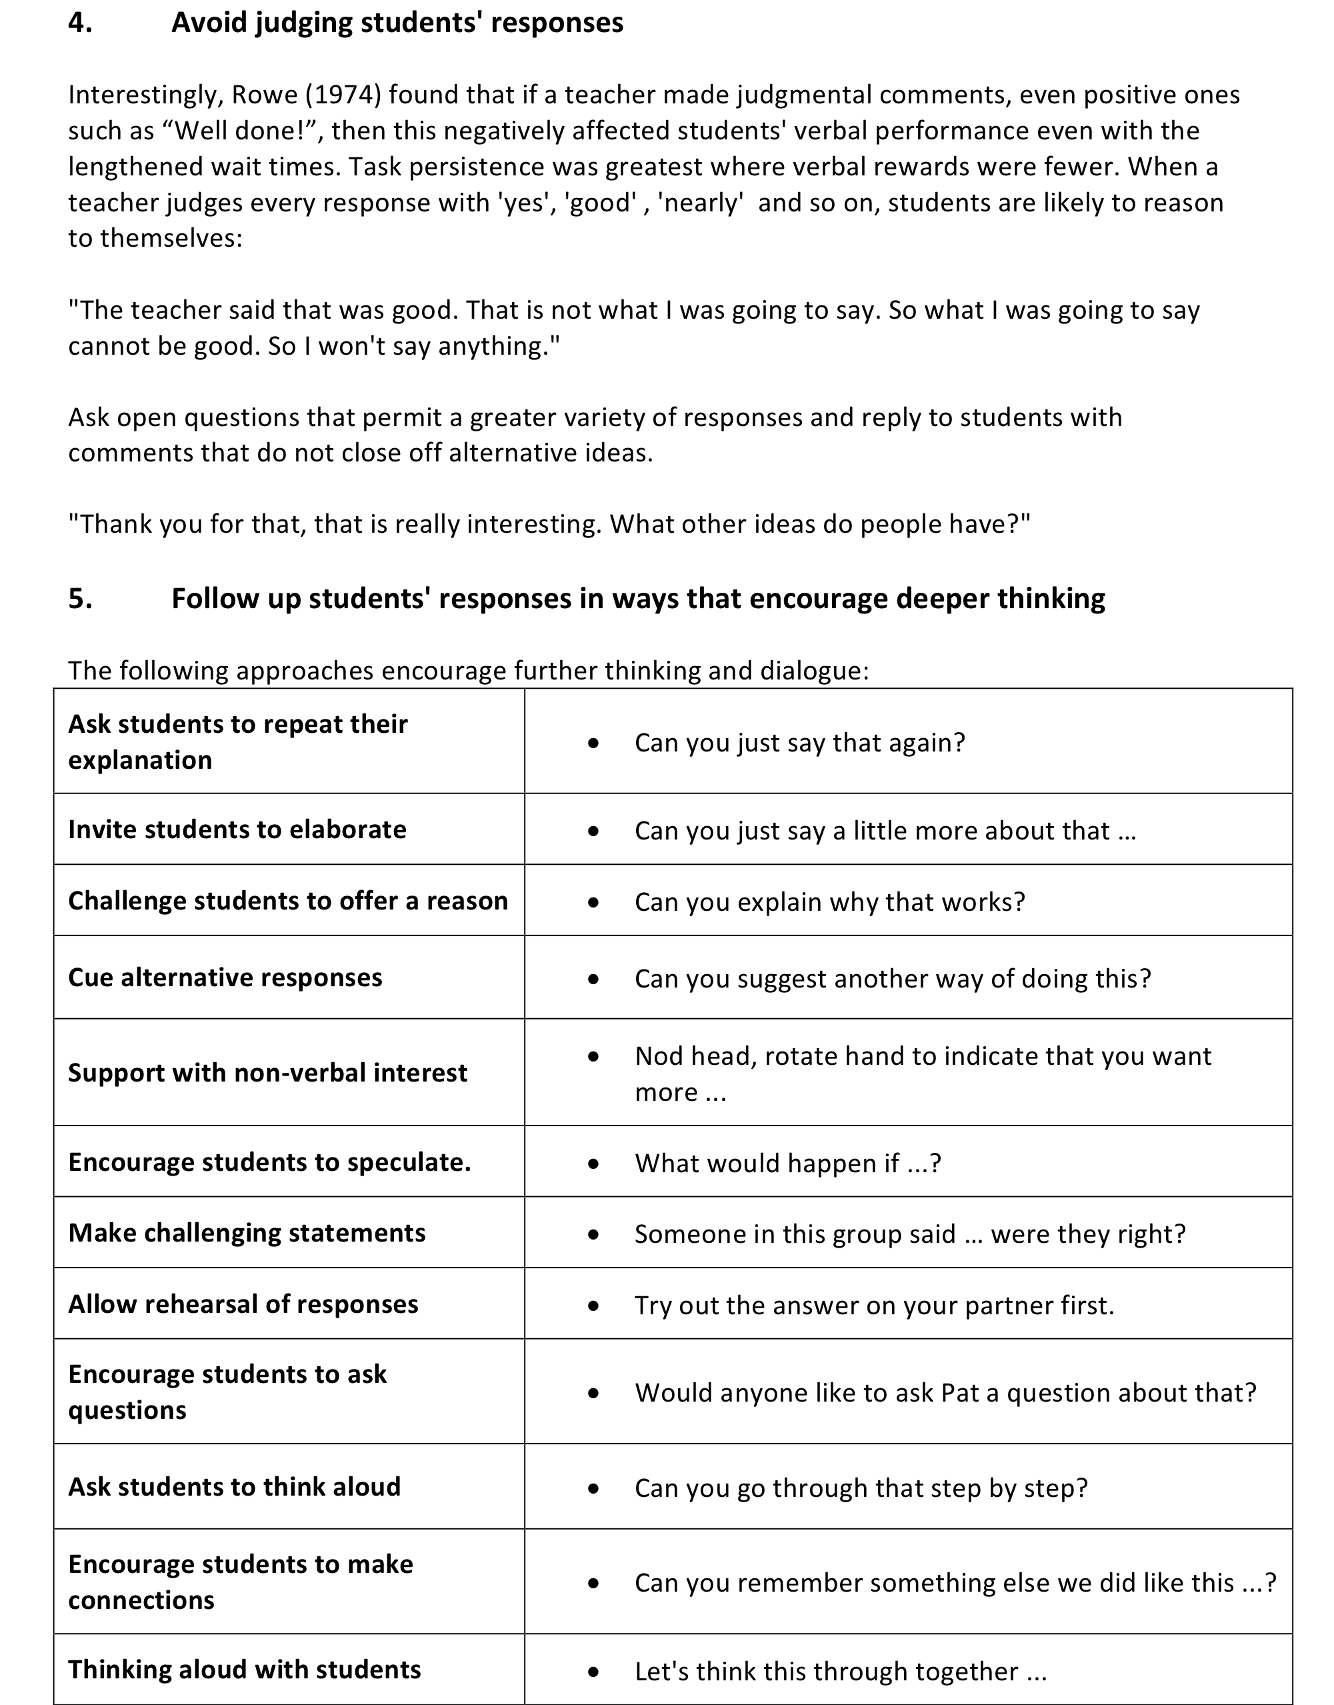

Activity C: ObservE and analyse a lesson

Time needed: 30 minutes.
Work on the problem shown on Handout 4.
- Compare the two solutions. Which do you consider better and why?

Now watch watch the video clip of Gwen's lesson and consider the following questions:
- Which of the following principles can you see Gwen using in her lesson? Give examples.
  - Plan questions that encourage thinking and reasoning.
  - Ask questions in ways that include everyone.
  - Give students time to think.
  - Avoid judging students' responses.
  - Follow up students' responses in ways that encourage deeper thinking.
- What do you think students learned from the lesson

- Plan questions that encourage thinking and reasoning.
Gwen has carefully planned the lesson so that the focus is not on answers but on reasoning. She begins the lesson by emphasising that lesson will be focused on the quality of students' thinking, reasoning and explaining and on listening to each other. This message is reinforced throughout by her interactions with students:
"Do you want to explain to me why that is fair?"; "How are you thinking of the journey? can you explain to me ..."; "How are you going to work out ...."; "What else is there that might help you? That's all I'm going to say. Keep thinking."
- Ask questions in ways that include everyone.
Gwen has introduced a 'no hands up' rule, so that she can choose who will respond to her questions and so that students continue to think while responses are made. She tries to encourage a range of responses and asks students to comment on each others' responses.
- Give students time to think.
Gwen gives students time to think individually before discussing, so that they all have something to share.
- Avoid judging students' responses.
Gwen collects the students' initial ideas and writes these on the board. She asks follow-up questions for clarification ("Just explain a little bit more about that.") and thanks them for their contributions, but does not judge responses with 'Well done", or "That's not quite right."
- Follow up students' responses in ways that encourage deeper thinking.
For example, Gwen invites students to elaborate: "Can you just say that again?"; asks students to think aloud: "Can you explain your thinking Alex?"; cues alternative responses: "Bethany, what do you think is best out of Hannah's suggestions?"; "Girls, can you see how that might help you? ... How might that help you?".

Handout 4. Observing a lesson

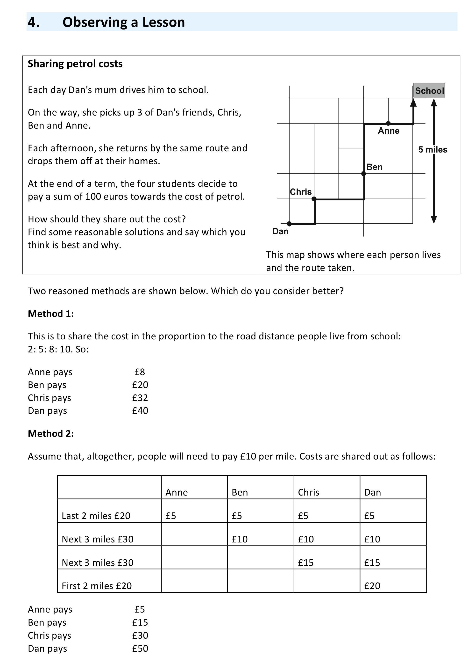

Activity D: Plan a lesson, teach it and reflect on the outcomes

Time needed:
- 15 minutes discussion before the lesson
- 1 hour for the lesson
- 15 minutes after the lesson

Choose a problem to try with your class.
Use the prompts on Handout 5 to plan a lesson that will promote thinking and reasoning.
- How will you organise the classroom and the resources?
- How will you introduce the questioning session?
- Which ground rules will you establish?
- What will be your first question?
- How will you give time for students to think before responding?
- Will you need to intervene at some point to refocus or discuss different strategies they are using?
- What questions will you use in plenary discussions during or towards the end of the lesson?

Because teachers will be focusing on the questions that they use and the way that the students answer those questions we suggest that they audio-record some whole class questioning lesson for discussion in Activity 5.

A sample lesson plan using the "Sharing Petrol Costs" problem is shown on Handout 6. This may be used as a model for teachers to follow.

After you have tried out your lesson with your own students, discuss the following issues:
- Which questions appeared to promote the most thoughtful and reasoned responses from students? Why was this?
- Which questions didn't work so well? Why was this?
- Which of the following four principles did you use? Give examples.
  - Plan questions that encourage thinking and reasoning.
  - Ask questions in ways that include everyone.
  - Give students time to think.
  - Avoid judging students' responses.
  - Follow up students' responses in ways that encourage deeper thinking.
- What will you do differently next time?

Handout 5. Planning for effective questioning
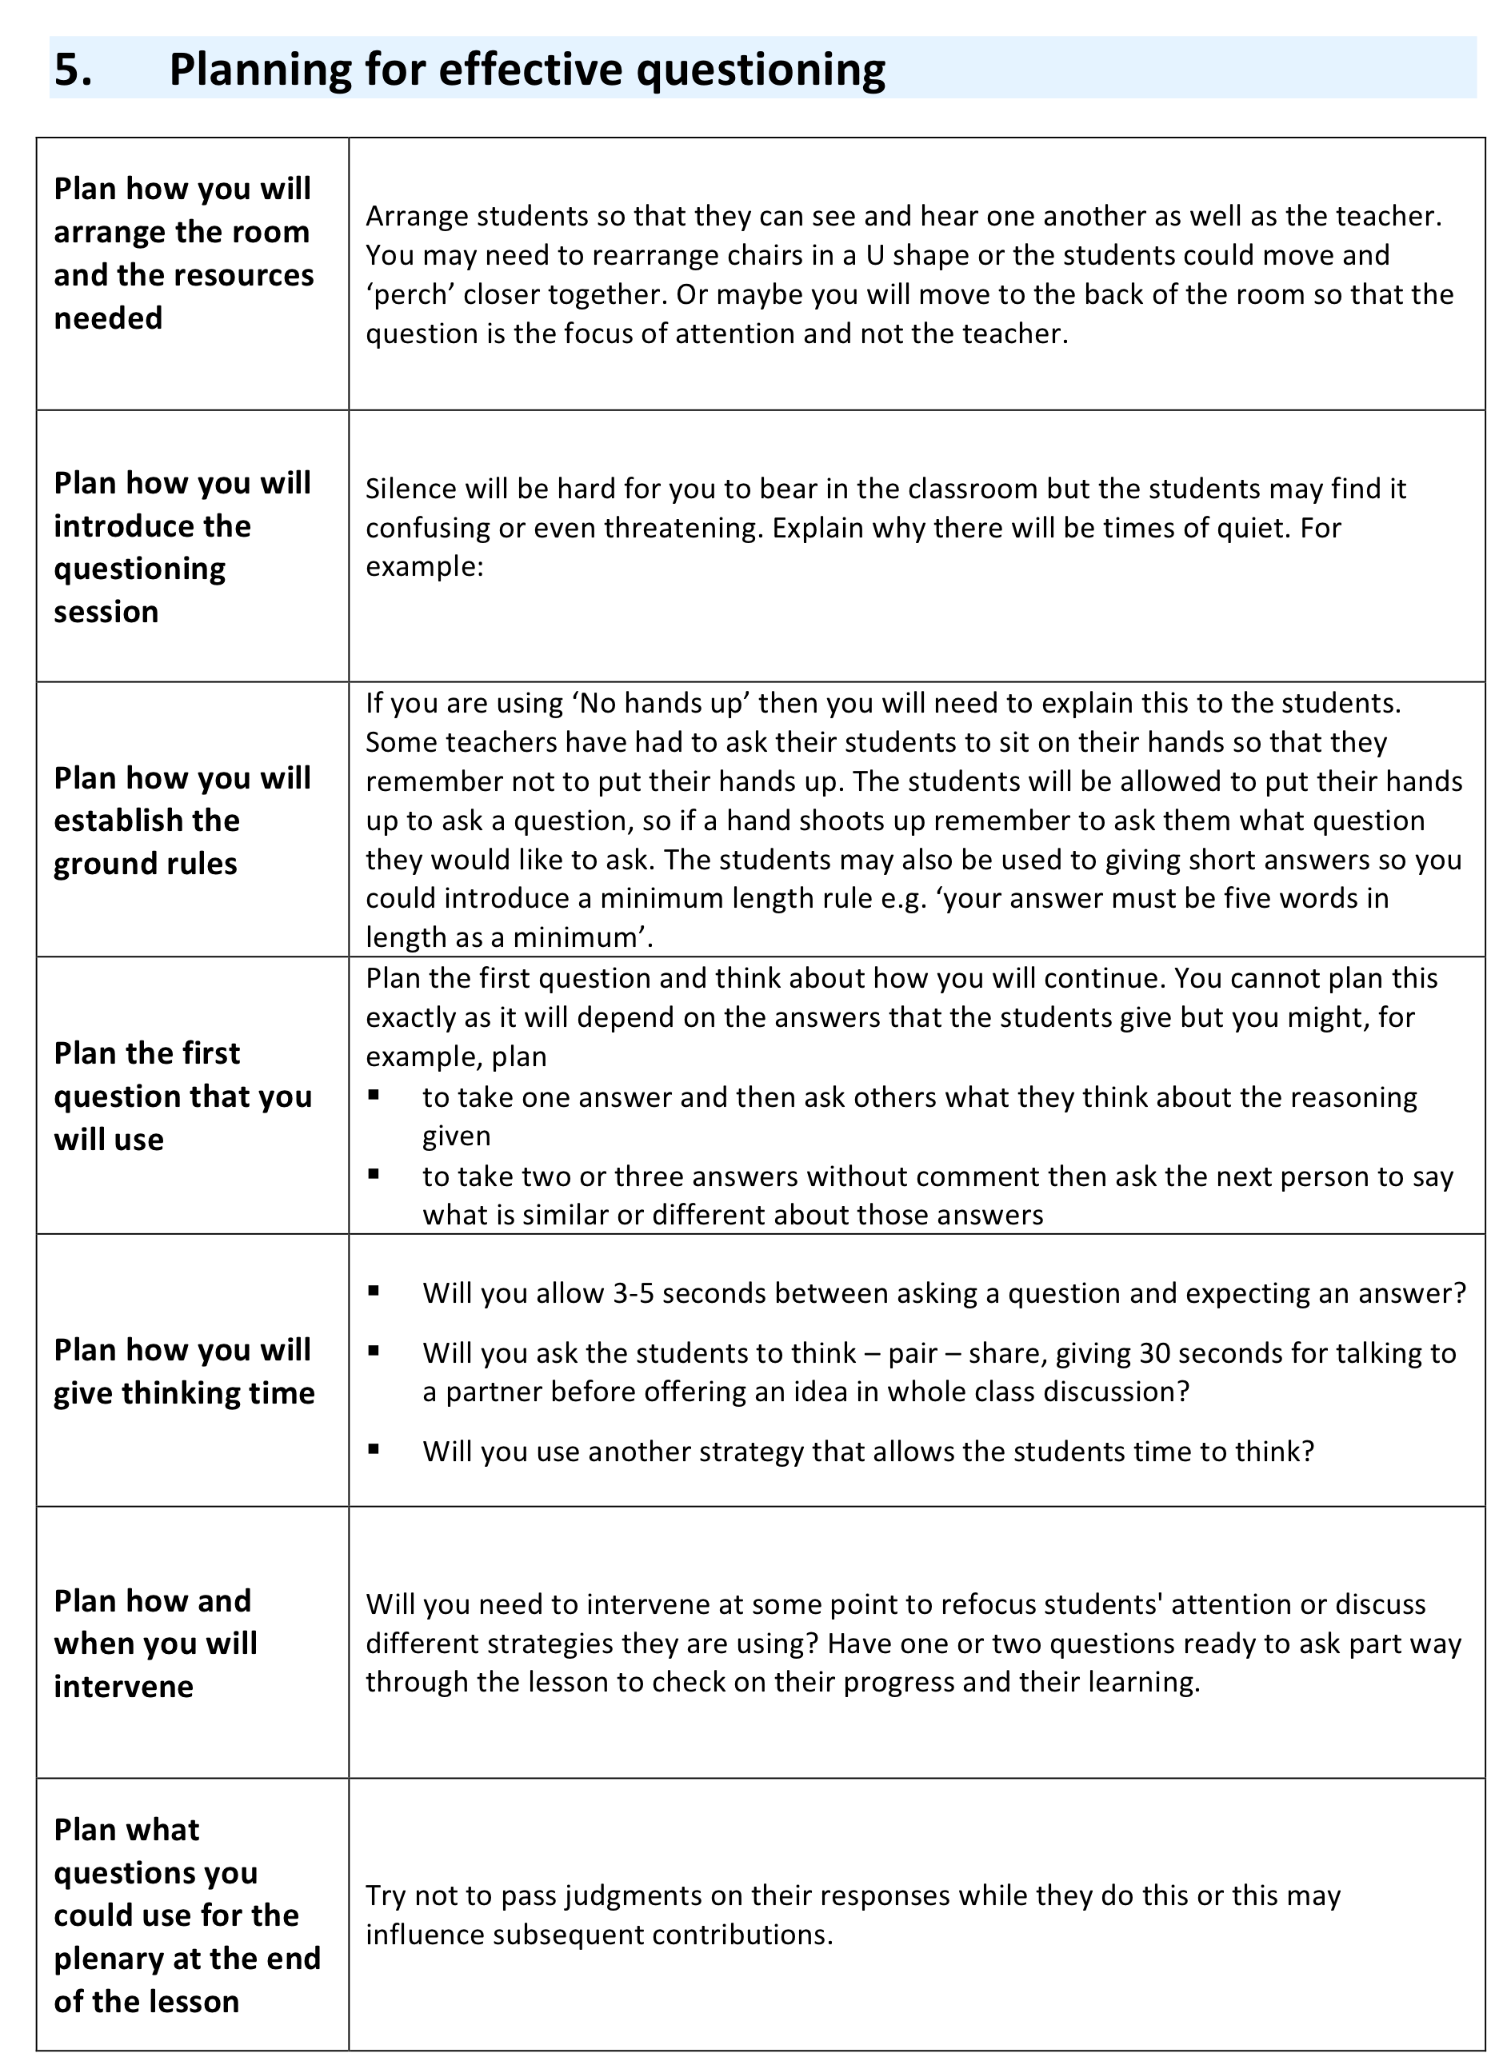

Handout 6. A lesson plan on sharing petrol costs
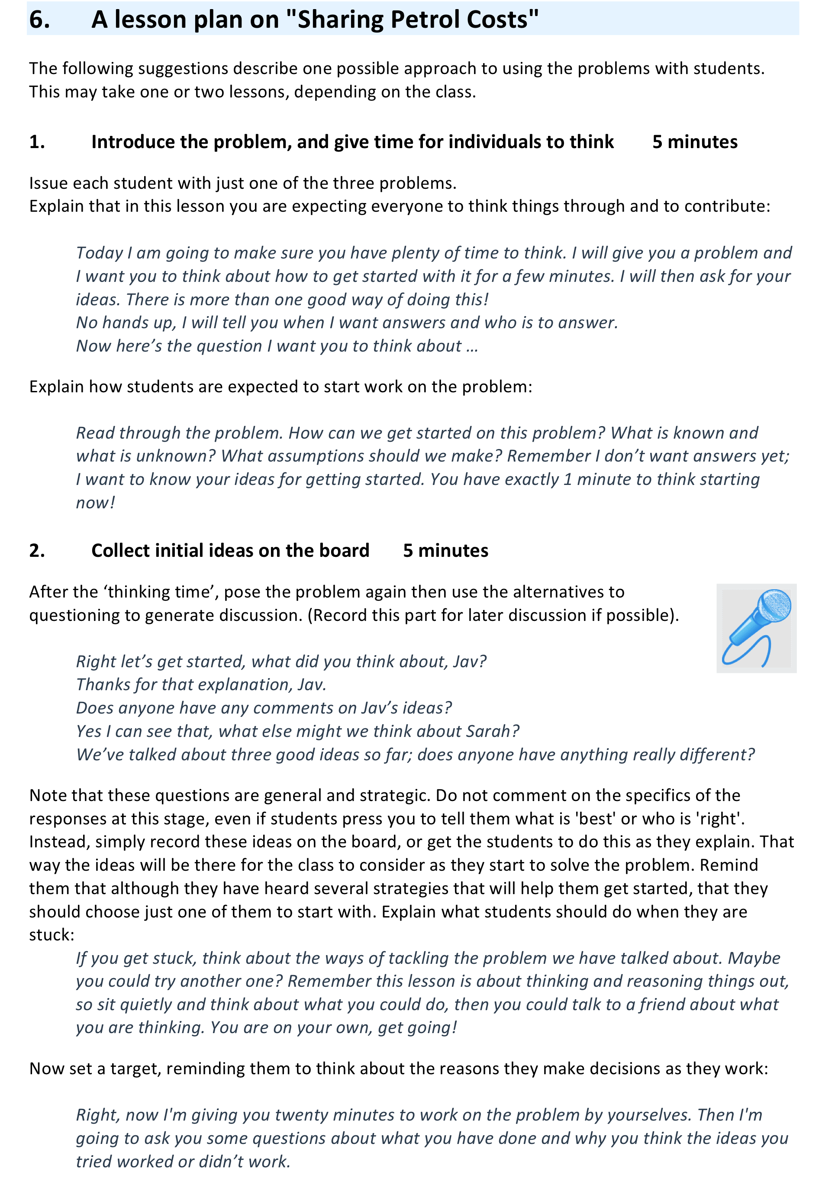 | 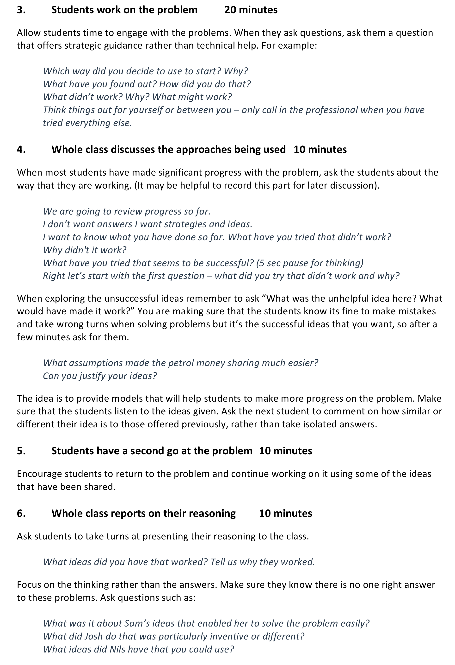

Activity E: Solve a problem, "thinking aloud"

Time needed: 20 minutes.
Teachers usually present science and mathematics as though they are a set of tidy results and procedures. Students often don't recognise the invisible, messy processes that go on inside the heads of scientists. One reason why some students are reluctant to persist is that they do not recognise that it is perfectly natural to get stuck, make mistakes, backtrack and look for alternative strategies. It is therefore helpful for a teacher to model these processes by tackling a problem from start to finish, thinking aloud and involving the class by careful questioning.

In the professional development session, it is useful for teachers to think through this process by tackling a problem together, 'thinking aloud'.

Try working out an answer to the following problem, thinking aloud as you do so:

About how many dentists are there in your country?

Afterwards think what it would feel like, doing this with a class, not knowing the answer beforehand.

If you are working with a group of teachers, ask two volunteers to tackle the problem publicly, thinking aloud at the front of the room. The other teachers should take the role of the pupils and try to assist when asked to do so.

Afterwards, discuss other possible strategies that might help students realise the mental processes that scientists and matehmaticians use every day. These may include, for example:

- Making a video of yourself and some colleagues solving a problem, while thinking aloud and discussing this with your class. We have included one such video on the resource.
- Students watching or reading biographies of mathematicians and scientists as they tell about their struggles and breakthroughs. See for example, Andrew Wiles' story on Youtube: http://video.google.com/videoplay?docid=8269328330690408516
- After working on a problem, reading solution attempts that have been produced by other students that reveal errors and the multiple trials and dead ends that have been encountered. Ask the students to work together to find, correct and comment on the ‘errors in reasoning’. They should also comment on where the reasoning was good so that they may use these ideas again.

Suggested further reading
Effective collection of questions for mathematical thinking
Bills, C., Bills, L., Watson A., J. Mason (2004), Thinkers, Association of Teachers of Mathematics, Derby. www.atm.org.uk

More effective questions for promoting mathematical thinking
Bills, L. Latham, P. and Williams, H. (2002) ‘Encouraging all learners to think’ Mathematics Teaching, 181, pp 14-16
http://www.atm.org.uk/mt/archive/mt181files/ATM-MT181-14-16.pdf

Questioning to enable effective learning and assessment for learning
Lee, C. (2006) Language for Learning Mathematics – assessment for learning in practice. Open University Press.

Questioning in the mathematics classroom, what really happens and what could happen?
Martin, N. (2003), ‘Questioning styles’, Mathematics Teaching, 184, pp 18-19
http://www.atm.org.uk/mt/archive/mt184files/ATM-MT184-18-19-mo.pdf

Is questioning really important?
Smith, J. (1986), ‘Questioning Questioning’, Mathematics Teaching, 115, p47.

The questions that make pupils think mathematically
Watson, A. and Mason, J. (1998) Questions and Prompts for Mathematical Thinking, Association of Teachers of Mathematics Derby, www.atm.org.uk

