|  |
| --- |
| Self and peer assessmentHow can students help each other to progress in using IBL processes? |

##### Handouts for teachers

### Contents

1 Helping students to become aware of IBL learning goals 2

2 An assessment task and five sample responses 3

3 Two assessment tasks with assessment frameworks 8

4 A lesson plan in which students are assessors 12

5 Meeting the needs of all students 15

6 Meeting the needs of all – some comments to consider 16

7 Suggestions for further reading 17

## 1 Helping students to become aware of IBL learning goals

### 1. Using a poster or handout

Make a poster showing the generic list of processes and display this on the classroom wall. Refer to this habitually, while students work on unstructured problems, so that they become more aware that your goals for the lesson are for them to become more able to simplify and represent, analyse and solve, interpret and evaluate, communicate and reflect.

### 2. Creating task-specific hints

Before the lesson, prepare some task-specific hints that apply IBL processes to the particular problem in hand. When students are stuck, give them the appropriate hint either on paper or orally. For example, you could ask: Can you use a table or graph to organise this data?”; “What is fixed and what can you change in this problem?”; “What patterns can you see in this data?”.

### 3. Asking students to assess provided samples of work

After students have worked on a task, present them with some prepared, sample responses from other students. These solutions provide alternative strategies students may not have considered and may also contain errors. Ask students to pretend they are examiners. The students rank order these solutions, along with their own response, giving explanations as to why they think one response is better than another.

### 4. Using prepared ‘progression steps’

Students evaluate sample responses as in (3) above, but this time you also provide them with prepared progression steps that highlight the IBL processes. Students use these to evaluate the work. End the lesson by sharing what has been learned from this process.

### 5. Asking students to assess each other’s work.

After tackling a task in pairs, students exchange their work. Each pair of students is given the work of another pair. Students make suggestions for ways of improving each solution and stick these on the work using “sticky” notes. These comments are passed back to the originators, who must then produce a final, improved version based on the comments received. This is a more challenging strategy for the teacher than (3), as the issues that arise will be less predictable.

### 6. Students interview each other about the processes they have used.

When students have finished working on a task, ask them to get into pairs. Each member of a pair interviews his or her partner about their approach and the processes they have used while working on the task. The teacher may provide some pre-prepared questions to assist in this. After noting down the replies, students change roles. Suitable questions might be:

• What approach did you take?

• Which processes did you use (from a provided list)?

• How could this work be improved?

• What could you have done differently?

• Is there still something you are confused by?

## 2 An assessment task and five sample responses

### Text Messaging



1. How many text messages are sent if four people all send messages to each other?
2. How many text messages are sent with different numbers of people?
3. Approximately how many text messages would travel in cyberspace if everyone in your school took part?
4. Can you think of other situations that would give rise to the same mathematical relationship?

### Follow-up task for students

Look carefully at the following extracts of work from other students. Imagine you are their teacher. Go through each piece of work and write comments on each one.

* Have they chosen a sensible method?
* Are the calculations correct?
* Are the conclusions sensible?
* Is the work easy to understand?

|  |  |
| --- | --- |
| **Name** | **Comments** |
| Tom |  |
| Sam |  |
| Chris |  |
| Lily |  |
| Marvin |  |

Now try to write out an answer that is better than all of them!

*Tom’s answer*

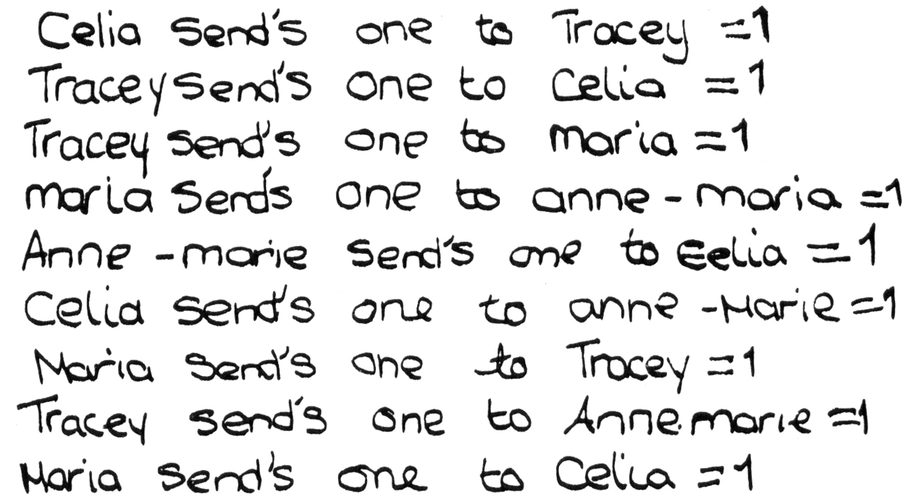

*Sam’s answer*

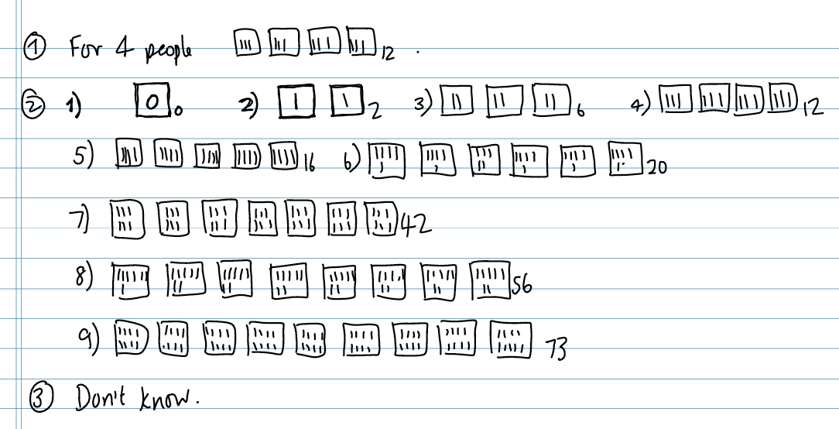

*Chris’s answer*

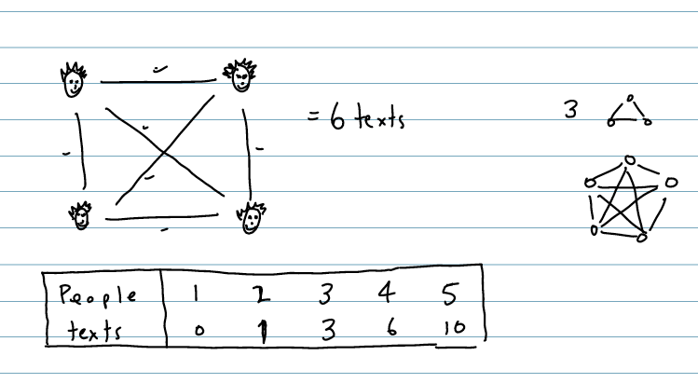

*Lily’s answer*

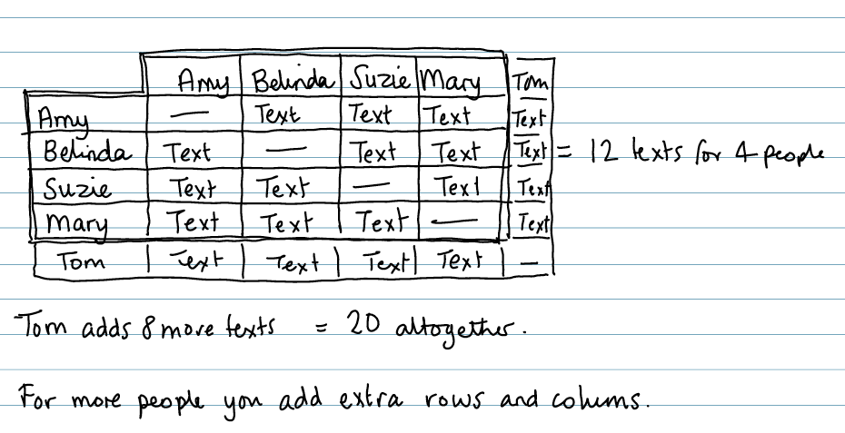

*Marvin’s answer*



## 3 Two assessment tasks with assessment frameworks

### Golden Rectangles

|  |  |
| --- | --- |
| In the 19th century, many adventurers travelled to North America to search for gold.  A man named Dan Jackson owned some land where gold had been found.  Instead of digging for the gold himself, he rented plots of land to the adventurers.  Description: goldgr_hint | Description: goldgr  Dan gave each adventurer four wooden stakes and a rope measuring exactly 100 metres.  Each adventurer had to use the stakes and the rope to mark off a rectangular plot of land. |

1. Assuming each adventurer would like to have the biggest plot, how should he place his stakes?   
   Explain your answer.

Read the following proposition:

“Tie the ropes together! You can get more land if you work together than if you work separately.”

1. Investigate whether the proposition is true for two adventurers working together, still using four stakes.
2. Is the proposition true for more than two people?   
   Explain your answer.

### Assessment framework for Golden RectanglesCounting Trees



This diagram shows some trees in a plantation.

The circles show old trees and the triangles show young trees.

Tom wants to know how many trees there are of each type, but says it would take too long counting them all, one-by-one.

1. What method could he use to estimate the number of trees of each type?  
   Explain your method fully.
2. On your worksheet, use your method to estimate the number of:
   1. Old trees
   2. Young trees

**Assessment framework for Counting Trees**

## 4 A lesson plan in which students are assessors

The following suggestions describe one possible approach to self- and peer-assessment. Students are given a chance to tackle a problem unaided, to begin with. This gives you a chance to assess their thinking and to identify students that need help. This is followed by formative lesson in which they collaborate, reflect on their work and try to improve it.

### Before the lesson 20 minutes

Before the lesson, perhaps at the end of a previous lesson, ask students to attempt one of the assessment tasks, *Text messages,* *Golden rectangles or Counting Trees,* on their own. Students will need calculators, pencils, rulers, and squared paper.

The aim is to see how able you are to tackle a problem without my help.

* You will not be told which bits of maths to use.
* There are many ways to tackle the problem - you choose.
* There may be more than one 'right answer'.

Don’t worry if you cannot understand or do everything because I am planning to teach a lesson on this next in the next few days.

Collect in students’ work and review a sample of it. Look carefully at the range of methods students use and the quality of the reasoning. Try to identify particular students who have struggled and who may need support. Also look out for students that have been successful. These my need an extension activity to challenge them further.

### Re-introduce the problem to the class 5 minutes

Begin the lesson by briefly reintroducing the problem:

Do you remember the problem I asked you to have a go at last time?

Today we are going to work together and try to improve your first attempts.

Even if you got most of it right first time, you will learn something because there are different ways to tackle the problem.

At this point, choose between the Track A *or* Track B. Either decide to let students assess and improve their own work, *or* offer them the provided samples of work to assess. There won’t be time for both!

### Track A: Using students’ own work

### *Track A: Students assess and improve their own work 15 minutes*

Ask students to work in pairs or threes and give each group a large sheet of card and a felt-tipped pen. Give each group back their initial attempts at the problem.

I want you to look again at you answers but this time, work as a group.

Take it in turns to describe your attempt to the rest of the group.

After each suggestion, the others in the group should say what they like about your method and also where they think it can be improved.

After you have all done this, I want you to work together to produce a better answer than you did separately.   
Make a poster showing your best ideas.   
It doesn’t have to be beautiful, but it should show you thinking.

Go round the room, listening, assessing their thinking and making appropriate interventions. Listen specifically to students that struggled with the task when they worked alone, and offer them support. If students have succeeded and their work is correct, provide one of the planned extensions.

### *Track A: Students exchange and comment on each others’ work 15 minutes*

Ask students to exchange their posters with another pair and issue each group with a copy of the “progression steps” framework for the task – one that is written in student-friendly language.

On a separate sheet of paper, write comments on:

• Representing: Did they choose a good method?

• Analysing: Is the reasoning correct – are the calculations accurate?

• Interpreting: Are the conclusions sensible?

• Communication: Was the reasoning easy to understand and follow?

As they do this, go round encouraging students to read the work carefully and comment on the points mentioned. You may need to help them understand what the ‘progression steps’ mean. When students have commented on the work, one person from the group should take the poster to the group that produced it, and explain what needs to be done for the work to be improved.

### *Track A: Students improve their own work 5 minutes*

Give groups a little time to absorb the comments and time to further improve their ideas.

### *Track A: Plenary discussion on approaches and changes 15 minutes*

Towards the end of the lesson hold a discussion on the approaches used and the changes that have been made:

What changes have you made to your initial work?

Why is it now better than it was before?

Collect in the work and assess how the thinking has improved.

**Track B: Using the provided sample work**

### *Track B: Students assess provided sample work 15 minutes*

Give out the sample student work.

These samples of work were taken from another class. I want you to imagine that you are their teacher. This work may give you ideas you haven’t thought of. It is also full of mistakes!

I want you to comment on each of the following themes:

• Representing: Did they choose a good method?

• Analysing: Is the reasoning correct – are the calculations accurate?

• Interpreting: Are the conclusions sensible?

• Communication: Was the reasoning easy to understand and follow?

In this way, students will become more aware of what is valued in their work – the Key Processes of representing, analysing, interpreting and communicating.

Listen to their discussions and encourage them to think more deeply. Encourage students to say what they like and dislike about each response and ask them to explain their reasons.

### *Track B: Students assess sample work using “progression steps” 10 minutes*

After students have had time to respond freely, issue each group with a copy of the “progression steps” framework for the task – one that is written in student-friendly language.

This framework may give you further ideas.

Where would you put the work on the framework?

### *Track B: Plenary discussion of the sample work 15 minutes*

Project each piece of sample student work on the board and ask students to comment on it:

What can we say about this piece of work?  
Share some of the comments you wrote.   
  
What did you think of the methods they chose?  
Which method did you like best? Why was this?

Did you find any mistakes in their work?

Do you agree with their conclusions?

### *Track B: Working in pairs: Students improve their own work. 10 minutes*

Now using what they have learned, ask students to work together to improve their own solutions. As they do this, as students to explain their thinking.

Max, tell me what you have done to improve your own solution.

Collect examples of students’ work for the follow-up session. Try to assess how much students have learned from the sharing session.

## 5 Meeting the needs of all students

Assessment reveals that all students have different learning needs.

How do you respond to this in your normal lessons?

Discuss and note down the advantages and disadvantages of each approach. Add your own ideas underneath.

|  |
| --- |
| **Differentiate by quantity?**  When students appear successful, you provide them with a new problem to do.  *............................................................................................................................................*  *............................................................................................................................................*  *............................................................................................................................................*  *............................................................................................................................................* |
| **Differentiate by task?**  You try to give each student a problem that is matched to their capability.  *............................................................................................................................................*  *............................................................................................................................................*  *............................................................................................................................................*  *............................................................................................................................................* |
| **Differentiate by outcome?**  You use open problems that encourage a variety of possible outcomes.  *............................................................................................................................................*  *............................................................................................................................................*  *............................................................................................................................................*  *............................................................................................................................................* |
| **Differentiate by level of support?**  You give all students the same problem, but then offer different levels of support, depending on the needs that become apparent.  *............................................................................................................................................*  *............................................................................................................................................*  *............................................................................................................................................*  *............................................................................................................................................* |

## 6 Meeting the needs of all – some comments to consider

**Differentiate by quantity?**

*When students appear successful, you provide them with a new problem to do.*

This approach is common, but it leads to students viewing the curriulum as a list of problems to do, rather than processes to acquire. This approach will not promote reflection on alternative methods for doing a problem - different ways of representing, analysing, interpreting and communicating.

**Differentiate by task?**

*You try to give each student a problem that is matched to their capabilities.*

But how does one know if a problem is suitable? We can only match a problem to a student if we have a profound understanding of both. Our view of the problem is usually based on our own way of doing it – and there may be many other approaches. We also have an imperfect and often prejudiced view of students’ capabilities. We so easily judge students’ ‘mathematical ability’ by their ability to carry out routine procedures they have recently been taught. Problem solving requires a different set of skills and may result in different students performing well. This approach also creates management difficulties as different problems are used with different students. This reduces possibilities for whole class discussions and sharing knowledge.

**Differentiate by outcome?**

*You use more open problems that encourage a variety of possible approaches and outcomes.*

This approach requires problems and situations that allow for such a variety to emerge. The Bowland problems are like this, but they do make considerable demands on students who are unfamiliar to problem solving. Many teachers comment that as soon as students begin to struggle, they want to ‘leap in’, ‘take over’ and structure the problem, so that students have clear steps to follow. This tendency undermines the very purpose of the lesson – to develop students’ ability to use Key Processes in an autonomous way. On the other hand, too little guidance may result in prolonged failure and frustration. Some teachers therefore make it a rule that students should always help and share ideas with each other, before asking for help from the teacher.

**Differentiate by level of support?**

*You give all students the same problem, but then offer different levels of support, depending on the needs that become apparent.*

This approach avoids many of the difficulties described above. The support may be by other students, or by the teacher - orally, or in written form. In the lessons we have suggested, the teacher asks the students to attempt what they can unaided, then they are offered the support of their peers as ideas and approaches are shared and discussed. If further support is needed, then the teacher may supply this through questions that cause students to attend to particular features of the problem, or through more specific hints. Timing such help is critical. One of the important goals of problem solving is to allow students the experience of *struggling* with a problem for some time and experiencing the sense of achievement that arrives when the problem has been overcome. If we help students too quickly, we rob them of this experience.

## 7 Suggestions for further reading

Black, P., & Wiliam, D. (1998). *Inside the black box: raising standards through classroom assessment*. King's College London School of Education.   
Now published by GL Assessment: http://shop.gl-assessment.co.uk

This short booklet offers a summary of the extensive research literature into formative assessment. It shows that there is clear evidence that improving formative assessment raises standards, and offers evidence showing how formative assessment may be improved. This booklet is essential reading for all teachers.

Black, P., & Harrison, C. (2002). *Working inside the black box: Assessment for learning in the classroom*. King's College London School of Education.   
Now published by GL Assessment: http://shop.gl-assessment.co.uk

In this booklet, the authors describe a project with teachers in which they studied practical ways of implementing formative assessment strategies and the effect this had on learning. The section on peer-assessment and self-assessment (pages 10-12) are particularly relevant to this module.

Black, P., Harrison, C., Lee, C., Marshall, B., & Wiliam, D. (2003). *Assessment for learning: Putting it into practice*. Buckingham: Open University Press.

This book gives a fuller account of the earlier booklets *Inside the black box* and *Working inside the black box*. It discusses four types of action: questioning, feedback by marking, peer- and self assessment and the formative use of summative tests. The section on peer and self-assessment (pp 49-53) is particularly relevant to this module.

Hodgen, J., & Wiliam, D. (2006). *Mathematics inside the black box*. King's College London School of Education. Now published by GL Assessment: http://shop.gl-assessment.co.uk

This booklet applies the above findings specifically to Mathematics. It considers some principles for Mathematics learning, choice of activities that promote challenge and dialogue, questioning and listening, peer discussion, feedback and marking, and self and peer assessment. This booklet is essential reading for all mathematics teachers. Pages 9-10 are particularly relevant to this module.