Student-led inquiry

How might students be encouraged to ask and follow-up their own questions?

Handouts for teachers

Contents

1. Phenomena to explore 2
2. The modeling cycle 3
3. Photographs to explore 5
4. Building a school with bottles in Honduras 8
5. Building a school with bottles: the modeling cycle 10
6. A sample lesson plan 13

1. Phenomena to explore

Rolling cups
Look at these two paper cups.
Imagine that they are going to roll across the floor.
- List some possible questions that occur to you.
"Will the cups roll in a ...?"
"How can I predict ...?"
"What would happen if....?"
- Make up some conjectures. These might start like this:
" When you use this shape of cup then this is what will happen ..."
" If you roll the cup too hard, then ..."
- Now carry out an experiment and collect some data.
Can you explain and prove your conjectures?

Spirolaterals
Type some numbers into the Spirolaterals machine. Press "Go" and watch what happens.
- How do the numbers control what is drawn on the screen?
- List some questions to explore.
These might start like this:
"How can we make the computer draw ....?"
"What will happen if we .....?"
Try and answer your own questions!
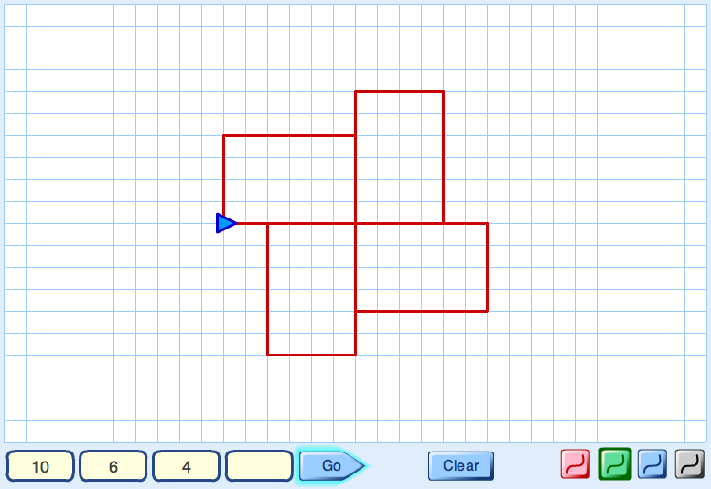
- Make up some conjectures. These might start like this:
" When you use three numbers then ..."
" When you repeat a number then ..."
" If you change the order of the numbers then ..."
Can you explain and prove your conjectures?

2. The modeling cycle
The narrow boxes represent states of the modeling process.
The wide boxes describe the actions that move from one state to the next.

Simplify and represent
- identify a problem
- simplify and represent the problem
- select information, methods and tools

Situation
Mathematical model
Analyse and solve
- make connections with what you already know
- visualise; draw diagrams
- systematically change variables
- look for patterns and relationships
- make calculations and keep records
- make conjectures and generalisations
- use logical, deductive reasoning

Solution
Interpret and evaluate
- form conclusions, arguments and generalisations
- consider appropriateness and accuracy
- relate back to the original situation
Is the solution good enough?

Communicate and reflect
- communicate and discuss findings effectively
- consider alternative solutions
- consider elegance, efficiency and equivalence
- look for connections to other problems

Report
NO
YES

Simplify and represent
- What exactly is the problem? Can I say it clearly?
- What do I know, and what do I need to find out?
- Can I make the problem a bit simpler?
- What assumptions can I make?
- What bit of maths might help me?

Situation
Mathematical model
Analyse and solve
- Have I seen something like this before?
- Is there a diagram that I could draw?
- What is fixed, and what can I change?
- Can I do this in an organised way?
- How can I keep a record of what I am doing?
- Can I see any patterns or relationships?
- Will this pattern always work? How can I be sure?

A solution to the problem
Interpret and evaluate
- What conclusions can I draw?
- How can I check my work?
- Are my conclusions reasonable?
Is my solution good enough?

Communicate and reflect
- What is the best way to show my work to others?
- Looking back, was there a better way to do it?
- Will this work be useful for other problems?
Report
NO
YES

3. Photographs to explore
Look at each of the photographs below and, for each one:
- Make a list of things you notice.
- Write down some questions that occur to you. They might, for example, start like this:
How could I describe ..... ?
How many ...?
What would happen if I changed ....?
Now do some mathematics based on the photograph!

Dominoes

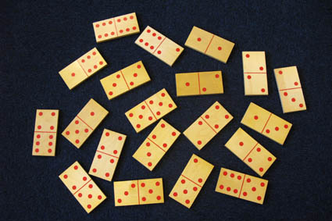

Calendar

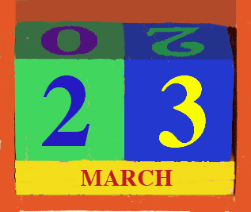

Stack of barrels
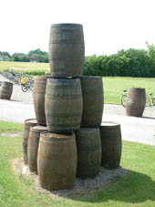

A pavement in Germany

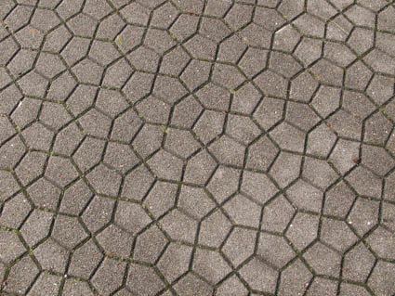

Trike with square wheels
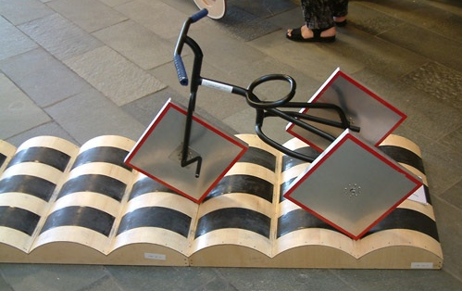

Russian dolls

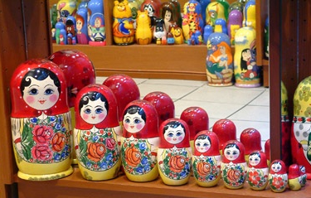

These photographs were taken by Malcolm Swan.

Further photographs leading to interesting mathematical discussions may be obtained from Richard Phillips at http://www.problempictures.co.uk/

4. Building a school with bottles in Honduras
Look at the pictures and:
- Make a list of things you notice.
- Write down some mathematical problems that occur to you.
- Now try to solve one problem!

First we collect old plastic bottles ..... and fill them with sand.

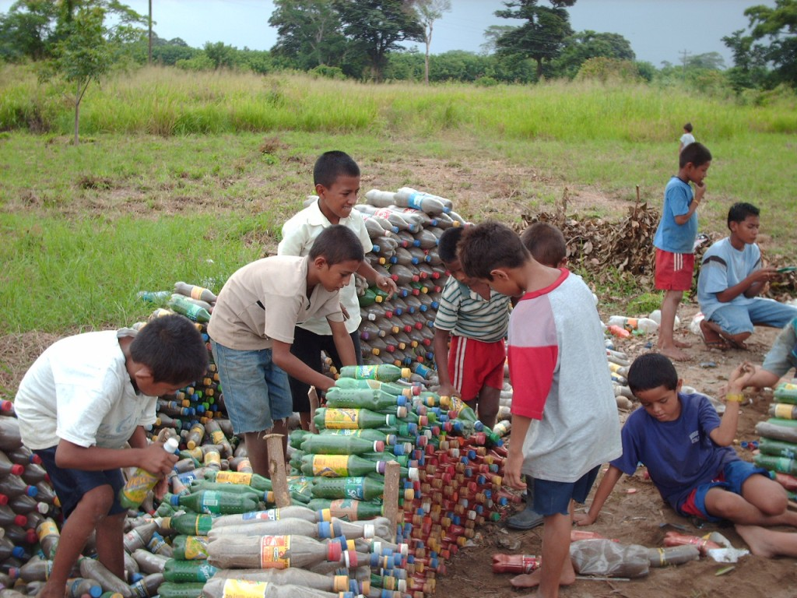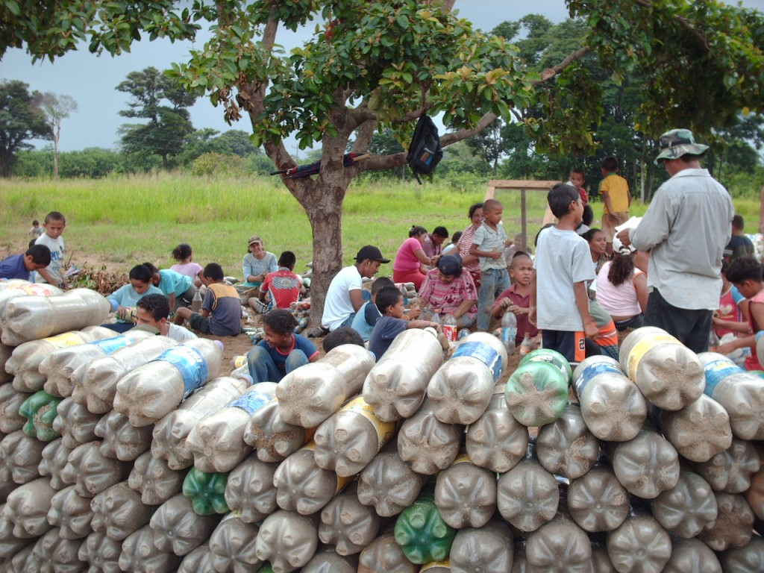

and make some foundations with rocks.... and start to build....

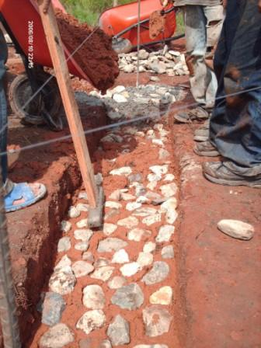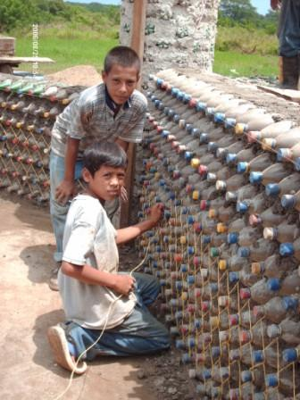

and build.... and build....

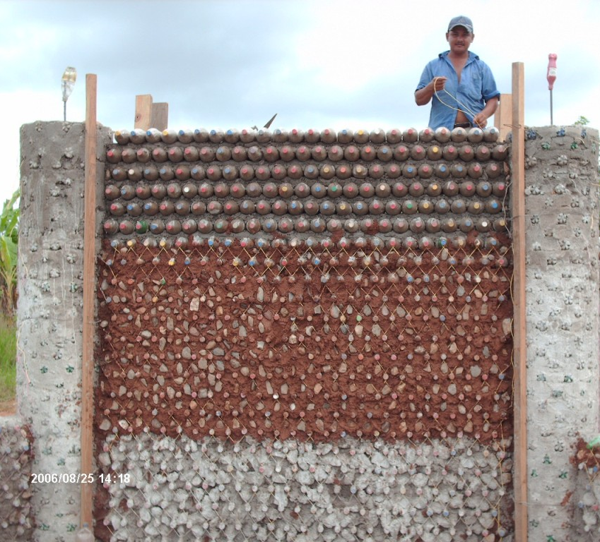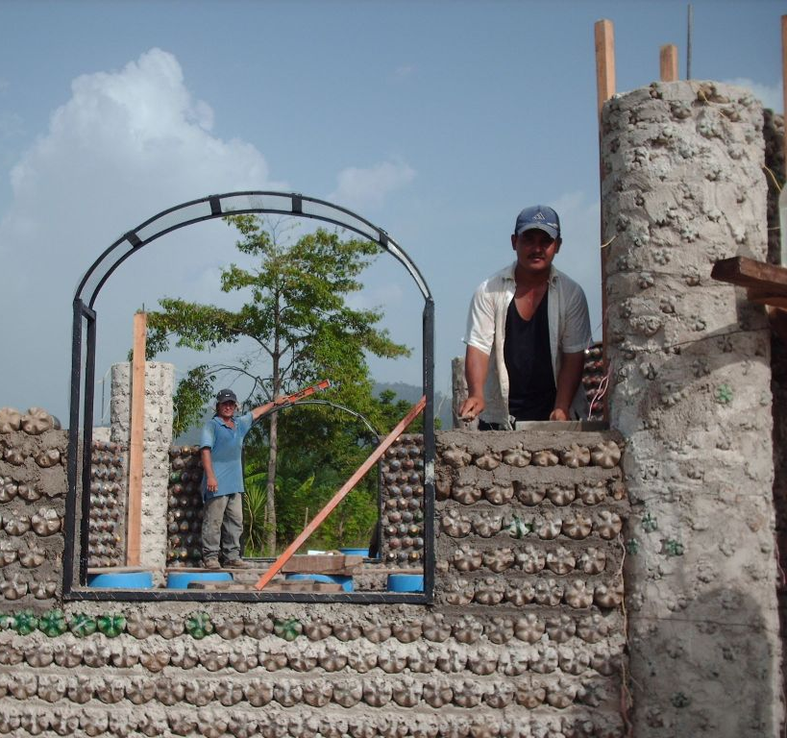

Add windows... and plaster the walls.

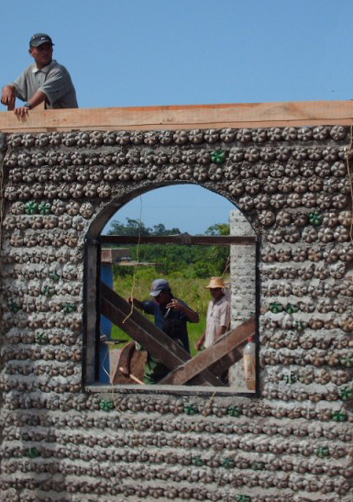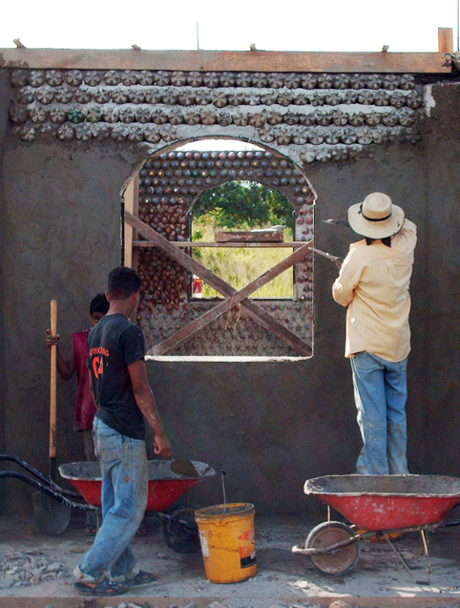

This building is in Honduras and is now a centre for a secondary education programme that is designed to equip and motivate young people to help their communities and to reduce poverty. The programme is particularly designed to help students develop a capacity for problem solving.

Photographs with kind permission from:
Bayán Asociación de Desarollo Socio-Económico Indígena, La Ceiba, Honduras.

5. Building a school with bottles: the modeling cycle
Below we illustrate the modeling cycle applied to the Bottles situation.

(i) Simplify and Represent
We first identify some of problems that may be asked:
- How many bottles do I need for a building like this?
- How tall is the building, and the man?
- How do the bottles fit together?
- How much sand will we need to fill the bottles?
- What about the mortar in between?
- How do the corners work?
- What about doors and windows?
- What about the roof?

We'll focus (to begin with, at least) on a practical approach to
How many bottles do I need for a building like this?

To begin with we'll simplify the situation to assume there are 4 walls (as suggested by the angles in the bottom photograph), all the same size, and that there are no windows! We'll make calculations easier if we also assume that the number of bottles needed would not be much different if they were stacked in a 'square' fashion: i.e.

like this... rather than like this...
We'll modify these assumptions in the second cycle of the process.

(ii) Analyse and solve
Count the number of bottles in a row.
Estimate the number of rows (you can’t see them all)
Number in one wall is approximately the product of these.
Add up for 4 walls – assume the walls are the same size.

There are about 25 bottles in a row.
We can see and count only the top 7 rows clearly; these are about 1/3rd of the height
So we estimate that there are about 3 x 7 ~ 20 rows
So the wall contains about 25 x 20 ~ 500 bottles
Assuming the 4 walls are the same size gives 4 x 500 = 2000 bottles

(iii) Interpret and evaluate
This is good enough to illustrate the modeling process (and easy to report), but (and this is why it is a modeling cycle) if we were really serious about understanding the problem it would need to be improved by returning to tackle some of the other questions listed above.

Possible refinements include, for example:
- What size bottles are these? (We could estimate from the height of the man)
- How much sand would we need?
(E.g., 2000 one-litre bottles need 2-3 tonnes; why? )
- …. and, of course, we would need to make a proper plan for the building

(i) Simplify and represent
We could represent the stacking of the bottles in other ways, for example by closer packing like figure A (assuming no mortar) or figure B (with some mortar).

No mortar: Some mortar between rows:
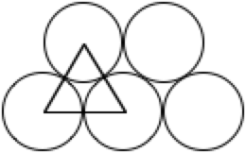 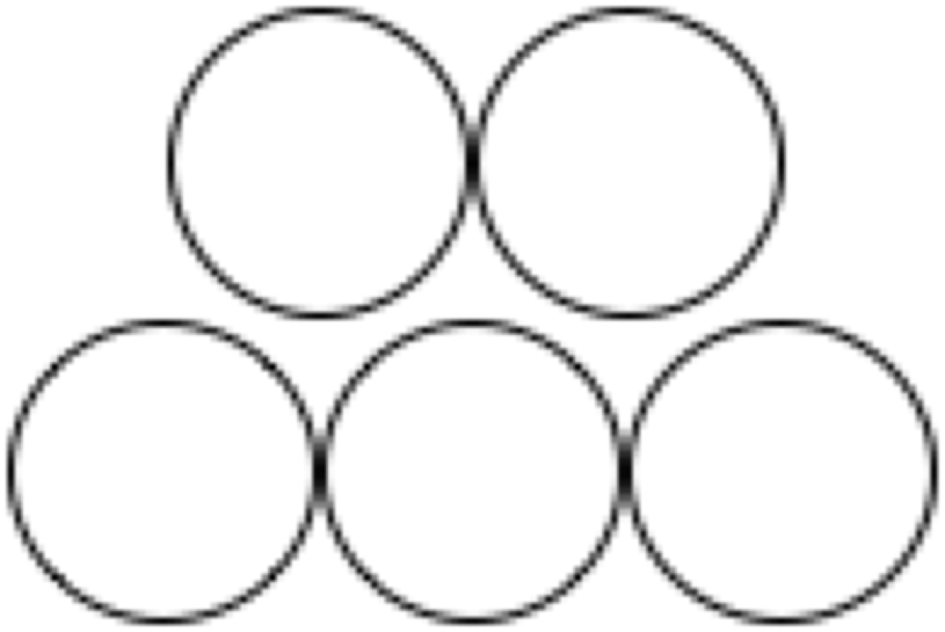

(ii) Analyse and solve
If there was no mortar, the length of the longest row would be equal to the diameter of bottle x number of bottles in a row. The height between rows would be the height of the equilateral triangle in the figure. This might be calculated either by Pythagoras or simply by measuring a model made from three bottles!
Height between rows =
So the saving in gaps from close packing (compared with square stacking) would be about 13% although there are bigger gaps at the ends of each row.

With mortar, the height between rows appears to be approximately equal to the diameter of each bottle. Thus we can reasonable assume that the height of a wall is approximately equal to the diameter of bottle x number of rows of bottles.

Both models reduce the number of bottles needed by only one for every two rows.

The number of bottles needed for each wall may be counted and represented in a table:

Number of rows of bottles  (r) | 6 | 9 | 15 | 21 | 27 | 33 | 39
 | 5 | 8 | 13 | 18 | 23 | 28 | 33
 | 4 | 6 | 10 | 14 | 18 | 22 | 26
 | 3 | 5 | 8 | 11 | 14 | 17 | 20
 | 2 | 3 | 5 | 7 | 9 | 11 | 13
 | 1 | 2 | 3 | 4 | 5 | 6 | 7
 |  | 2 | 3 | 4 | 5 | 6 | 7
 | Number of bottles in longest row (n)
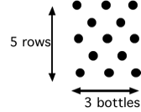

If we assume (as before) that there are 25 bottles in the longest row and 20 rows, then this arrangement would require just 10 fewer bottles, or 490 bottles for each wall.
For 4 walls this gives 1960 bottles - only 2% fewer than our previous estimate!

(iii) Interpret and evaluate
This analysis confirms our earlier one as being very reasonable.
The following analysis is algebraic, an approach that reveals the general structure of the problem. This will be beyond the capabilities of many students, but it illustrates here the process of analytic modeling in a simple situation.

(i) Simplify and represent
How many bottles do I need to build any rectangular building of bottles?

First select and list the variables:

Height of wall h
Width of wall w
Diameter of a bottle d
Number in row n
Number of rows r
Number in wall W
Total number of bottles T
We will also denote each wall by subscripts 1 to 4.

Now we generate relationships between the variables:

(Total number of bottles in all 4 walls)
etc. (Assume all walls have same height, thus same r)
(Assume rows are d apart)
etc. (Not assuming each wall is same width)

(ii) Analyse and solve
We can form some new equations by combining these:

(iii) Interpret and evaluate
We can get estimates for the number of bottles needed from either of these two last equations. The final one also doesn't assume that there are no doors and windows.
It simply states that each bottle occupies a wall area equal to the square of its diameter. Perhaps we should have seen this simple relationship at the outset!

6. A sample lesson plan

The following suggestions describe one possible approach to using the photographs with students. This approach is intended to introduce them to the modeling cycle. The timings below are very tentative. This lesson outline may well stretch into two lessons in practice!

Introduce the situation, then ask students to identify problems 5 minutes

The aim of today's lesson is to see if you can use mathematics to analyse a situation.
To start with, you may not think the situation has anything at all to do with maths or science.
I want to see if you can be creative and find ways of using the things you have learned at school.

Introduce the situations carefully and vividly. Use the PowerPoint presentation on an interactive whiteboard, if possible.
These photographs were taken in Honduras. They show some people building a school out of old one-litre plastic bottles, just like the ones you buy lemonade in. They first fill them up with sand and then use them as bricks.
This is a great way of using waste materials!
What questions could we ask about this situation?

Give students two minutes to note down any problems that spring to mind, then collect their ideas on the board. For example:

How many bottles (or how much sand) will it take to build one wall?
How many bottles to build the whole building?
How do the corners work?

Ask students to identify which problems may be solved using mathematics and ask each group to choose one of these problems to work on.

Simplify and represent the problem 10 minutes

Explain that situations are sometimes too complicated to analyse as they stand. We have to simplify them before representing them with maths. Thinking with mathematics almost always involves this process.
How might we get started on the problem? Can we try a simpler problem first?
What resources could we use to help us think about the problem?
Would squared paper, isometric paper, a tape measure, a ruler help?
What kinds of diagrams might help?

Describe the resources that are available for working on the problem. Where appropriate, leave these at the side of the room, so that students can choose whether or not they use them.

Allow students 10 minutes to plan how they will work on the problems.

Right, now I'm giving you ten minutes to work on the problem in pairs. Then I'm going to ask some of you to come out and talk about the different approaches you are using.

Review the representations students use 10 minutes

Ask students to describe the methods and notations they are using. For example:
"We are simplifying the problem by looking at smaller walls and seeing if we can find a way of counting how many bottles will be needed. We are showing the bottles as black blobs.

This diagram shows that when there are 5 rows of bottles and the longest row contains 3 bottles, then 13 bottles are needed."

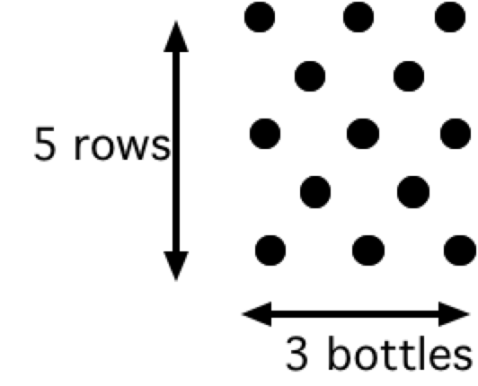

Of course, students may use all kinds of simplifications and notations and some may be more helpful than others. Spend some time discussing their advantages and disadvantages insofar as they are clear at this stage.

Analyse and solve the problems 20 minutes

Allow students time to work on the problems in pairs. As they do this, go round and offer general strategic guidance such as:
Take you time, don't rush.
What do you know?
What are you trying to find out?
Don't ask for help too quickly - try to think it out between yourselves.

To those who are struggling, ask appropriate questions from Handout 2:
Where have you seen something like this before?
Drawing this diagram out each time is taking you too long. Can you use a simpler representation?
What are you keeping fixed? What are you changing? Can you do this in a systematic way?
Can you see any patterns or relationships here? Can you explain them?
How can you keep a record of what you are doing?
Can you explain to me how this step follows this step?

For those who have made progress, move them towards interpretation and evaluation:

What have you found out so far?
Convince me that your solution is a good one.
How accurate is your answer? Is it accurate enough?
Can you find another way that would give other ways of looking at the problem?

Students communicate and reflect on their different approaches. 10 minutes

When most students have made significant progress with the problem, invite a few pairs of students to come to the front and communicate their ideas to the rest of the class. It does not matter if some have not yet reached any conclusions. They can still share their approaches and ideas.

Let's stop and share some of the different approaches we have used and consider what maths has been helpful and what unhelpful in each approach. Not everyone has finished, so I don't want to know about your answers; I want to hear your reasoning.

Tell us about:
- the problem you are solving;
- how you have represented the problem as a mathematical model;
- how you are analysing your model to get answers;
- any conclusions you have reached so far. Do your answers make sense?
We decided to find out how many bottles you would need for a building. We counted the bottles in one row, then the number of rows – but that wasn’t easy to see. Then we multiplied those numbers. Then we said there were 4 walls, hopefully the same size. Then we began to worry about doors and windows...

As students present their ideas, ask other students to comment on the advantages and disadvantages of each approach. If an explanation seems sound but is garbled, try:

Can you say that again please?
You seem to have a good idea there but I want you to explain it
as clearly as you can.
Clear communication is important in mathematics.

Review the processes that students have been through 5 minutes

Introduce students to a simplified version of the modeling cycle and discuss the process they have been through. Try to make them a little more aware of the value of modeling.

Using mathematics and science involves all these processes. It is not just about learning simple techniques like how to add fractions! It is also about looking at situations in the world, simplifying them and analysing them to understand them better.

This is what professional mathematicians and scientists do in their work.

