Learning Concepts throUgh InquirY

Introduction
This unit considers how the processes of inquiry based learning may be integrated into the teaching of Mathematics and Science content. Often, these two aspects of learning are kept separate: we teach content as a collection of facts and skills to be imitated and mastered, and/or we teach process skills through investigations that do not develop incorporate important content knowledge. The integration of content and process raises many pedagogical challenges.

The processes under consideration here are: observing and visualising, classifying and creating definitions, making representations and translating between them, finding connections and relationships, estimating, measuring and quantifying, evaluating, experimenting and controlling variables. As some have pointed out, these are developments of natural human powers that we employ from birth (Millar, 1994). To some extent, we use them unconsciously all the time. When these powers are harnessed and developed by teachers to help students understand the concepts of mathematics and science, students become much more engaged and involved in their learning.

This unit has many activities within it - too many for one session. It is suggested that this unit is used as a menu, from which professional development providers can choose. It is however, important that participants are given an opportunity to try out some of these activities in their lessons and to report back on the outcomes.

Activities
Activity A: Observing and visualising 2
Activity B: Classifying and defining 4
Activity C: Representing and Translating 6
Activity D: Making connections 8
Activity E: Estimating 10
Activity F: Measuring and quantifying 12
Activity G: Evaluating statements, results and reasoning 14
Activity H: Experimenting and Controlling variables 16
Activity I: Plan a lesson, teach it and reflect on the outcomes 18
Further reading 19
References 19

Acknowledgement:
The modules have been compiled for PRIMAS from professional development materials developed by the Shell Centre team at the Centre for Research in Mathematics Education, University of Nottingham. This includes material adapted from Improving Learning in Mathematics © Crown Copyright (UK) 2005 by kind permission of the Learning and Skill Improvement Service www.LSIS.org.uk.

Activity A: Observing and visualising
Time needed - 30 minutes
The processes of observing and visualising are natural human powers that we have from birth. Observation is primarily about what we can see and notice directly, whereas visualisation concerns what we can imagine and transform mentally, in our 'mind's eye'. The contention here is that these powers are often under-used in classrooms, at least partly because we don't use tasks that require the use of these powers for their successful completion.

The activities presented here are intended to be just examples of three ways of harnessing students' powers of observation and visualisation. These are only examples; alternatives are easily found at any level of difficulty. In the left hand column of the worksheet we offer generic descriptions of the activities, while in the right hand column we offer a specific example. These are discussed briefly, below.

- Work on some of the activities on Handout 1.
- Share you observations and mental images:
- how did you 'see' the object differently?
- what did you notice or single out for attention?
- what did you try to manipulate mentally?
- Try to develop an activity using one of these types for use in your own classroom. Try to devise examples that force students to observe properties carefully, and that will create discussion about definitions.
- Try out your activity and report back on it.

Alhambra
The Alhambra tiling is a complex repeating pattern made from many different shapes. Participants may be asked to sketch the individual tiles that went in to constructing it. Two small tiles will do, as shown below.
Could the pattern be made from one small tile?

Cube of cheese
Ask participants to describe all the shapes that they 'see' as the cheese is cut. Initially a small triangle is formed, but this may be of any type, depending on the angle of the knife. As larger and larger cuts are made, participants may be surprised to 'see' all kinds of quadrilaterals, pentagons and hexagons. They may want to sketch diagrams and work on this further as they discuss. Encourage this, but only after trying to work mentally.

Suspension bridge cables
Different ways of seeing lead to different sequences and algebraic expressions:
 | 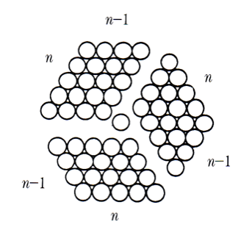 | 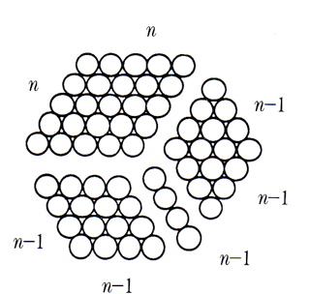 | You may also be able to see the diagram as the difference of two cubes:
1, 7, 19, ..... | 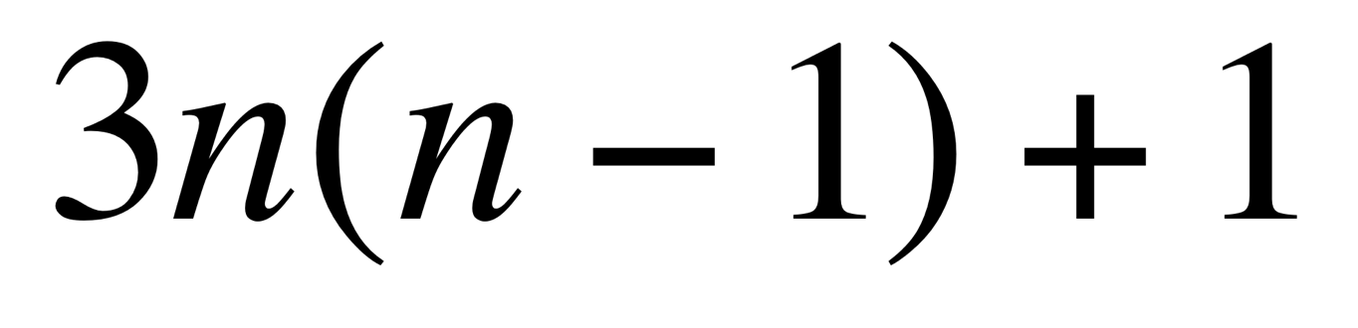 | 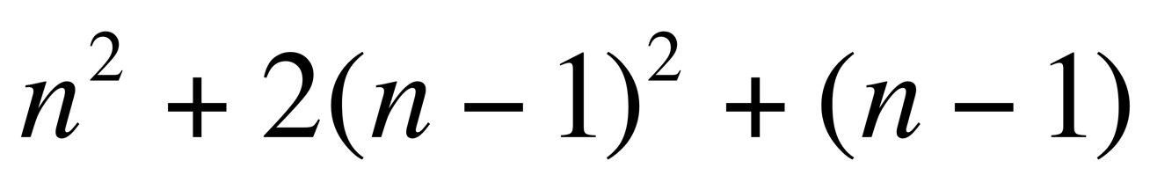 | 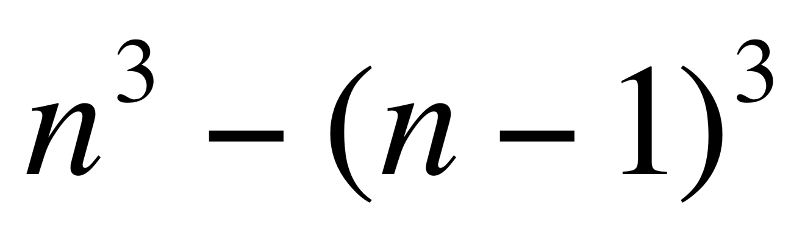

Handout 1: Observing and visualising activities
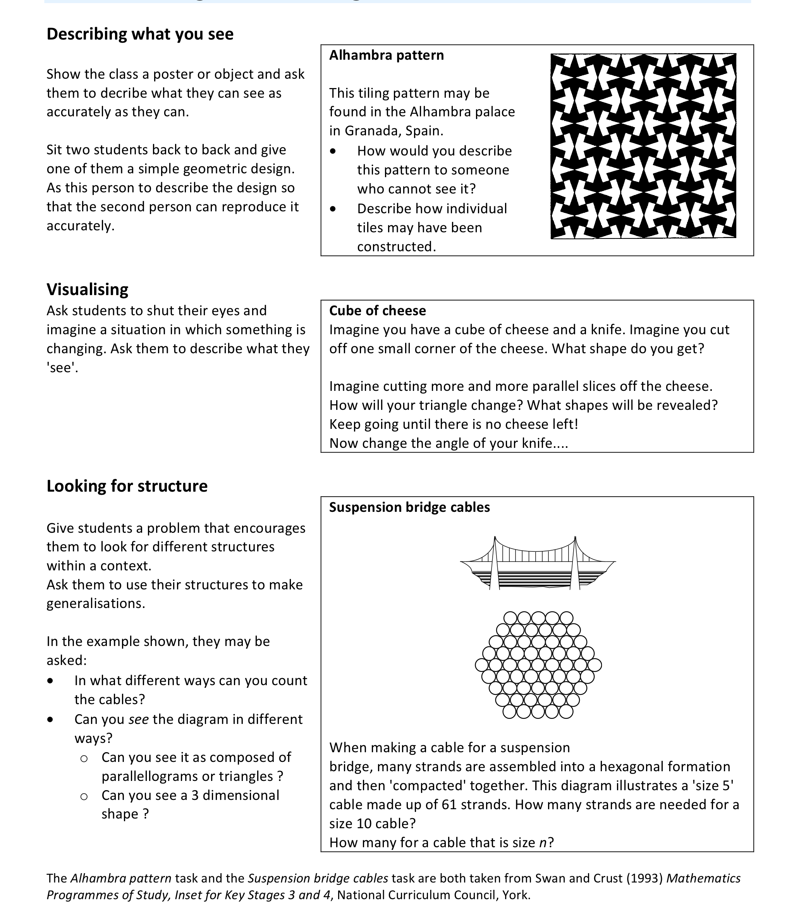

Activity B: Classifying and defining
Time needed - 30 minutes
Classification and definition clearly play key roles in Science and Mathematics. Here we are not only concerned with learning classifications and definitions devised by others, but also with students engaging in these processes to gain an understanding of how Scientific and Mathematical concepts come about. In these activities, students examine a collection of 'objects' carefully, and classify them according to their different attributes. Students select each object, discriminate between that object and other similar objects (what is the same and what is different?) and create and use categories to build definitions. This type of activity is powerful in helping students understand what is meant by different terms and symbols, and the process through which they are developed.

- Work on some of the activities on Handout 2.
- What kinds of 'objects' do you ask students to classify and define in your classroom?
- Try to develop an activity using one of these types for use in your own classroom. Try to devise examples that force students to observe the properties of objects carefully, and that will create discussion about definitions.
- Try out your activity and report back on it in a later session.

The types of activity shown here may be extended to almost any context. In Mathematics, for example, the objects being decribed, defined and classified could be numerical, geometric or algebraic. In Science they could be organisms or elements. The activity here is for teachers to try to explore the range of possibilities.

Similarities and differences
In the examples shown, students may, for example, decide that the square is the odd one out because it has a different perimeter to the other shapes (which both have the same perimeter); the rectangle is the odd one out because it has a different area to the others and so on. Properties considered may include area, perimeter, symmetry, angle, convexity etc. In the silhouettes, students may consider many aspects: where the animals live, how they move, reproduce etc. Participants should try to devise their own examples.

Properties and definitions
None of the properties by themselves defines the square. It is interesting to consider what other shapes are included if just one property is taken. For example, when the property is "Two equal diagonals" then all rectangles and isosceles trapezia are included - but is that all the cases?
Taken two at a time, then results are not so obvious. For example, "Four equal sides" and "four right angles" defines a square, but "diagonals meet at right angles" and "four equal sides" does not (what else could this be?).

Creating and testing definitions
Participants usually write a rather vague definition of "polygon" or "bird" to begin with, such as: "A shape with straight edges" or an "animal that flies". They then see that this is inadequate for the given examples. This causes them to redefine more rigorously, like "a plane figure that is bounded by a closed path or circuit, composed of a finite sequence of straight line segments". Defining is a difficult area, and students should realise that there are competing definitions for the same idea (such as "dimension", for example).

Classifying using two-way tables
Two-way tables are not the only representation that may be used, of course, and participants may suggest others. Venn diagrams and tree diagrams are just two examples used both in science and maths.

Handout 2: Classifying and defining
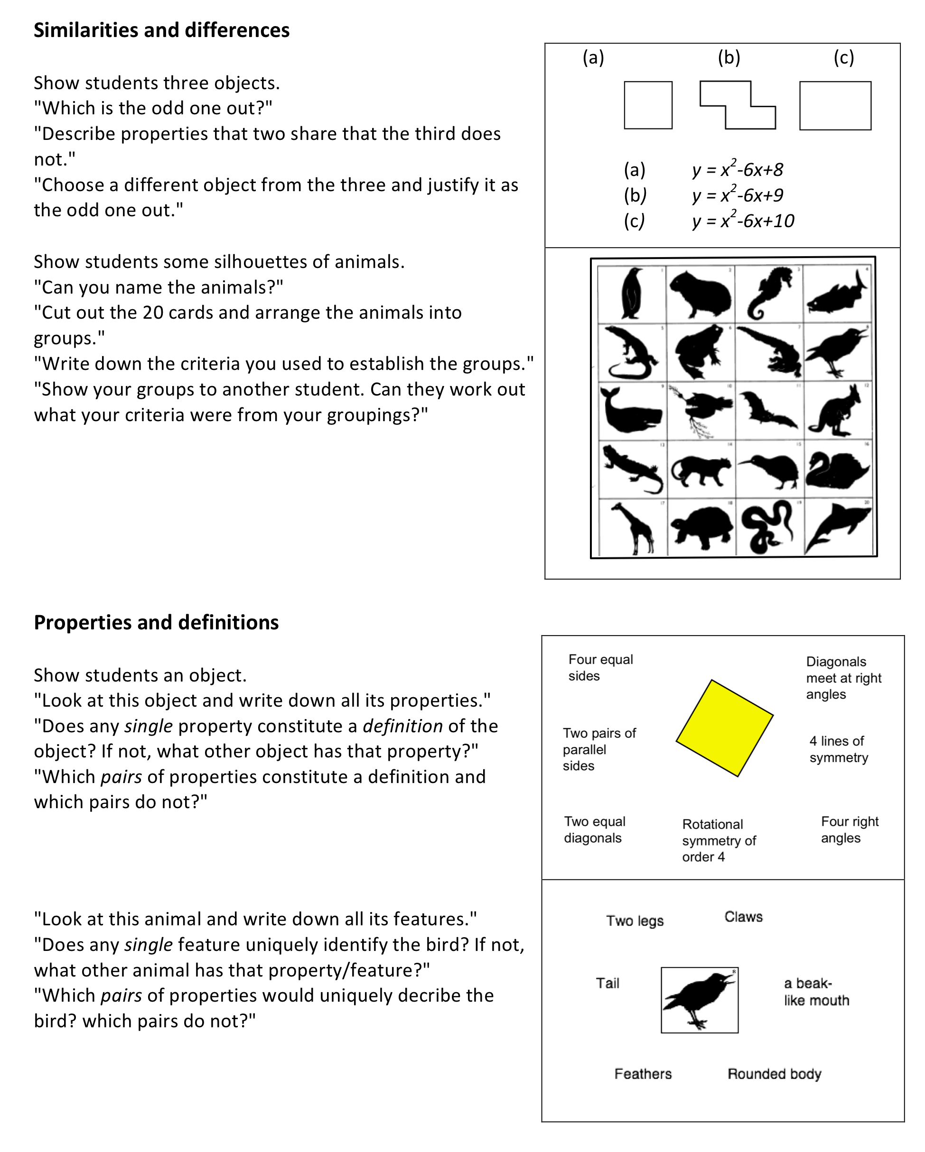
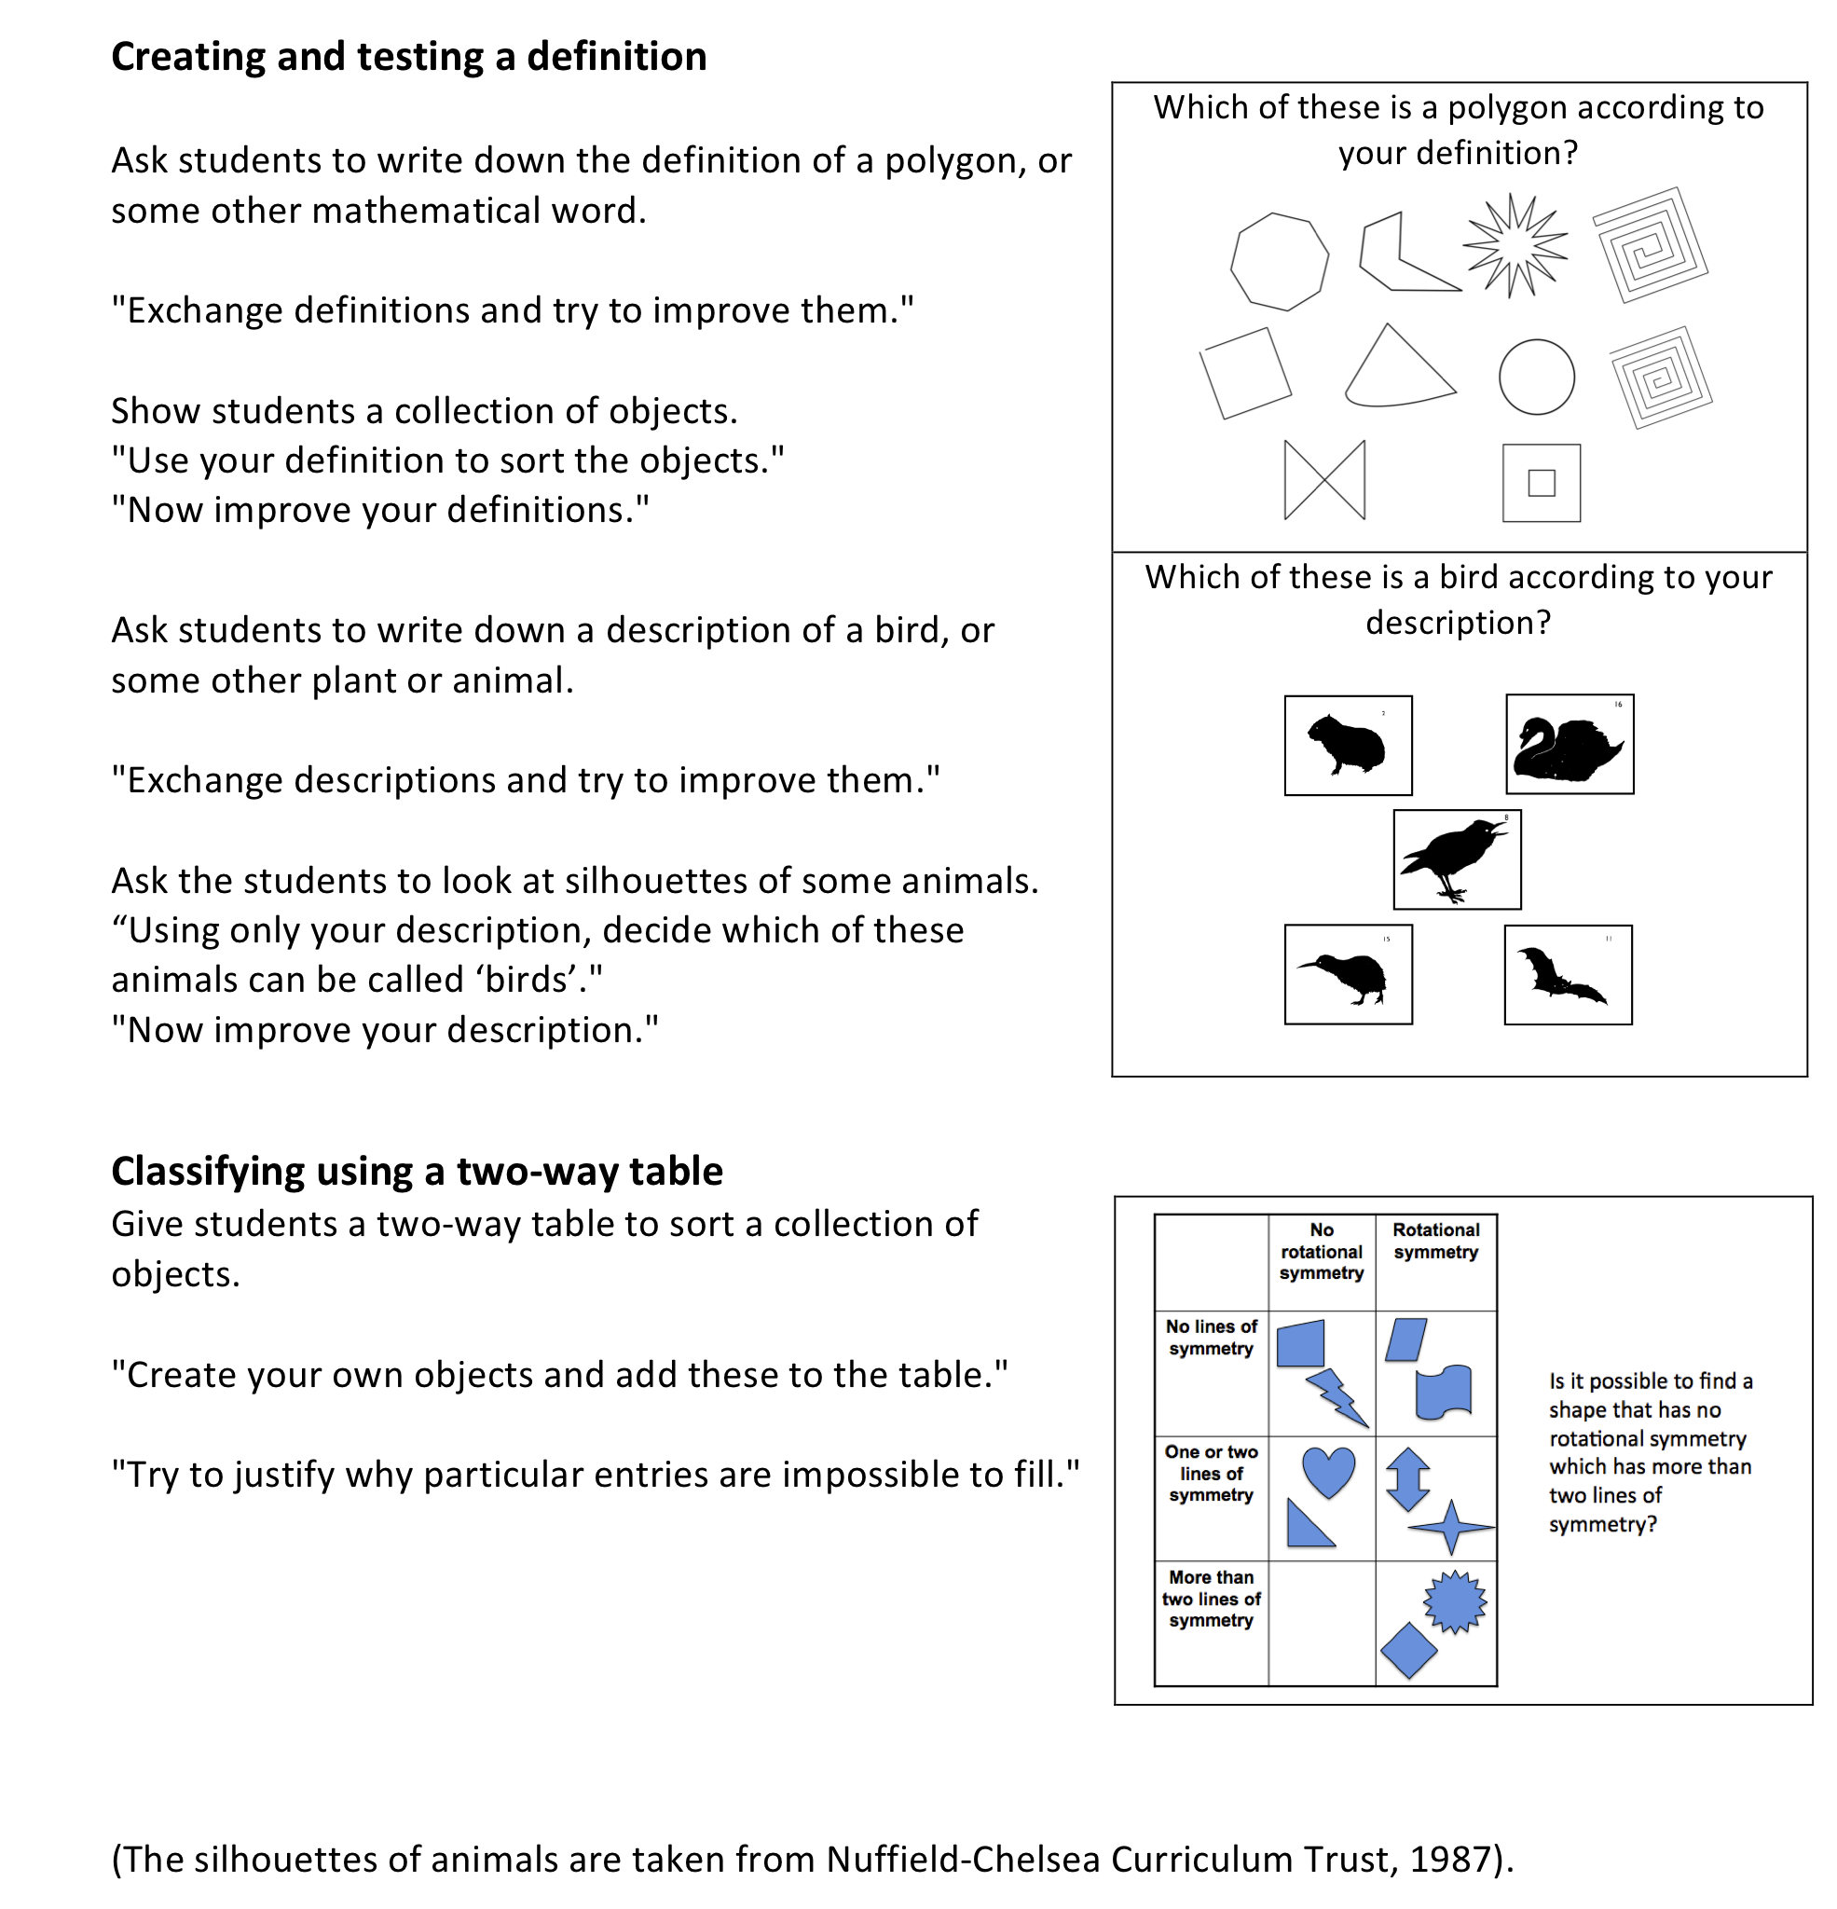

Activity C: Representing and Translating

Time needed: 20 minutes
Mathematical and Scientific concepts have many representations; words, diagrams, algebraic symbols, tables, graphs and so on. It is important for students to learn to 'speak' these representations fluently and to learn to translate between them. It is helpful to think of each cell in the grid below as a translation process. Some translations are more common than others in classroom activities. For example, we often ask students to move between tables and graphs. This is labelled as 'plotting'.
from\to | words | pictures | tables | graphs | formulae
words
pictures
tables |  |  |  | plotting
graphs
formulae

- Which representations do you use most often in your classroom?
- Which translation processes do you emphasise most? Which receive less attention?
- Discuss the examples shown in Handout 3.

As participants work on the activities they may begin to realise that some of these are less common in their classroom. Some notes on each activity are given below:

Job times  The words describe an inverse proportion, such as the following.  Number of people 1 2 3 4 5 6  Time taken in hours 24 12 8 6 4.8 4 |  | Roller coaster  A suitable graph is shown below. It is interesting to note how difficult some students find this, particulaly when they misinterpret the graph as a picture of the situation.  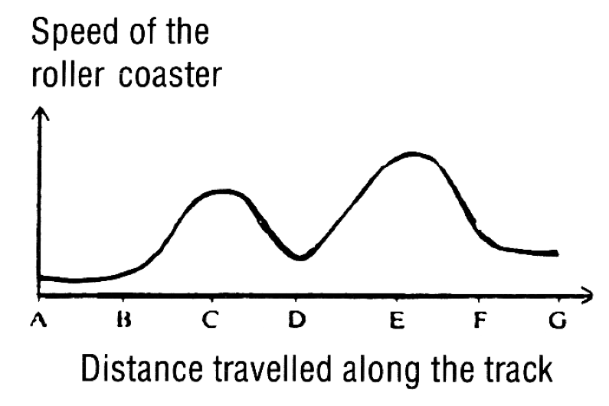
Words and formulae  Students enjoy trying to construct these and making them as difficult as possible! |  | Tables and graphs  This particular example focuses on graph sketching rather than graph plotting.
Tournament  The diagram shows the structure of the situation.  There are n² - n cells. | 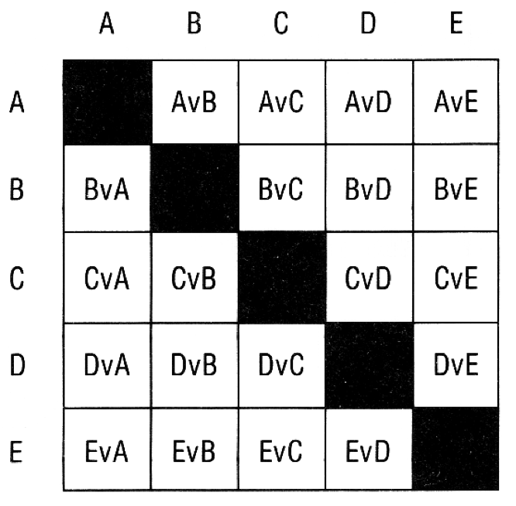 | Penguins  The weight is proportional to volume, then dimensional analysis should suggest that weight is proportional to the cube of the height if the penguins are geometrically similar. This turns out to be a reasonable assumption and an approximate model is:  w = 20 h³  where h is the height in metres,  and w is the weight in kg.

Handout 3: Translating between representations

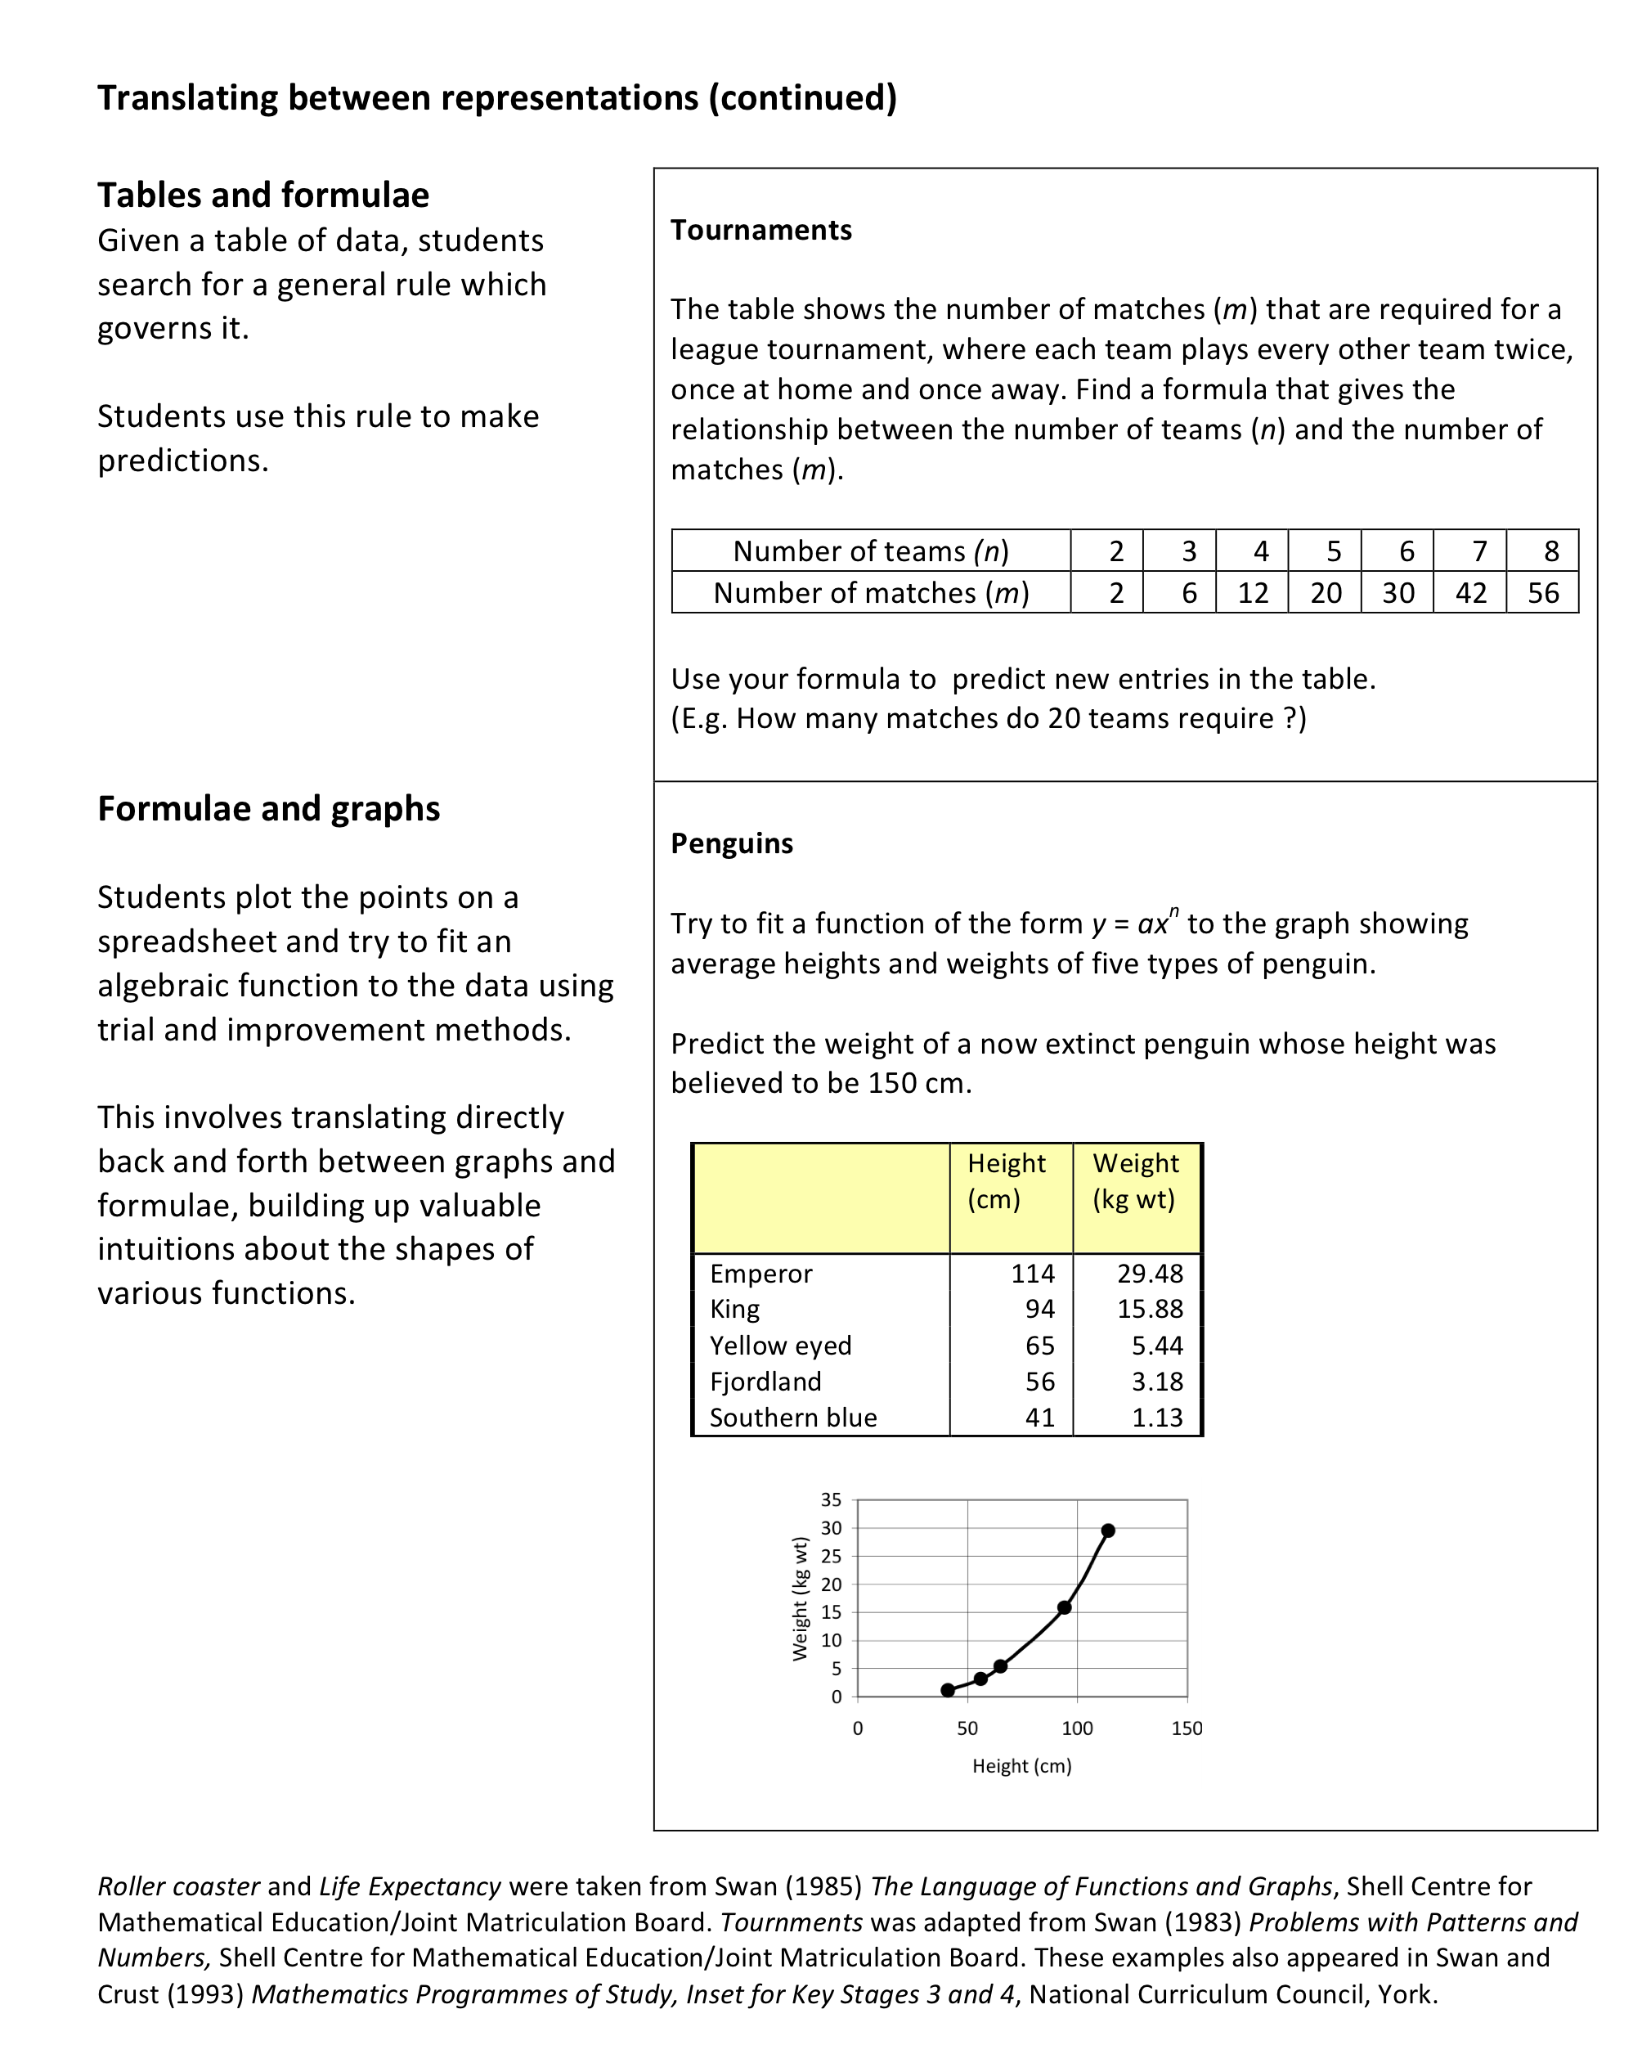
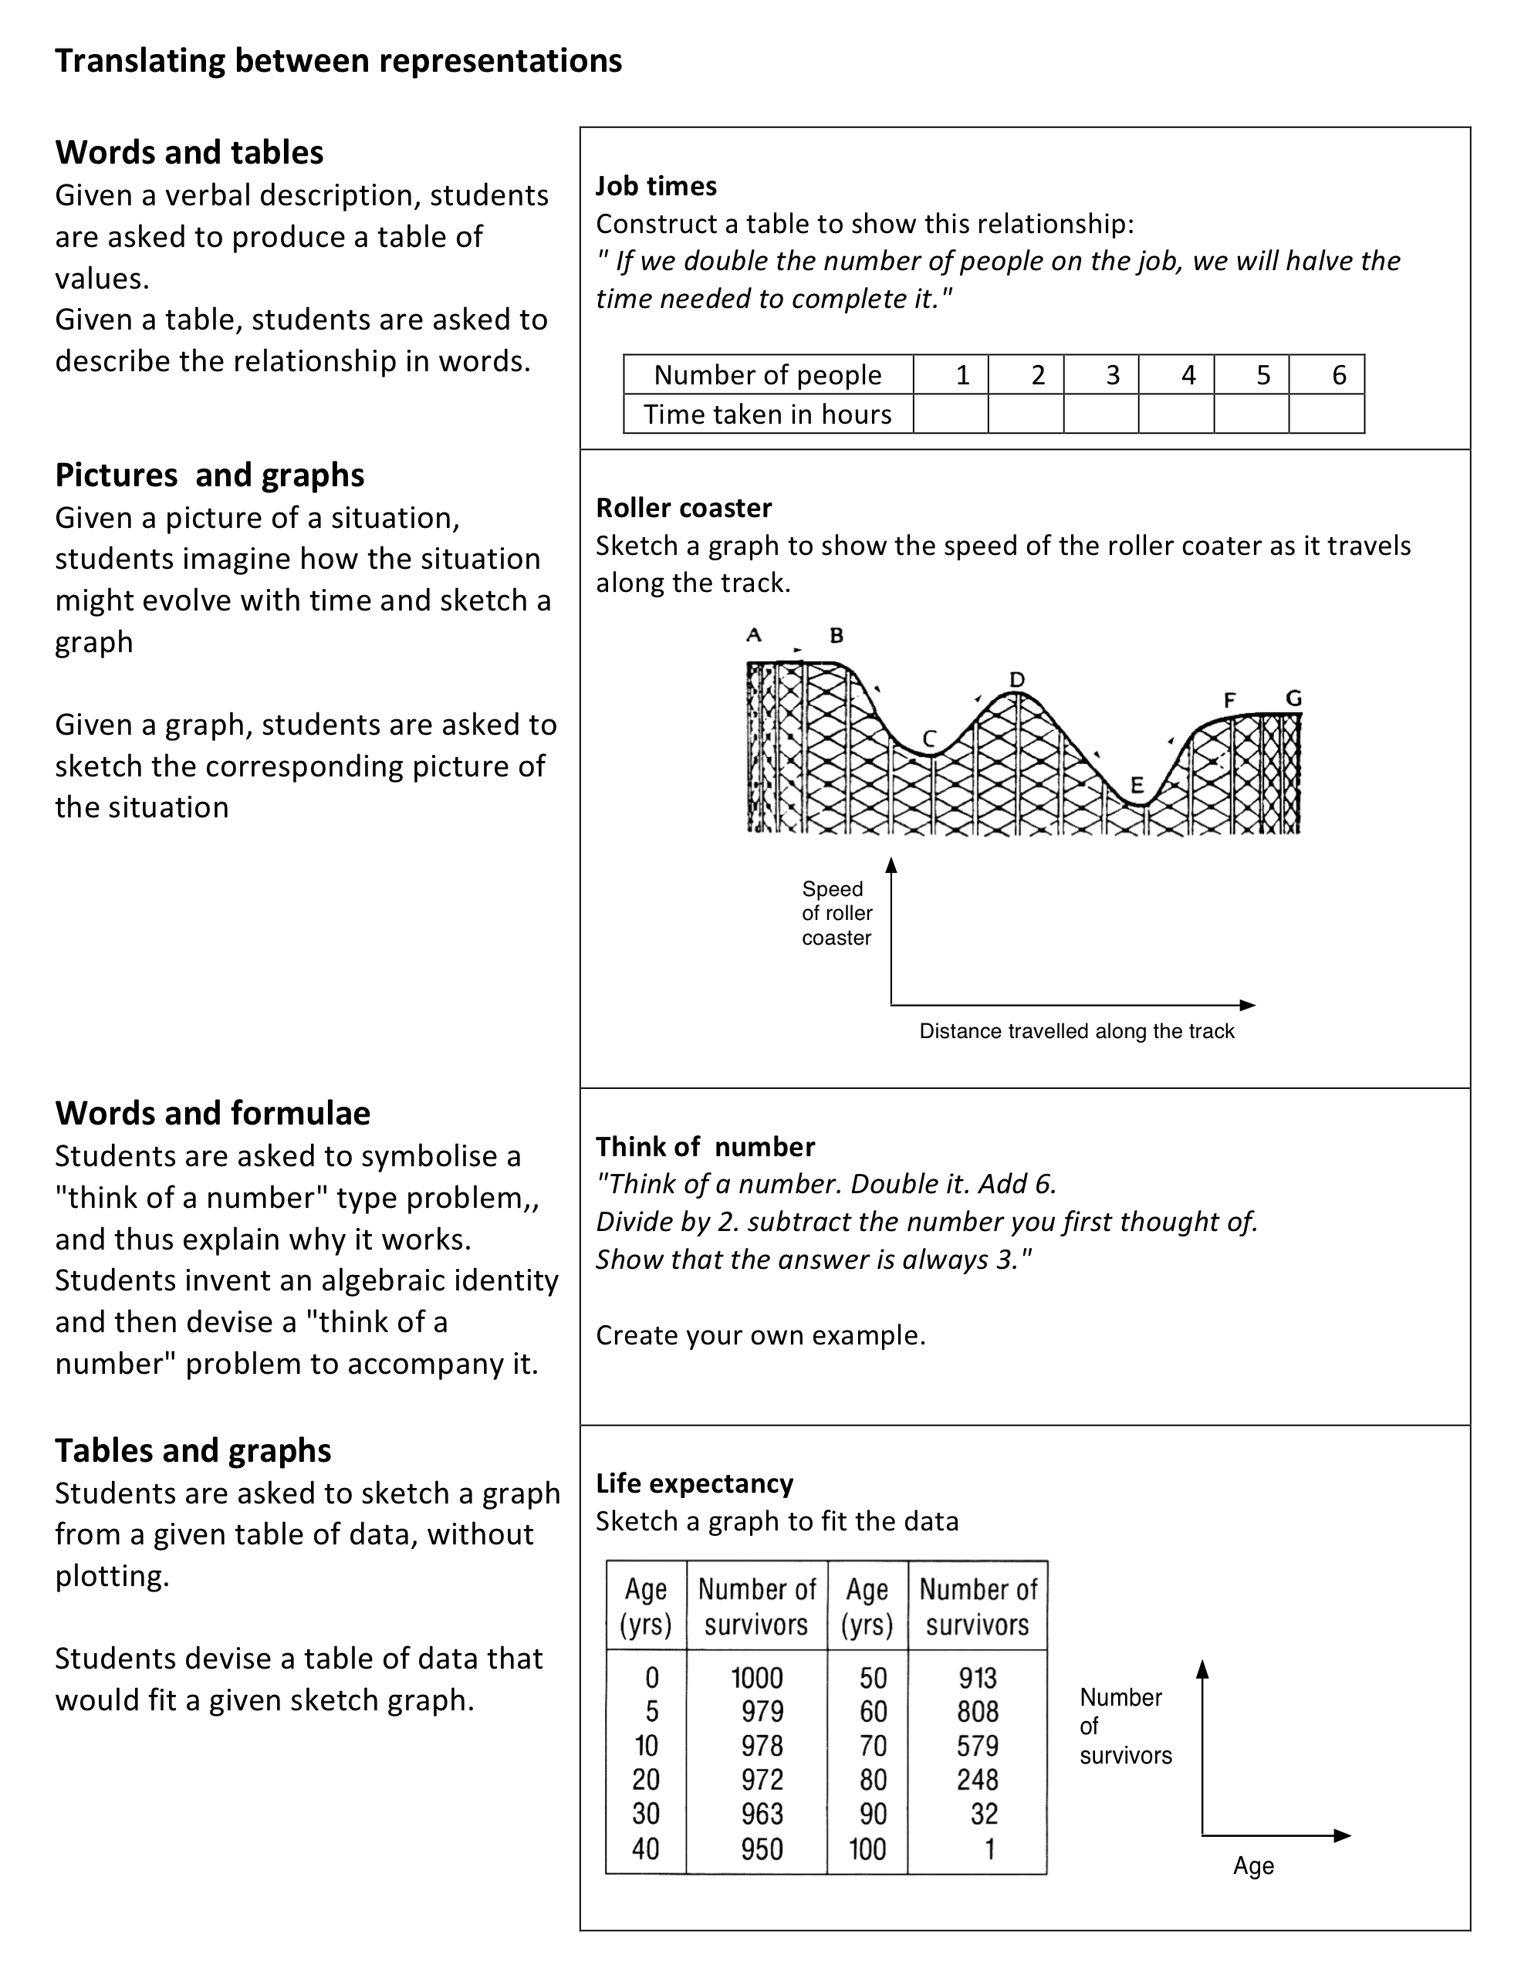

Activity D: Making connections

Time needed: 20 minutes
The activity in Handout 4 is intended to encourage students to discuss connections between verbal, numeric, spatial and algebraic representations. For the following activity, participants should work in pairs or threes. They should begin by cutting out the cards.

- Cut out the set of cards on Handout 4.
- Take it in turns to match Card Set A: algebra expressions with the Card Set B: verbal descriptions. Place pairs of cards side-by-side, face up on the table. If you find cards are missing, create these for yourself.
- Next, match Card set C: tables to the cards that you have already matched. You may find that a table matches more than one algebra expression. How can you convince yourself or your students that this will always be true, whatever the value for n?
- Next, match Card set D: areas to those cards that have already been grouped together.
How do these cards help you to explain why different algebra expressions are equivalent?
- Discuss the difficulties that your students would have with this task.
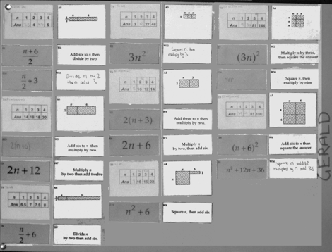
The final matching may be made into a poster, as has been done here.

The next activity encourages participants to compare their own thinking with an episode of learning from the classroom. The students on the 5 minute video clip are all low attaining 16-17 years old who have had very little understanding of algebra previously.

- Watch the video clip.
- What difficulties do the students have while working on this task?
- How is the teacher helping students?

Finally, participants may begin to consider how this type of activity may be applied to representations that they teach.
- Devise your own set of cards that will help your students translate between different representations that you are teaching.

Handout 4: Representing and making connections
Each group of students is given a set of cards. They are invited to sort the cards into sets, so that each set of cards have equivalent meaning. As they do this, they have to explain how they know that cards are equivalent. They also construct for themselves any cards that are missing. The cards are designed to force students to discriminate between commonly confused representations.

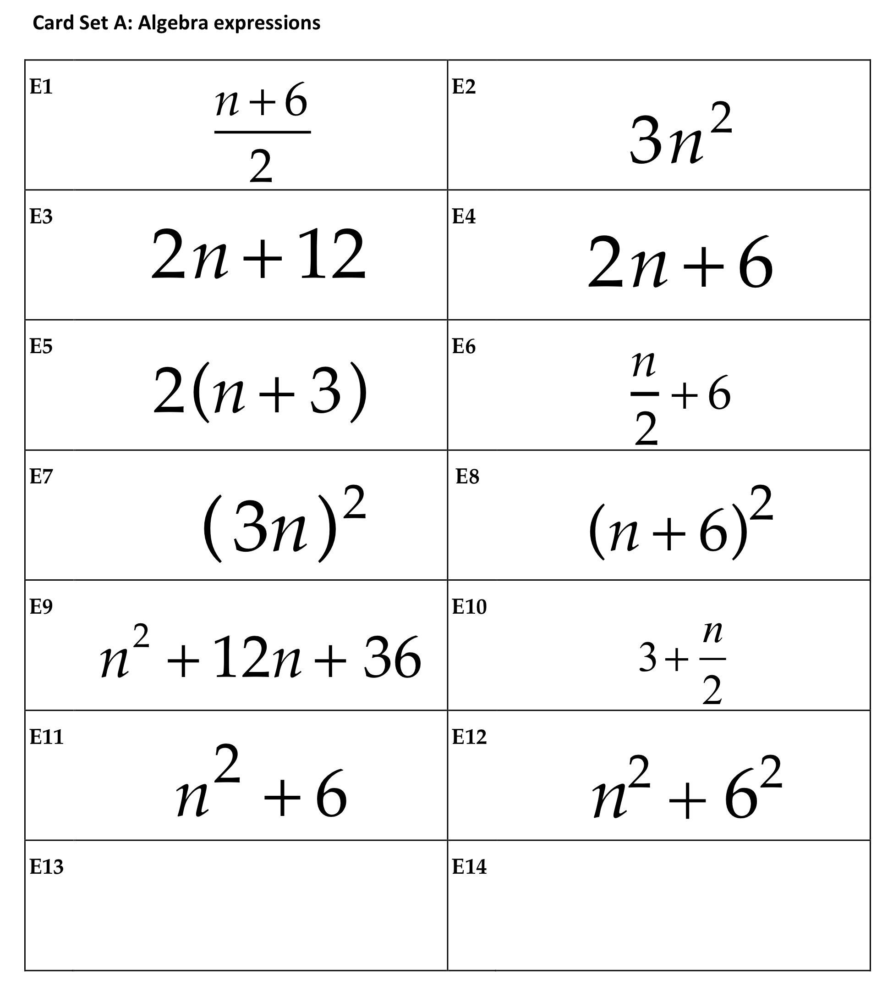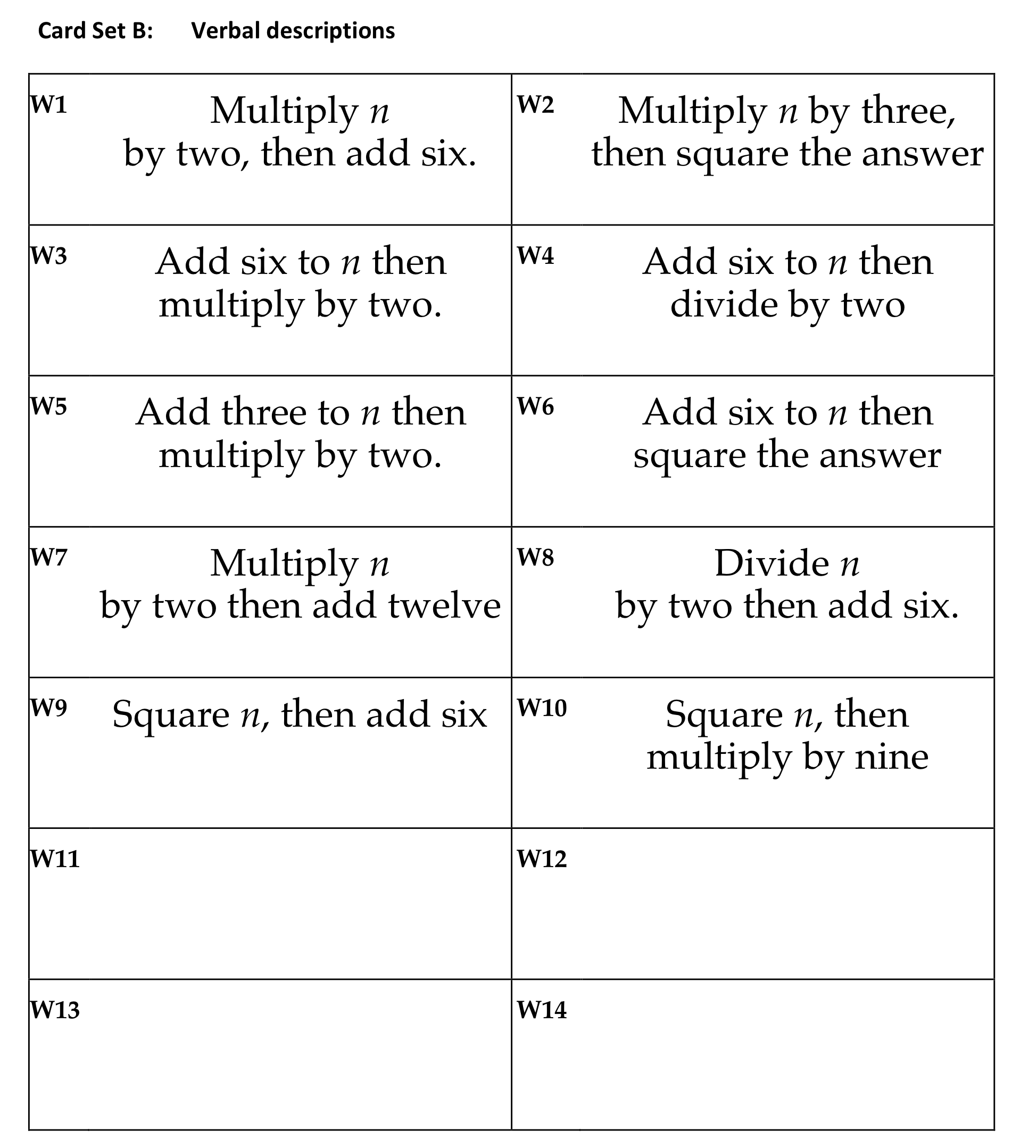
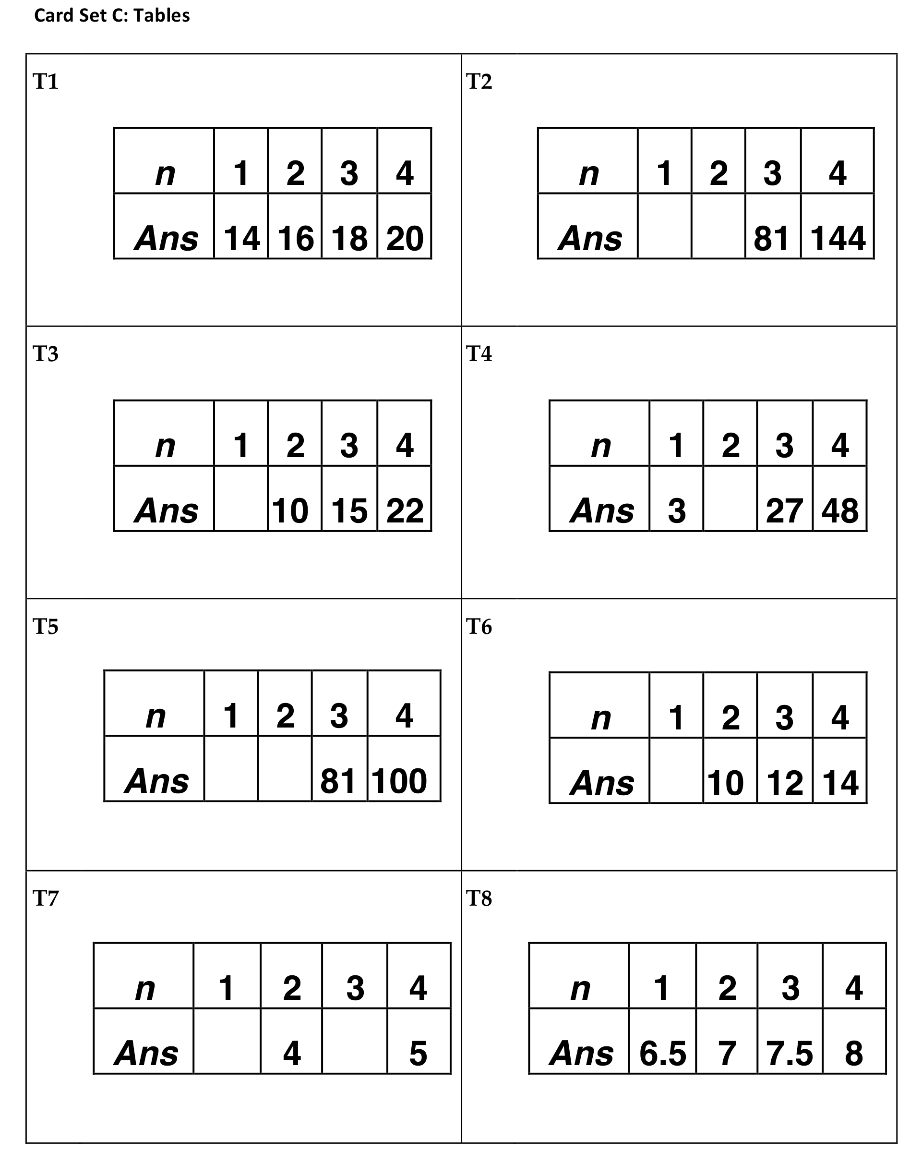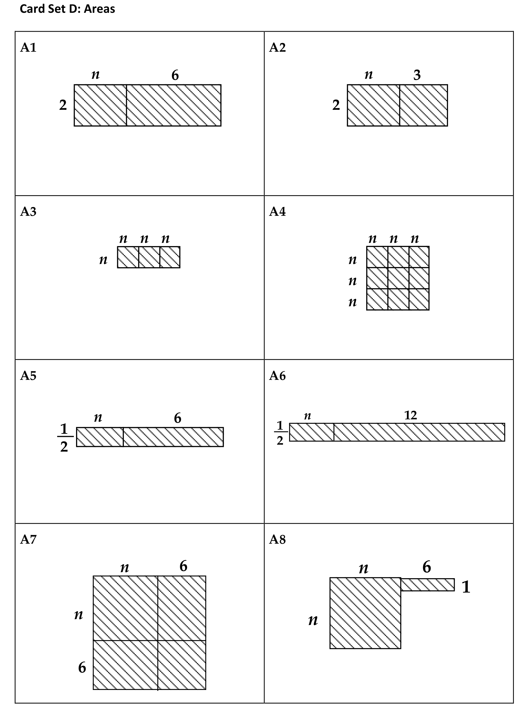

Swan, M. (2008), A Designer Speaks: Designing a Multiple Representation Learning Experience in Secondary Algebra. Educational Designer: Journal of the International Society for Design and Development in Education, 1(1), article 3.

Activity E: Estimating

Time needed: 20 minutes.
Estimation problems involve students making assumptions, then working with these assumptions to build chains of reasoning. It is often the case that, individually, students feel unable to cope with such problems but when they work collaboratively, they are surprised at how much knowledge they can build on.
- In pairs or small groups, work together on the trees problem on Handout 5.
- When each group has produced a reasoned answer, take it in turns to explain your solutions, describing all the assumptions you have made.
- In which solution do you have most confidence? Why is this?

The following shows just one approach that teachers have adopted:
- Estimate the number of teachers in the country.
- Estimate the size of the average family.
- Estimate the volume of a typical newspaper.
- Assuming that each family buys one newspaper per day, estimate the total volume of newspaper consumed per day.
- Estimate the radius and height of the useable part of a suitable tree.
- Calculate the volume of the trunk.
- Assuming that the total volume of the trunk is converted into newsprint, use your answers from (4) and (6) to estimate the required number of trees.
The following data was supplied by the forestry commission, and may provide a useful independent check:
"The example assumes that the whole tree goes for paper. In reality only the smaller end would be used. Approximately 2.8kg of wood will make 1 kg of newsprint. 1 cubic metre of wood, freshly felled, as supplied to a pulp mill, weights about 920 kg. This is based on the Sitka spruce and is the average throughout the year. At the time of felling at the age of 55 years, each tree will have a volume of 0.6 cubic metres, including the bark. The diameter at 1.4 metres from the ground would be 27 cm."

- Make a list of estimation problems that would be accessible to one of your classes.
- Discuss how you might organise a lesson based on an estimation problem.

A possible list of questions might be:
- How much do you drink in one year?
- How many teachers are there in your country?
- How long would it take you to read out all the numbers from one to one million? Would this be different in different languages?
- How many people could stand comfortably in your classroom?
- How many times does a person's hear beat in one year?
- How many exercise books do you fill in your school career?
- How many pet dogs are there in your town?

Handout 5 Estimating
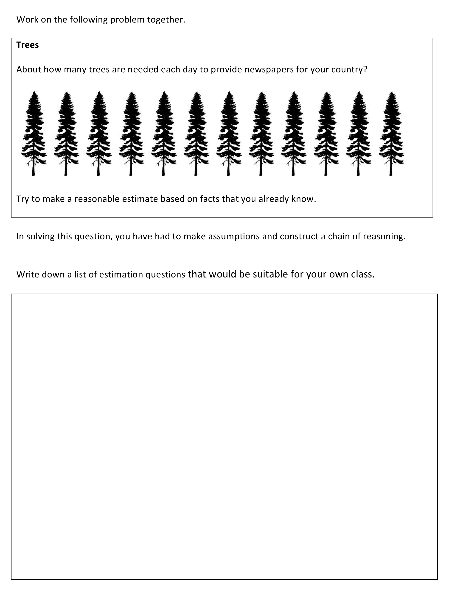

Activity F: Measuring and quantifying

Time needed: 20 minutes.
Our society creates and uses measures all the time. We create measures for fundamental concepts (e.g. length, time, mass, gradient, speed, density) and more complex social constructs (e.g. academic ability, wealth, inflation, job performance, quality of education, sporting prowess, physical beauty). Scientists and Mathematicians devise measures in order to seek patterns, relationships and laws. Politicians use measures to monitor and control. All educated citizens should realise that many of these measures are open to criticism and improvement.

- What kinds of measure do you meet in your everyday life? Make a list on Handout 6.
- What kinds of measure do your students experience?

On Handout 6, two types of activity are suggested for students.

- Work on the measuring slope task together.
- Try to arrive at a convincing explanation as to why height of step ÷ length of step is the better measure for slope.
- Can you think of other examples of alternative measures for the same concept?

The ratio height of step ÷ length of step is better than the difference height of step - length of step because the ratio is dimensionless. This means that if you geometrically enlarge a staircase, the ratio will not change, whereas the difference will.

The final activity suggests devising a measure for an everyday phenomenon. Participants may like to start this by thinking about "compactness":

Over recent years, geographers have tried to find ways of defining the shape of an area of land. In particular, they have tried to devise a measure of 'compactness'. You probably have some intuitive idea of what 'compact' means already. On the right are two islands. Island B is more compact than island A. 'Compactness' has nothing to do with the size of the island. You can have small, compact islands and large compact islands. | 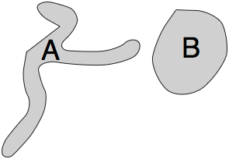
- Draw some shapes and put them in order of compactness.
- Try to agree what is meant by the term.
- Is area ÷ perimeter a good measure of compactness? Why or why not?
- Try to devise several ways of measuring compactness. Try to make your measures range from 0 to 1, where 1 is given to a shape that is perfectly compact.
- Afterwards, compare your ideas with those used by geographers on Handout 7.
- Finally, consider other everyday phenomena and consider how you would measure them (return to Handout 6).

Handouts 6 and 7 Measuring and quantifying
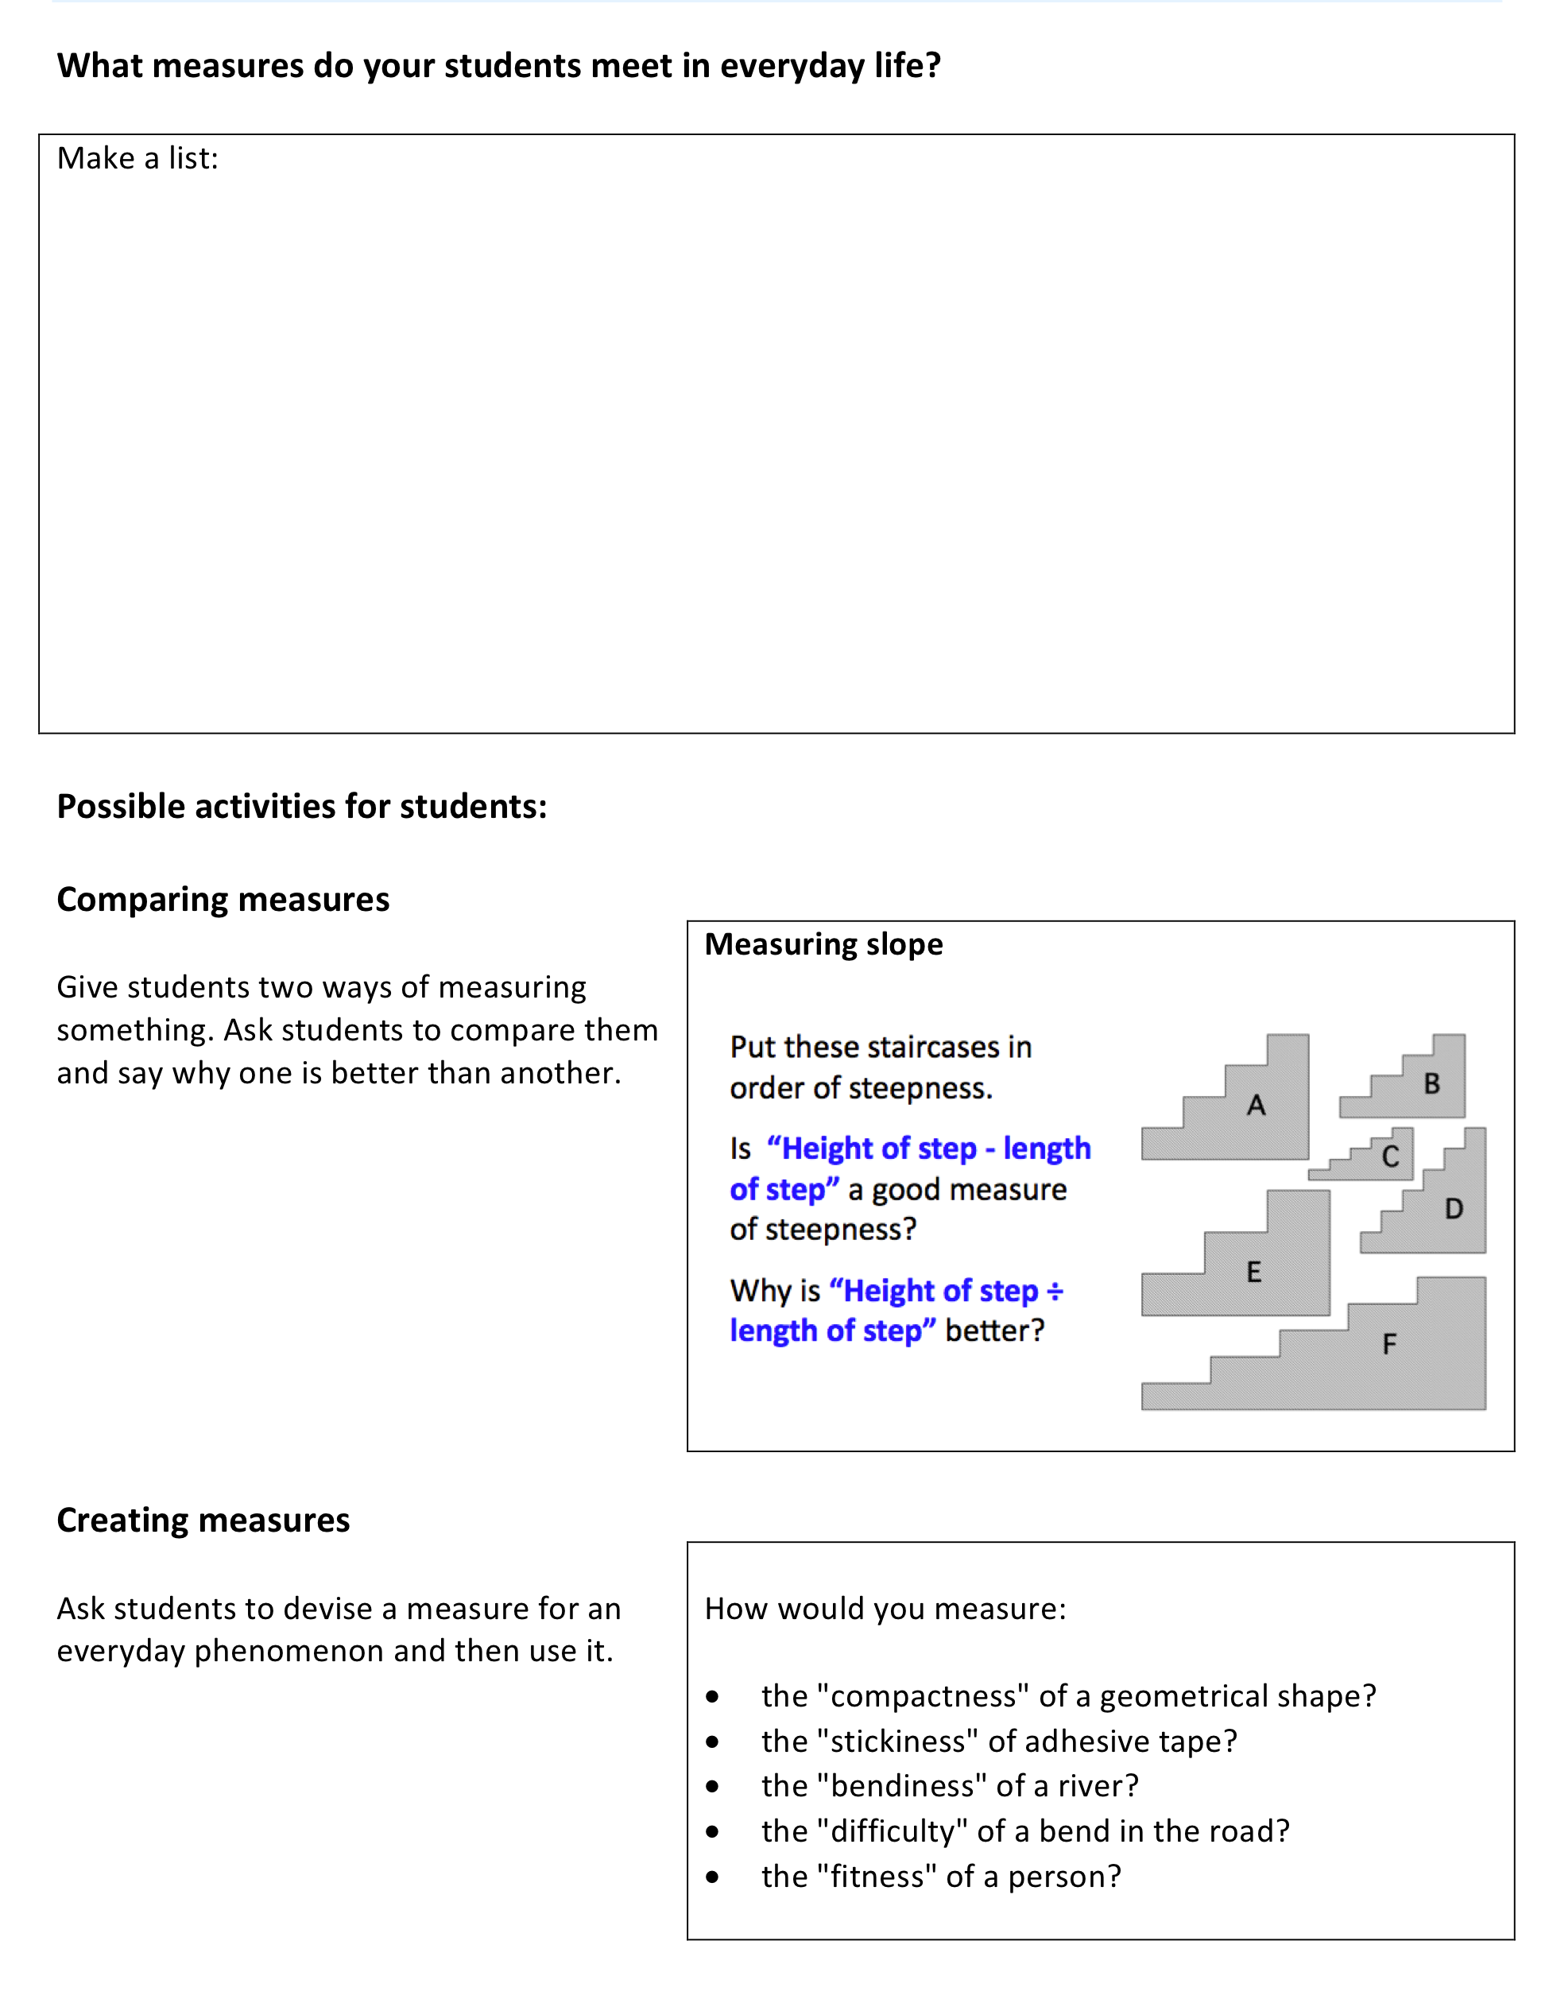

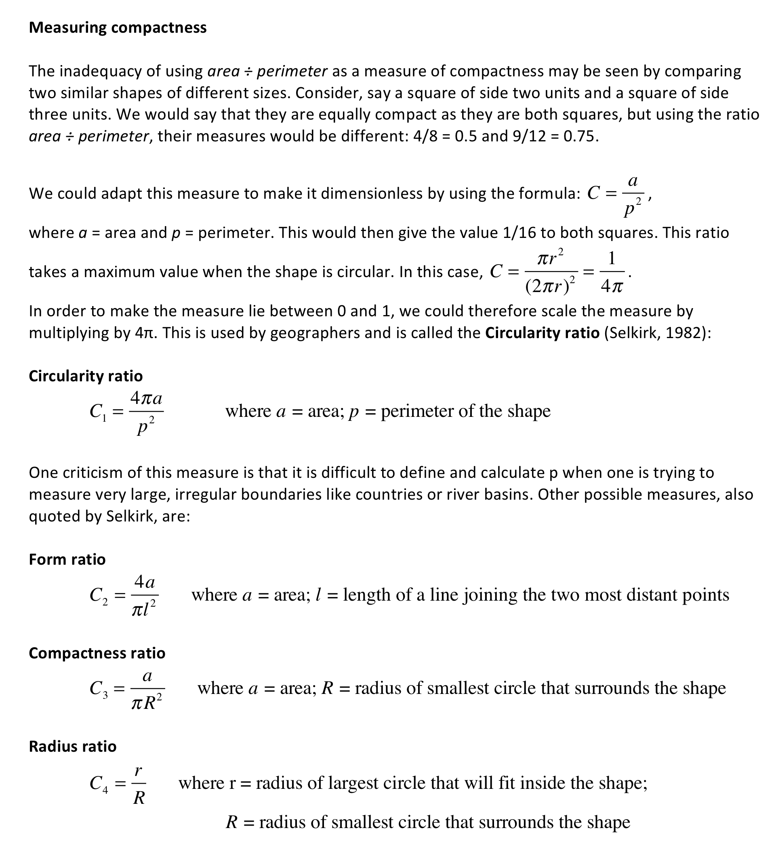

Reference: Selkirk, K (1982) Pattern and Place - An Introduction to the Mathematics of Geography, Cambridge University Press.

Activity G: Evaluating statements, results and reasoning
Students that are actively learning are constantly challenging hypotheses and conjectures made by others. The activities considered here are all designed to encourage this kind of behaviour.

Ask participants to work together in groups of two or three using the activity of Handout 7.

In this activity, you are given a collection of statements.

- Decide on the validity of each statement and give explanations for your decisions. Your explanations will involve generating examples and counterexamples to support or refute the statements.

- In addition, you may be able to add conditions or otherwise revise the statements so that they become ‘always true’.

- Create some statements that will create a stimulating discussion in your classroom.

This kind of activity is very powerful. The statements may be prepared to encourage students to confront and discuss common misconceptions or errors. The role of the teacher is to prompt students to offer justifications, examples, counterexamples. For example:

Pay rise:
"OK you think it is sometimes true, depending on what Max and Jim earn. Can you give me a case where Jim gets the bigger pay rise? Can you give me an example where they both get the same pay rise?"

Area and perimeter:
"Can you give me an example of a cut that would make the perimeter bigger and the area smaller?"
"Suppose I take a bite out of this triangular sandwich. What happens to its area and perimeter?"
Right angles.
Can you prove this is always true?

Bigger fractions
You think this is always true? Can you draw me a diagram to convince me that this is so?
What happens when you start with a fraction greater than one?
Handout 7: Always, sometimes or never true?

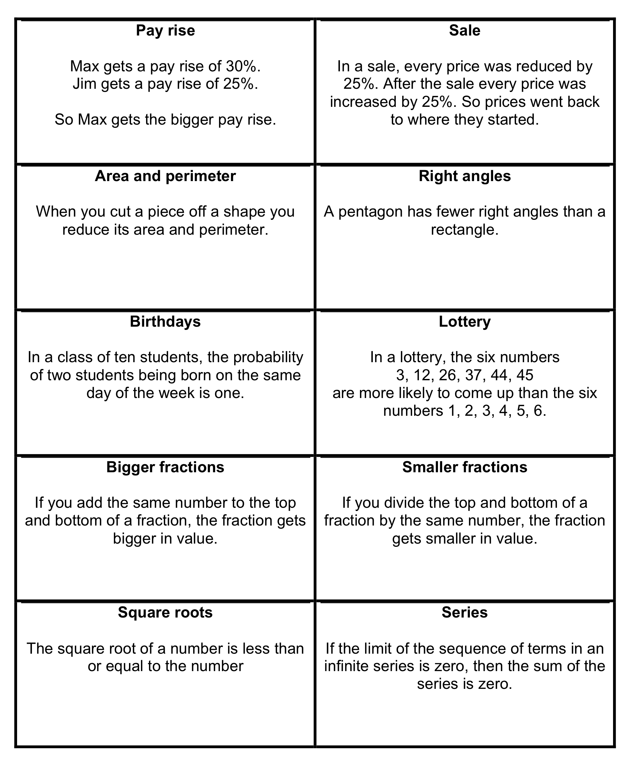

Activity H: Experimenting and Controlling variables

Time needed: 40 minutes.
Two activities are presented here. One involves the planning of an experiment, the other involves a computer applet that is presented with this unit.

Start by discussing the first two situations on Handout 8.
- Choose one of the scientific questions shown in Devising a fair test.
- Work on the experimental design in a small group.
- Often in science classrooms, the teacher designs the experiments and students carry them out. Handing over the experimental design decisions presents many challenges for both teachers and students. For example, students may ask for equipment that you do not have readily available. What other challenges are there? Make a list.

Now ask participants to consider the final problem Body Mass index.

- Work on the Body Mass Index problem in pairs, using the computer applet.
- Note down the method you adopt.
- Now watch the video clip showing a lesson with students.
  - How did the teacher organise the lesson? What phases did it go through?
  - Why do you think she organised it this way?
  - How did the teacher introduce the problem to students?
  - What different approaches were being used by students?
  - How did the teacher support the students that were struggling?
  - How did the teacher encourage the sharing of approaches and strategies?
  - What do you think these students were learning?

It is easy to find the boundaries at which someone becomes underweight/overweight/obese if one variable is held constant while the other is varied systematically. The boundaries occur at:
 | BMI
Underweight | Below 18.5
Ideal weight | 18.5 - 24.9
Overweight | 25.0 - 29.9
Obesity | 30.0 and Above

In order to find out how the calculator works, it is better to forget realistic values for height and weight and simply hold one variable constant while changing the other systematically. For example, if students hold the height constant at 2 metres (not worrying if this is realistic!), then they will obtain the following table and/or graph:
Weight (kg) | 60 | 70 | 80 | 90 | 100 | 110 | 120 | 130
BMI | 15 | 17.5 | 20 | 22.5 | 25 | 27.5 | 30 | 32.5
 | Underweight |  | Ideal weight |  | Overweight |  | Obese

From this it can be seen that there is a proportional relationship between weight and BMI. (If you double weight, you double BMI; Here BMI = Weight/4)

Handout 8: Experimenting and controlling variables
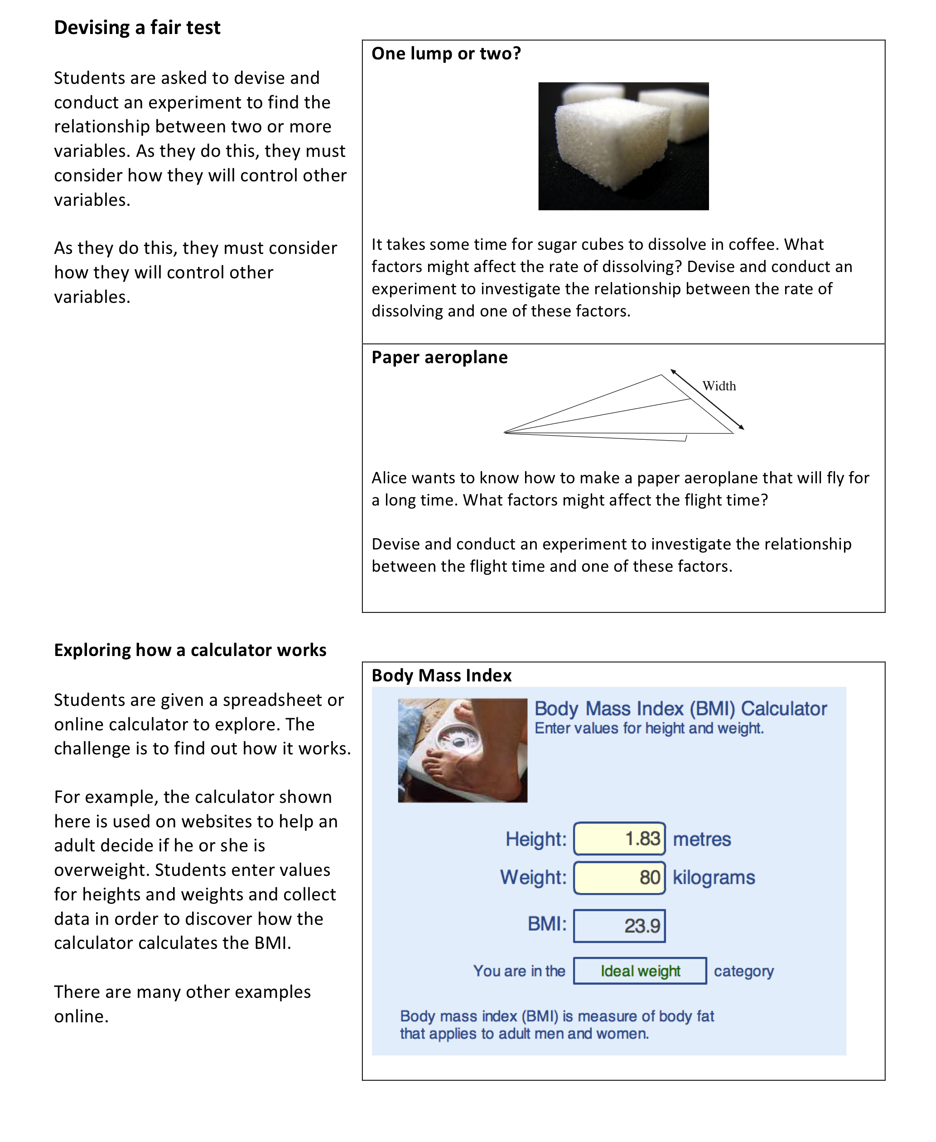

The BMI activity is taken from Swan, M; Pead, D (2008). Professional development resources. Bowland Maths Key Stage 3, Bowland Trust/ Department for Children, Schools and Families. Available online in the UK at: http://www.bowlandmaths.org.uk. It is used here by permission of the Bowland Trust.

Activity I: Plan a lesson, teach it and reflect on the outcomes

Time needed:
- 15 minutes discussion before the lesson
- 1 hour for the lesson
- 15 minutes after the lesson

Choose one of the problems in this unit that you feel would be appropriate for your class.

Discuss how you will:
- Organise the classroom and the resources needed.
- Introduce the problem to students.
- Explain to students how you want them to work together.
- Challenge/assist students that find the problem straightforward/ difficult.
- Help them share and learn from alternative problem-solving strategies.
- Conclude the lesson.

If you are working on this module with a group, it will be helpful if each participant chooses the same problem, as this will facilitate the follow-up discussion.

Now you have taught the lesson, it is time to reflect on what happened.

- What range of responses did students have to the task?
Did some appear confident? Did some need help? What sort of help? Why did they need it?
- What different scientific processes did students use?
Share two or three different examples of students' work.
- What support and guidance did you feel obliged to give?
Why was this? Did you give too much or too little help?
- What do you think students learned from this lesson?

Further reading
Swan, M (2005) Improving Learning in Mathematics: Challenges and Strategies, Department for Education and skills and dowloadable from:
http://www.nationalstemcentre.org.uk/elibrary/resource/1015/improving-learning-in-mathematics-challenges-and-strategies

References
Millar, R. (1994). What is 'scientific method' and can it be taught? In R. Levinson (Ed.), Teaching Science (pp. 164-177). London: Routledge.
Wood, D. (1988). How Children Think and Learn. Oxford and Cambridge, MA: Blackwell.
Wood, D., Bruner, J., & Ross, G. (1976). The role of tutoring in problem solving. Journal of child psychology and psychiatry, 17, 89-100.

