Asking Questions that encourage Inquiry-based learning

How do we ask questions to develop scientific thinking and reasoning?

Handouts for teachers

Contents

1. Thinking about why we ask questions 1
2. What kinds of questions promote inquiry-based learning? 3
3. Five principles for effective questioning 4
4. Observing a Lesson 7
5. Planning for effective questioning 8
6. A lesson plan on "Sharing Petrol Costs" 9

Acknowledgement:
This material is adapted for PRIMAS from:
Swan, M; Pead, D (2008). Professional development resources. Bowland Maths Key Stage 3, Bowland Charitable Trust. Available online in the UK at: http://www.bowlandmaths.org.uk
It is used here by kind permission of the Bowland Charitable Trust.

1. Thinking about why we ask questions

What different types of questions are there?

What different functions do your questions serve?

Which types of questions do you use most frequently?

What common mistakes do you make when asking questions?
What are the unintended effects of each of these mistakes?

Common mistake | Unintended effect

2. What kinds of questions promote inquiry-based learning?

What types of questions seem to encourage inquiry-based learning?

Give a few examples that you have recently used.

Now look at Handout 3

This describes five principles for effective questioning.
Reflect on the implications of these ideas for your own practice.

3. Five principles for effective questioning

1. Plan to use questions that encourage thinking and reasoning
Really effective questions are planned beforehand. It is helpful to plan sequences of questions that build on and extend students' thinking.
A good questioner, of course, remains flexible and allows time to follow up responses.
Beginning an inquiry | - What do you already know that might be useful here?  - What sort of diagram might be helpful?  - Can you invent a simple notation for this?  - How can you simplify this problem?  - What is known and what is unknown?  - What assumptions might we make?
Progressing with  an inquiry | - Where have you seen something like this before?  - What is fixed here, and what can we change?  - What is the same and what is different here?  - What would happen if I changed this.. to this...?  - Is this approach going anywhere?  - What will you do when you get that answer?  - This is just a special case of ... what?  - Can you form any hypotheses?  - Can you think of any counterexamples?  - What mistakes have we made?  - Can you suggest a different way of doing this?  - What conclusions can you make from this data?  - How can we check this calculation without doing it all again?  - What is a sensible way to record this?
Interpreting and evaluating the results of an inquiry | - How can you best display your data?  - Is it better to use this type of chart or that one? Why?  - What patterns can you see in this data?  - What reasons might there be for these patterns?  - Can you give me a convincing argument for that statement?  - Do you think that answer is reasonable? Why?  - How can you be 100% sure that is true? Convince me!  - What do you think of Anne's argument? Why?  - Which method might be best to use here? Why?
Communicating conclusions and reflecting | - What method did you use?  - What other methods have you considered?  - Which of your methods was the best? Why?  - Which method was the quickest?  - Where have you seen a problem like this before?  - What methods did you use last time? Would they have worked here?  - What helpful strategies have you learned for next time?

2. Ask questions in ways that include everyone

It is very important that everyone is included in thinking about the questions asked. Here are three ways that teachers have tried to achieve this:

- Use a 'no hands up' rule. After a few hands have gone up some students stop thinking because they know that the teacher will not ask them. When students have their hands up they too stop thinking as they already have the answer they want. "No hands up" encourages everyone to keep thinking as anyone may be called upon to respond.
- Ask questions that encourage a range of responses. Rather than asking for specific right answers, ask for ideas and suggestions: "How can we get started on this?", "What do you notice about this?" Everyone will then be able to offer a response.
- Avoid teacher - student - teacher - student 'ping pong'. Encourage students to listen to and to reply to each other's responses. Aim for a pattern more like: teacher - student A - student B - student C - teacher.
- Arrange the room to encourage participation. Think about where students are sitting – are there some who cannot hear? Can students see and hear one another so that they can respond to the points that another student makes? It is often better to sit students in a U-shape, if possible.

3. Give students time to think

The time interval between a teacher asking a question and supplying the answer herself, or following up with an additional question or comment, is commonly called 'wait time'. For many teachers, the mean wait time is less than one second (Rowe (1974)). When teachers increase this wait time to between three and five seconds the research shows that students begin to:
- respond at greater length and with greater confidence;
- offer more unsolicited, but appropriate, responses;
- offer more diverse, alternative explanations;
- relate responses to those from other students.

Increasing wait time is difficult. Silence in a classroom can be hard to bear!

- Talk to students about 'wait time'. Make sure that students know that they must take time to think before responding. (Some teachers even make themselves wait by counting slowly to themselves: "One, two, three, four, got to wait a little more"!)
- Use "Think - Pair - Share". Ask the question, give 10 seconds thinking time and then allow 30 seconds for talking to a partner. After this, everyone should be ready with an answer and they should know that anyone may be asked for what they think.
- Use mini whiteboards - Ask the students to spend 30 seconds thinking about the problem and jotting ideas for the solution onto their mini whiteboards. Then ask the students to share the ideas they had for starting the problem

4. Avoid judging students' responses

Interestingly, Rowe (1974) found that if a teacher made judgmental comments, even positive ones such as “Well done!”, then this negatively affected students' verbal performance even with the lengthened wait times. Task persistence was greatest where verbal rewards were fewer. When a teacher judges every response with 'yes', 'good' , 'nearly' and so on, students are likely to reason to themselves:

"The teacher said that was good. That is not what I was going to say. So what I was going to say cannot be good. So I won't say anything."
Ask open questions that permit a greater variety of responses and reply to students with comments that do not close off alternative ideas.

"Thank you for that, that is really interesting. What other ideas do people have?"

5. Follow up students' responses in ways that encourage deeper thinking

The following approaches encourage further thinking and dialogue:
Ask students to repeat their explanation | - Can you just say that again?
Invite students to elaborate | - Can you just say a little more about that …
Challenge students to offer a reason | - Can you explain why that works?
Cue alternative responses | - Can you suggest another way of doing this?
Support with non-verbal interest | - Nod head, rotate hand to indicate that you want more ...
Encourage students to speculate. | - What would happen if ...?
Make challenging statements | - Someone in this group said … were they right?
Allow rehearsal of responses | - Try out the answer on your partner first.
Encourage students to ask questions | - Would anyone like to ask Pat a question about that?
Ask students to think aloud | - Can you go through that step by step?
Encourage students to make connections | - Can you remember something else we did like this ...?
Thinking aloud with students | - Let's think this through together ...

4. Observing a Lesson

Sharing petrol costs
Each day Dan's mum drives him to school.  On the way, she picks up 3 of Dan's friends, Chris, Ben and Anne.  Each afternoon, she returns by the same route and drops them off at their homes.  At the end of a term, the four students decide to pay a sum of 100 euros towards the cost of petrol.  How should they share out the cost?  Find some reasonable solutions and say which you think is best and why. | 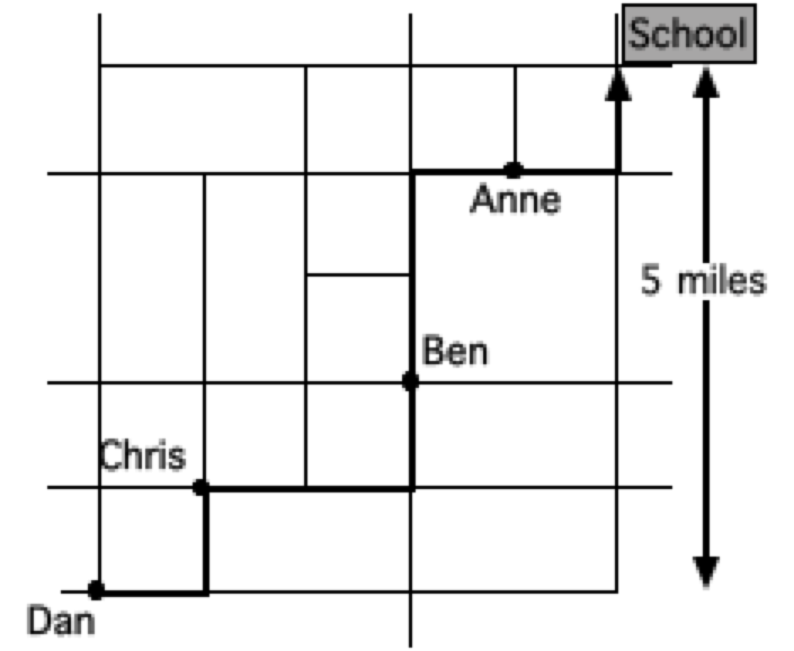  This map shows where each person lives and the route taken.
Two reasoned methods are shown below. Which do you consider better?
Method 1:
This is to share the cost in the proportion to the road distance people live from school:
2: 5: 8: 10. So:
Anne pays £8
Ben pays £20
Chris pays £32
Dan pays £40
Method 2:
Assume that, altogether, people will need to pay £10 per mile. Costs are shared out as follows:
 | Anne | Ben | Chris | Dan
Last 2 miles £20 | £5 | £5 | £5 | £5
Next 3 miles £30 |  | £10 | £10 | £10
Next 3 miles £30 |  |  | £15 | £15
First 2 miles £20 |  |  |  | £20
Anne pays £5
Ben pays £15
Chris pays £30
Dan pays £50

5. Planning for effective questioning
Plan how you will arrange the room and the resources needed | Arrange students so that they can see and hear one another as well as the teacher. You may need to rearrange chairs in a U shape or the students could move and ‘perch’ closer together. Or maybe you will move to the back of the room so that the question is the focus of attention and not the teacher.
Plan how you will introduce the questioning session | Silence will be hard for you to bear in the classroom but the students may find it confusing or even threatening. Explain why there will be times of quiet. For example:
Plan how you will establish the ground rules | If you are using ‘No hands up’ then you will need to explain this to the students. Some teachers have had to ask their students to sit on their hands so that they remember not to put their hands up. The students will be allowed to put their hands up to ask a question, so if a hand shoots up remember to ask them what question they would like to ask. The students may also be used to giving short answers so you could introduce a minimum length rule e.g. ‘your answer must be five words in length as a minimum’.
Plan the first question that you will use | Plan the first question and think about how you will continue. You cannot plan this exactly as it will depend on the answers that the students give but you might, for example, plan  - to take one answer and then ask others what they think about the reasoning given  - to take two or three answers without comment then ask the next person to say what is similar or different about those answers
Plan how you will give thinking time | - Will you allow 3-5 seconds between asking a question and expecting an answer?  - Will you ask the students to think – pair – share, giving 30 seconds for talking to a partner before offering an idea in whole class discussion?  - Will you use another strategy that allows the students time to think?
Plan how and when you will intervene | Will you need to intervene at some point to refocus students' attention or discuss different strategies they are using? Have one or two questions ready to ask part way through the lesson to check on their progress and their learning.
Plan what questions you could use for the plenary at the end of the lesson | Try not to pass judgments on their responses while they do this or this may influence subsequent contributions.

6. A lesson plan on "Sharing Petrol Costs"
The following suggestions describe one possible approach to using the problems with students. This may take one or two lessons, depending on the class.

1. Introduce the problem, and give time for individuals to think 5 minutes
Issue each student with just one of the three problems.
Explain that in this lesson you are expecting everyone to think things through and to contribute:

Today I am going to make sure you have plenty of time to think. I will give you a problem and I want you to think about how to get started with it for a few minutes. I will then ask for your ideas. There is more than one good way of doing this!
No hands up, I will tell you when I want answers and who is to answer.
Now here’s the question I want you to think about …
Explain how students are expected to start work on the problem:

Read through the problem. How can we get started on this problem? What is known and what is unknown? What assumptions should we make? Remember I don’t want answers yet; I want to know your ideas for getting started. You have exactly 1 minute to think starting now!

2. Collect initial ideas on the board 5 minutes
After the ‘thinking time’, pose the problem again then use the alternatives to questioning to generate discussion. (Record this part for later discussion if possible).

Right let’s get started, what did you think about, Jav?
Thanks for that explanation, Jav.
Does anyone have any comments on Jav’s ideas?
Yes I can see that, what else might we think about Sarah?
We’ve talked about three good ideas so far; does anyone have anything really different?
Note that these questions are general and strategic. Do not comment on the specifics of the responses at this stage, even if students press you to tell them what is 'best' or who is 'right'. Instead, simply record these ideas on the board, or get the students to do this as they explain. That way the ideas will be there for the class to consider as they start to solve the problem. Remind them that although they have heard several strategies that will help them get started, that they should choose just one of them to start with. Explain what students should do when they are stuck:
If you get stuck, think about the ways of tackling the problem we have talked about. Maybe you could try another one? Remember this lesson is about thinking and reasoning things out, so sit quietly and think about what you could do, then you could talk to a friend about what you are thinking. You are on your own, get going!
Now set a target, reminding them to think about the reasons they make decisions as they work:

Right, now I'm giving you twenty minutes to work on the problem by yourselves. Then I'm going to ask you some questions about what you have done and why you think the ideas you tried worked or didn’t work.

3. Students work on the problem 20 minutes
Allow students time to engage with the problems. When they ask questions, ask them a question that offers strategic guidance rather than technical help. For example:

Which way did you decide to use to start? Why?
What have you found out? How did you do that?
What didn’t work? Why? What might work?
Think things out for yourself or between you – only call in the professional when you have tried everything else.

4. Whole class discusses the approaches being used 10 minutes
When most students have made significant progress with the problem, ask the students about the way that they are working. (It may be helpful to record this part for later discussion).

We are going to review progress so far.
I don’t want answers I want strategies and ideas.
I want to know what you have done so far. What have you tried that didn’t work?
Why didn't it work?
What have you tried that seems to be successful? (5 sec pause for thinking)
Right let’s start with the first question – what did you try that didn’t work and why?
When exploring the unsuccessful ideas remember to ask “What was the unhelpful idea here? What would have made it work?” You are making sure that the students know its fine to make mistakes and take wrong turns when solving problems but it’s the successful ideas that you want, so after a few minutes ask for them.

What assumptions made the petrol money sharing much easier?
Can you justify your ideas?
The idea is to provide models that will help students to make more progress on the problem. Make sure that the students listen to the ideas given. Ask the next student to comment on how similar or different their idea is to those offered previously, rather than take isolated answers.

5. Students have a second go at the problem 10 minutes
Encourage students to return to the problem and continue working on it using some of the ideas that have been shared.

6. Whole class reports on their reasoning 10 minutes
Ask students to take turns at presenting their reasoning to the class.
What ideas did you have that worked? Tell us why they worked.
Focus on the thinking rather than the answers. Make sure they know there is no one right answer to these problems. Ask questions such as:
What was it about Sam’s ideas that enabled her to solve the problem easily?
What did Josh do that was particularly inventive or different?
What ideas did Nils have that you could use?

Rowe, M. B. 1974. Wait time and rewards as instructional variables, their influence on language, logic and fate control. Journal of Research in Science Teaching 11:81-94.

