Students working collaboratively
How can we foster scientific discussion?

Introduction
If students are to make sense of scientific and mathematical concepts, then they will need opportunities to share, discuss and work together. Research has shown that cooperative small group work has positive effects on learning, but that this is dependent on the existence of shared goals for the group and individual accountability for the attainment of these goals. It has also been seen to have a positive effect on social skills and self-esteem (Askew & Wiliam, 1995).

In many classrooms, however, traditional transmission teaching styles have reduced both the quantity and quality of student-student discussion. In others, students do work and talk together, but this talk does not always profit learning.

This unit is designed to offer the professional development provider some resources that will help teachers to:
- consider the characteristics of student-student discussion that benefit learning;
- recognise and face their own worries about introducing collaborative discussion;
- explore techniques for promoting effective student-student discussion;
- consider their own role in managing student-student discussion;
- plan discussion based lessons.

The activities described below are given here as a 'menu' of suggestions to help the provider plan. They are presented in a logical order, building up knowledge and expertise. Any planned professional development program should offer opportunities for teachers to take risks and try new pedagogies in the classroom and then report back and reflect on their experiences. Activity G is therefore essential in the program and should not be missed!

Activities
Activity A: Experiencing a discussion 2
Activity B: Analysing a discussion 4
Activity C: Recognising the concerns of teachers 6
Activity D: Creating & Establishing "Ground Rules" with students 8
Activity E: Managing collaborative discussion 10
Activity F: Observe and analyse a discussion lesson 12
Activity G: Plan a lesson, teach it and reflect on the outcomes 14
Suggested further reading 16

Acknowledgement:
This material is adapted for PRIMAS from two main sources:
Swan (2005) Improving Learning in Mathematics © Crown Copyright (UK) 2005, included by kind permission of the Learning and Skill Improvement Service (www.LSIS.org.uk);

Swan, M; Pead, D (2008). Professional development resources. Bowland Maths, © 2008-2010 Bowland Charitable Trust. Visit www.bowlandmaths.org.uk for more Bowland Maths materials.
Activity A: Experiencing a discussion

Time needed: 20 minutes.
Teachers find it helpful, and enjoyable, to engage in a collaborative activity themselves before discussing classroom issues. This activity will give a taste of this experience. It also offers an opportunity to reflect on the pedagogical implications for the classroom.

We suggest that you choose just one of the problems shown on Handout 1 for this activity, or substitute a similar problem of your own.

- On your own, write down a response to one of the problems on Handout 1.
- Together with your colleagues, compare your responses and try to refine your answers until you feel that you have reached a consensus.
- Take a few moments to reflect on the experience you have just had.
- Did you find it helpful to have a chance to think about the question yourself before it was discussed in your group?
- How far did you really think together, or did you tend to follow independent lines of thought?
- Did someone 'take over'? Was someone a 'passenger'?
- Did you listen to, share ideas with and consider the alternative views of everyone in the group?
- Did you build on each others' ideas to construct chains of coherent reasoning?
- Did you feel able to share your ideas without fear of embarrassment of being wrong? Did anyone feel uncomfortable or threatened? If so, why?
- Did your discussion stay 'on task' or were you 'wandering'?
- What are the implications of this activity for your classroom?
Teachers may not complete the problem in the time you have allowed, but do not worry too much about this. What is important is that they have had time to discuss and explore their ideas about one problem together. They may also want to know 'the answer'. It is interesting to ask different groups to compare answers, but resist giving them a 'definitive' answer - in fact most of the problems do not have one definitive answer. That is what makes them good discussion questions!

The initial time for individual work is important. When students are put straight into groups before they have had time to think for themselves, the 'quick thinking', confident students are more likely to take over and dominate the group. When students prepare something to share, and then take it in turns to make a contribution, more thoughtful and engaging discussions will result.

The questions asked here reflect the characteristics of powerful discussions that emerge from research literature (Alexander, 2006, 2008; Mercer, 1995, 2000). This is discussed more explicitly in the next activity.

Handout 1 Experiencing a discussion

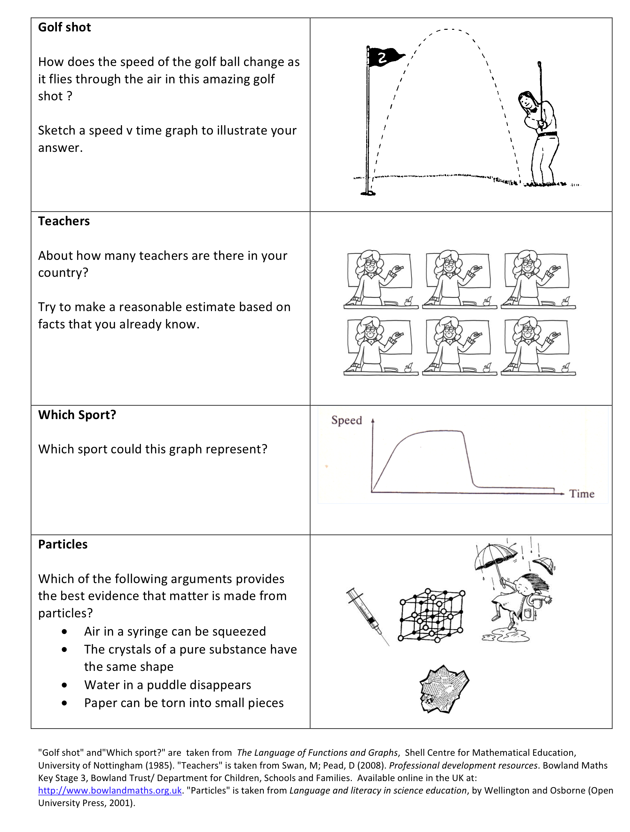

Activity B: Analysing a discussion

Time needed: 15 minutes.
There is a clear difference between working in a group and working as a group. It is quite common to see students working independently, even when they are sitting together. Disputational talk, in which students simply disagree and go on to make individual decisions is not beneficial. Neither is cumulative talk in which students build uncritically on what each other has said. For true collaborative work, students need to develop exploratory talk consisting of critical and constructive exchanges, where challenges are justified and alternative ideas are offered (Mercer, 1995, 2000). It is not enough for students to simply give each other right answers, as this does not produce enhanced understanding (Reynolds and Muijs, 2001). The most helpful talk appears to be that where the participants work on and elaborate each other’s reasoning in a collaborative, rather than competitive atmosphere. Exploratory talk enables reasoning to become audible and ‘publicly’ accountable.

In this activity, the teachers are given transcripts from classroom discussions and are invited to discuss how the discussions either help or hinder learning. Instead of transcripts, you may prefer to show some video clips of student-student discussions for this activity.

- Role-play each of the two transcripts on Handout 2.
- Look at the characteristics of helpful and unhelpful talk shown on Handout 3.
- Which of the characteristics in Handout 3 do you recognise in these transcripts?
- Would you describe the discussions as Disputational, Cumulative or Exploratory?
- What strategies could you use that would help students to discuss more profitably?
The Find the elephant transcript is disputational. The two boys are treating the computer software as a competitive game, making random guesses. They laughed or made derisory comments when their partner made an incorrect guess. There is little evidence of collaborative thinking.

The Rail prices transcript is more exploratory. These students are clearly listening to and engaging with each others' reasoning. Dan and Harriet are both working together to convince Andy and are backing up their argument with an example.

The Always, sometimes, or never true transcript is more cumulative. The students are trying to get through the task as quickly as possible. They do not disagree or challenge each other, they simply reinforce each others' unqualified assertions.

Clearly, the only dialogue that shows evidence of learning here is the one on Rail prices. The final question challenges teachers to think of ways of encouraging this kind of talk. One possible suggestion is that students themselves may role play different ways of working together and discuss how learning takes place.

Handouts 2 & 3

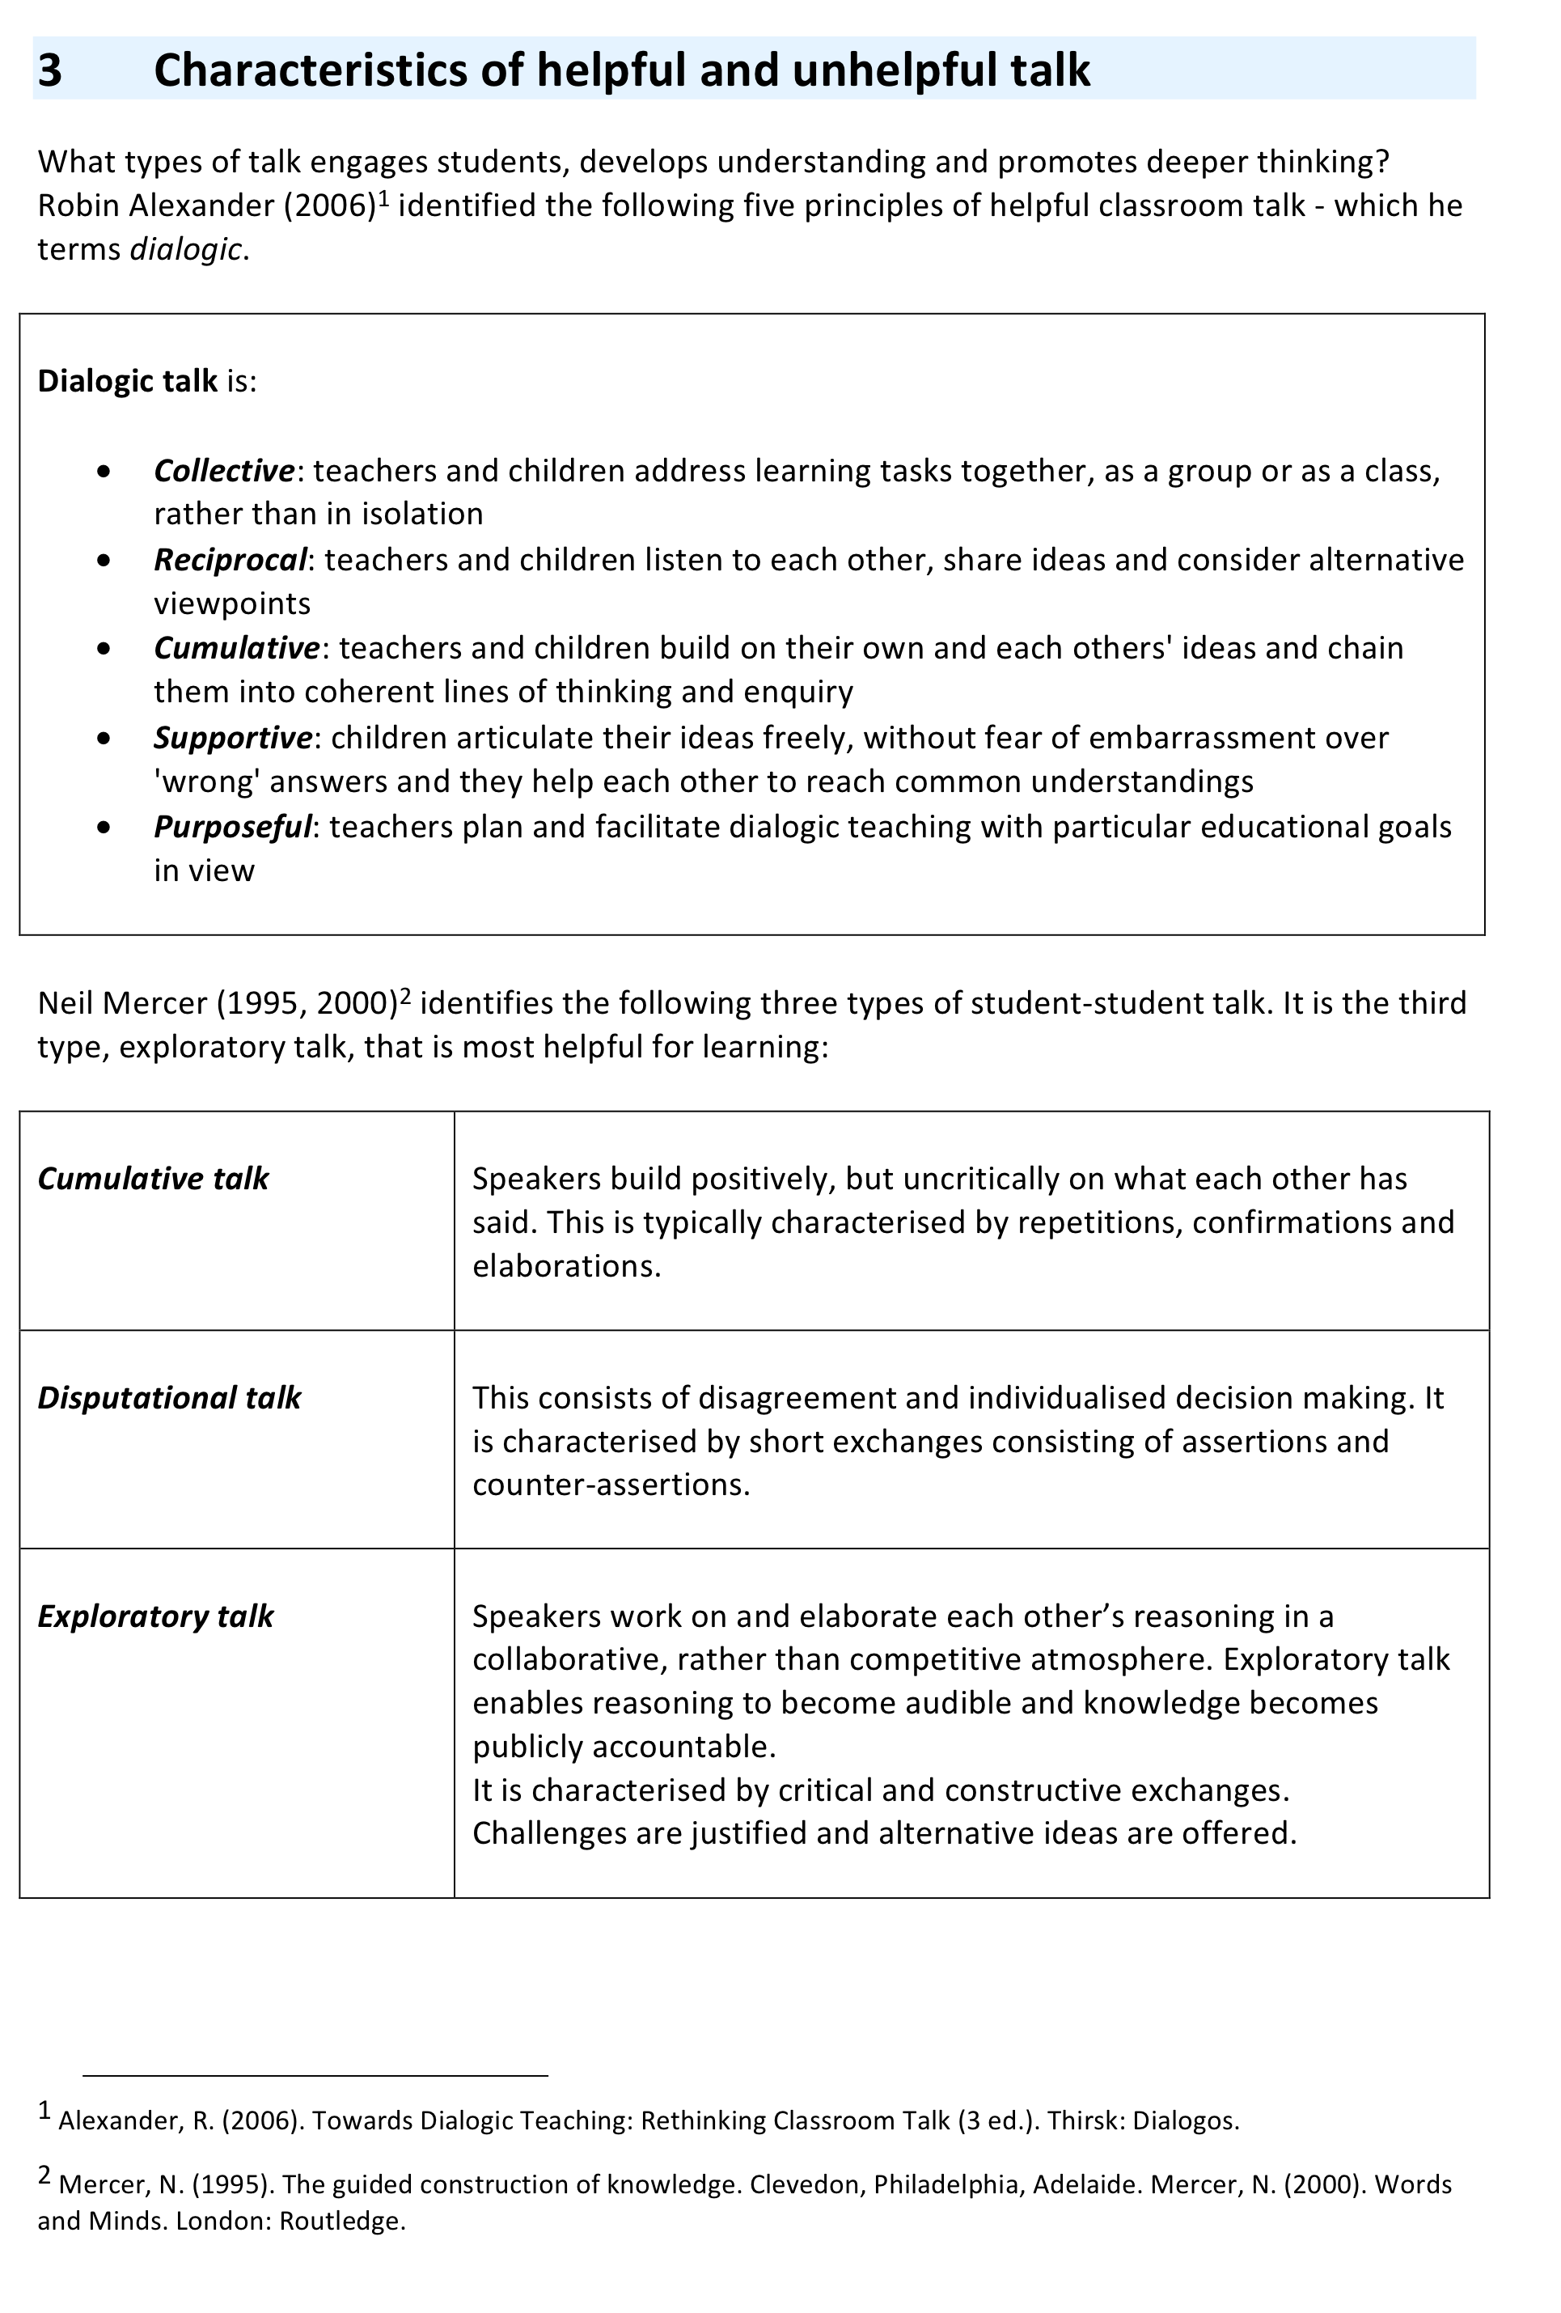
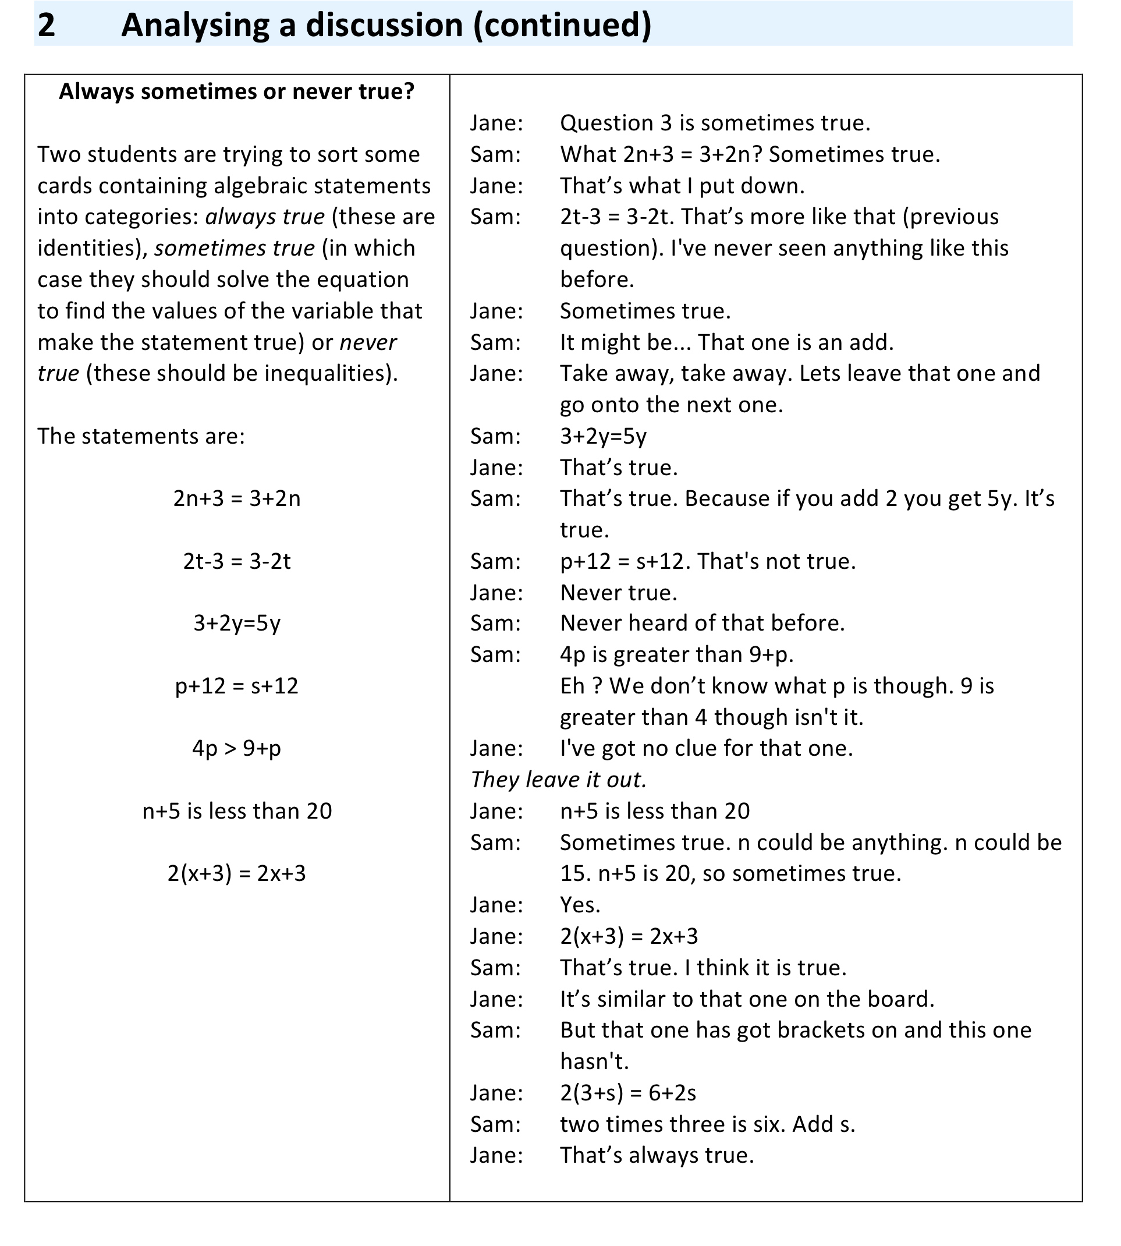
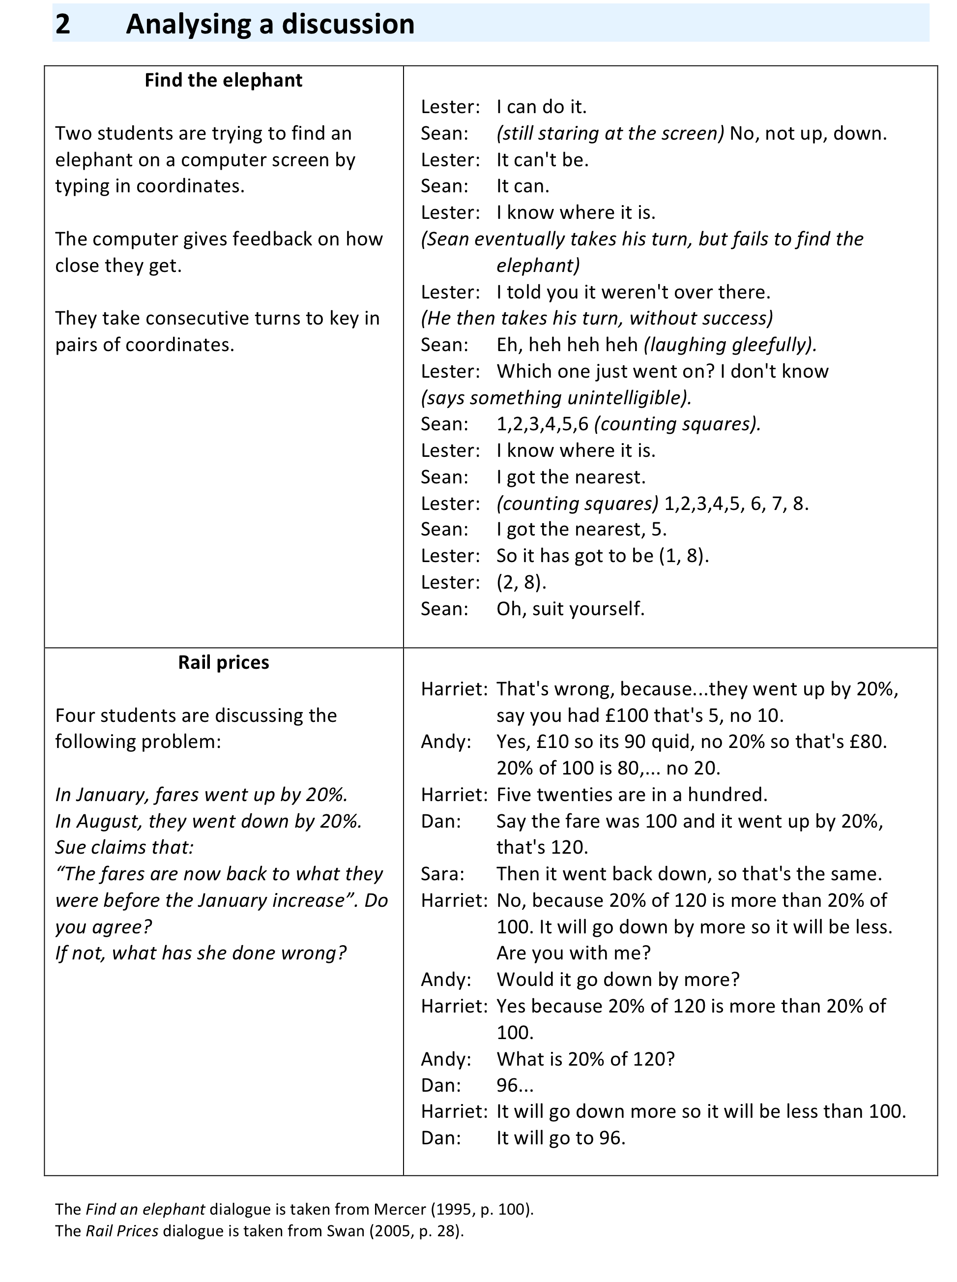

Activity C: Recognising the concerns of teachers

Time needed: 10 minutes.
This activity is designed to help teachers recognise and articulate their own concerns relating to collaborative work. It is important to address these explicitly, as they are often serious obstacles to them.

Handout 4 contains a number of concerns and opinions that are commonly expressed by teachers.

- Which of these do you share?
- In pairs, choose one of these comments and imagine that it was expressed by a teacher from your school. Take a few minutes to prepare a response. In the whole group, share your choice together with your response.

It is important to recognize that group work may not always be appropriate. When the purpose of the lesson is to develop fluency in a particular skill, then individual practice may be more suitable. This should not constitute the whole diet, however. Collaborative group work is necessary when the purpose of the session is to develop conceptual understanding or strategies for solving more challenging problems. In these cases, students need to share alternative views, interpretations or approaches.

Handout 4

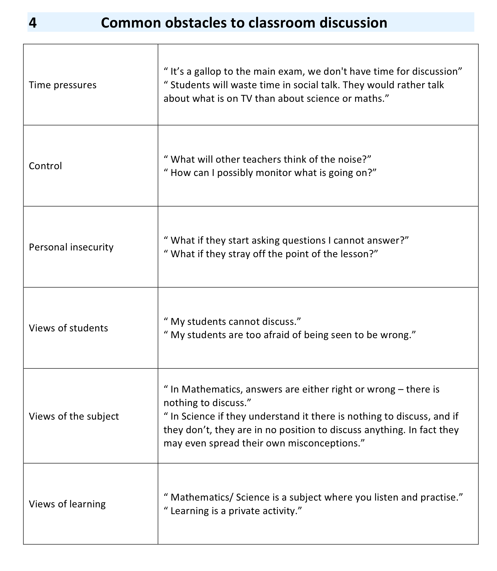

Activity D: Creating & Establishing "Ground Rules" with students

Time needed: 15 minutes.
As we have seen, students (and adults!) do not always discuss in helpful ways. Some are reluctant to talk at all, while others take over and dominate. Students therefore need to be taught how to discuss. Some teachers have found it helpful to introduce a list of 'ground rules for discussion' into their classes. These ground rules should, in appropriate language, give explicit guidance to students on how to talk together profitably.

- Imagine that you are starting with a new class. You want them to begin to work collaboratively. What classroom "rules" would you seek to establish?
- The ground rules on Handout 5 was developed for use with one class of students.
Compare your ideas with those offered here.
- How would you encourage your students to follow these rules?
- How could you involve your students in developing such a list?

Handout 5

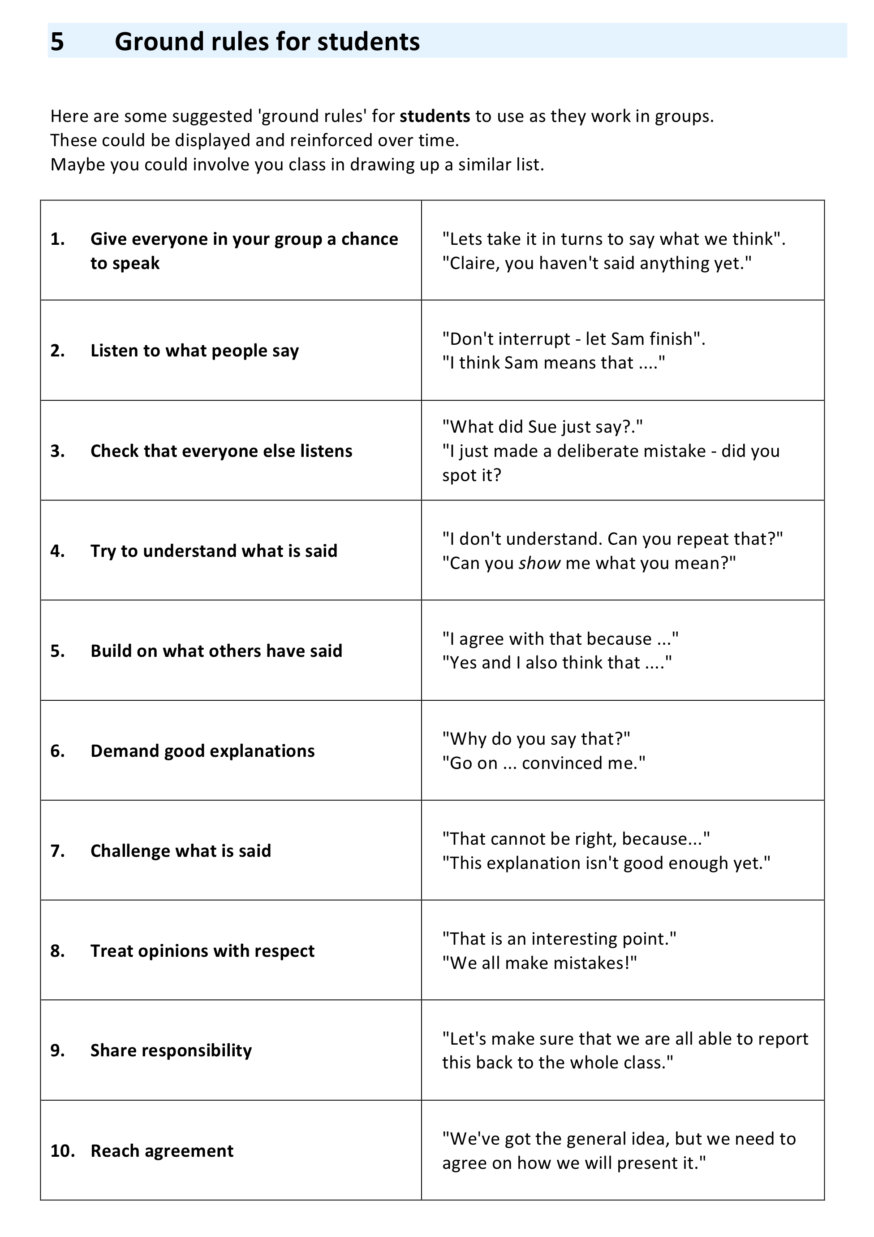

Activity E: Managing collaborative discussion

Time needed: 15 minutes.
A well-organised discussion lesson often has a number of distinct phases:
- Individual 'thinking time'.
Students think about the problem before the discussion begins. Without this opportunity, the discussion is likely to be dominated by more confident and assertive students.
- Small group discussion.
Students share and refine their ideas in small groups.
- Whole class discussion.
Students 'report back' to the class, and share their ideas with a wider audience.

In this session, participants consider these phases and in particular the teacher's role in each one.

How would you manage a discussion lesson?
- What is the purpose of 'thinking time'? What is your role?
- What is the purpose of the small group discussion? What is your role?
- What is the purposes of the final whole class discussion? What is your role?
Compare your thoughts with those given on Handouts 6 and 7.

Many teachers, used to transmission methods, appear unsure of their role during discussion lessons. When students are struggling, some quickly intervene and try to "ease the path" by giving strong hints and explanations. Others withdraw and offer little help, as though they now expect students to discover everything by themselves. The most effective teachers take neither of these positions. They challenge students to think more deeply, explain and justify (Handout 6):
- Make the purpose of the task clear
- Keep reinforcing the ‘ground rules’
- Listen before intervening
- Join in, don’t judge
- Ask students to describe, explain and interpret
- Make students do the thinking
- Don’t be afraid of leaving discussions unresolved.

Later in the lesson, when students have had an opportunity to think and discuss for themselves, a whole class discussion may be held in order to:
- present and report students' discussions;
- recognise and value the important ideas that have emerged;
- generalise and link these ideas to other situations.
During this phase of the lesson, the teacher's role is to chair the discussion and help students to clarify their own thinking.

Handouts 6&7  These resources are reproduced from  Improving Learning in Mathematics  Swan (2005) | 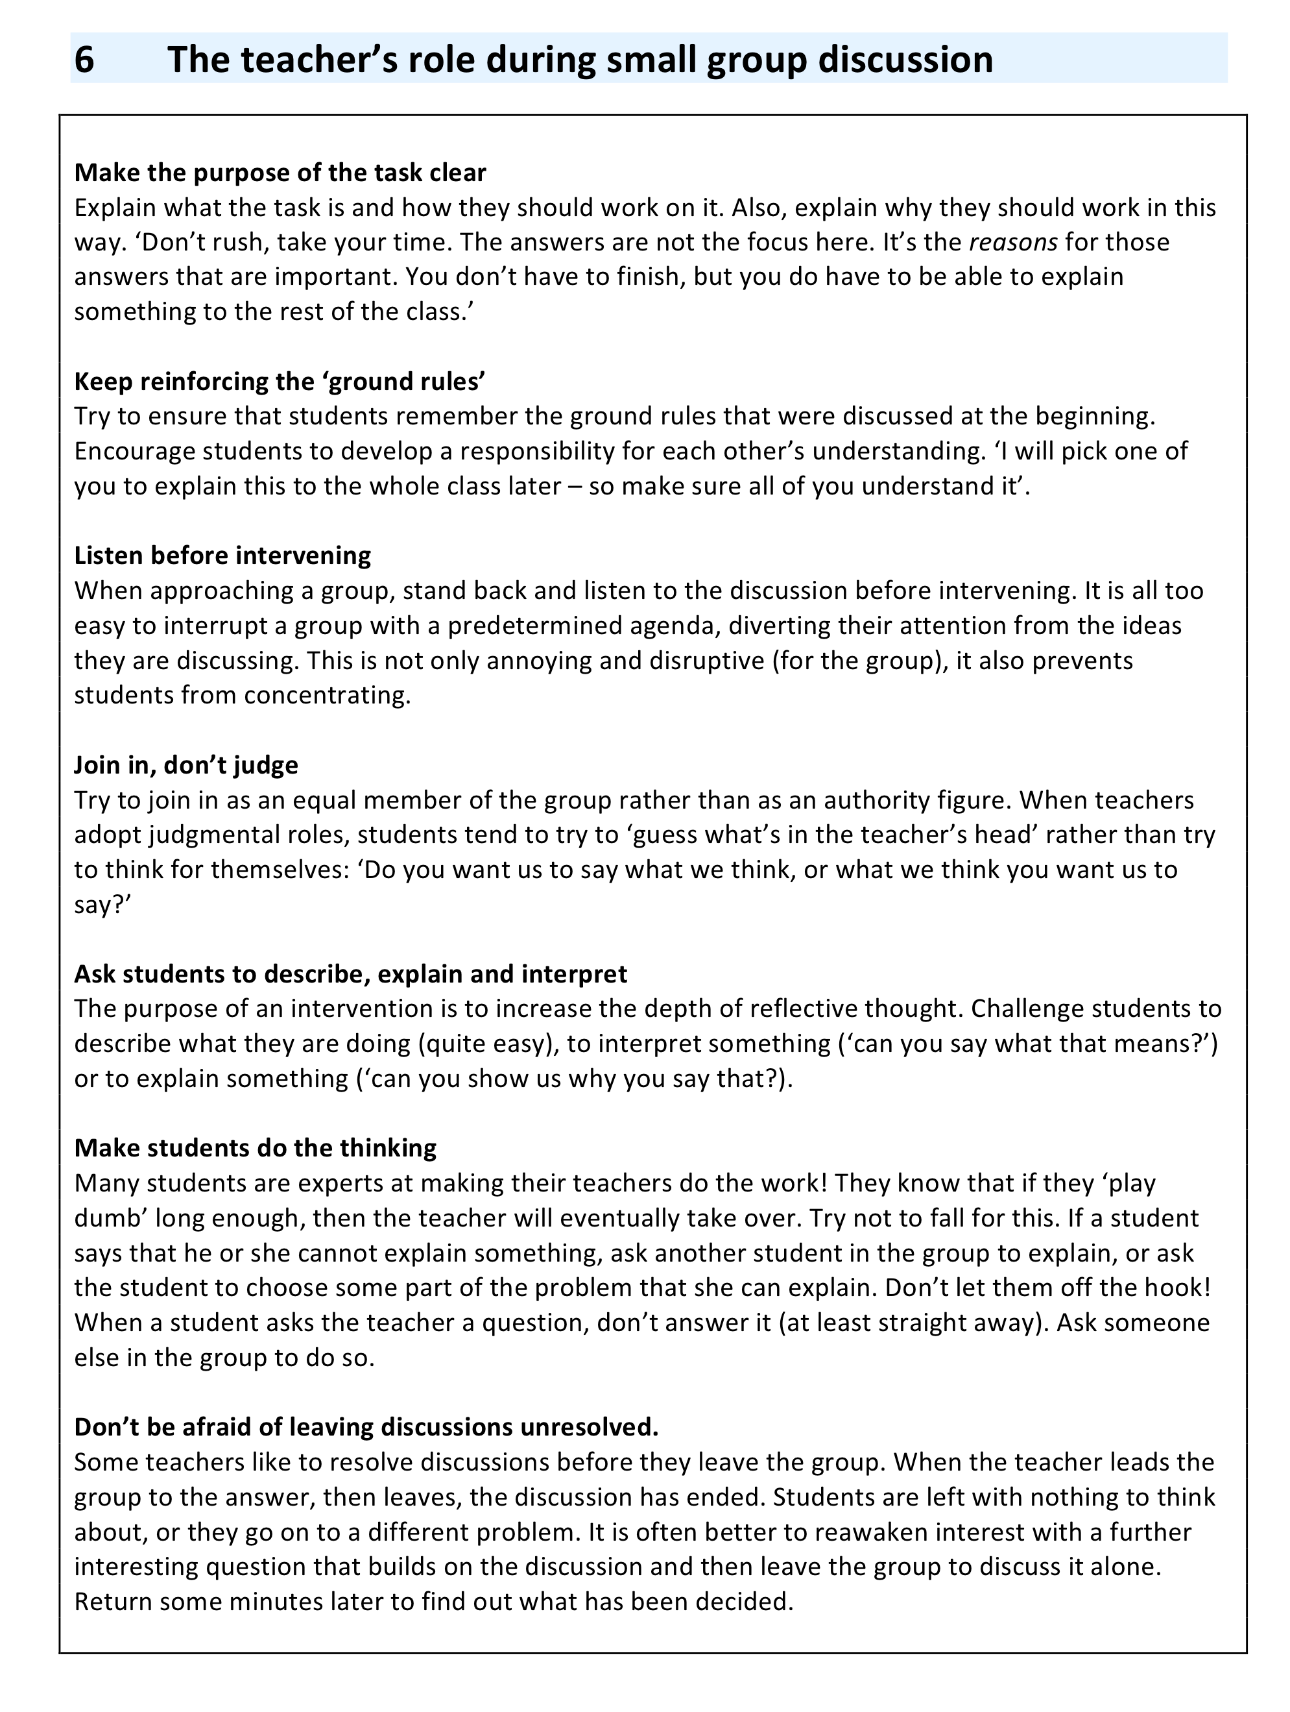  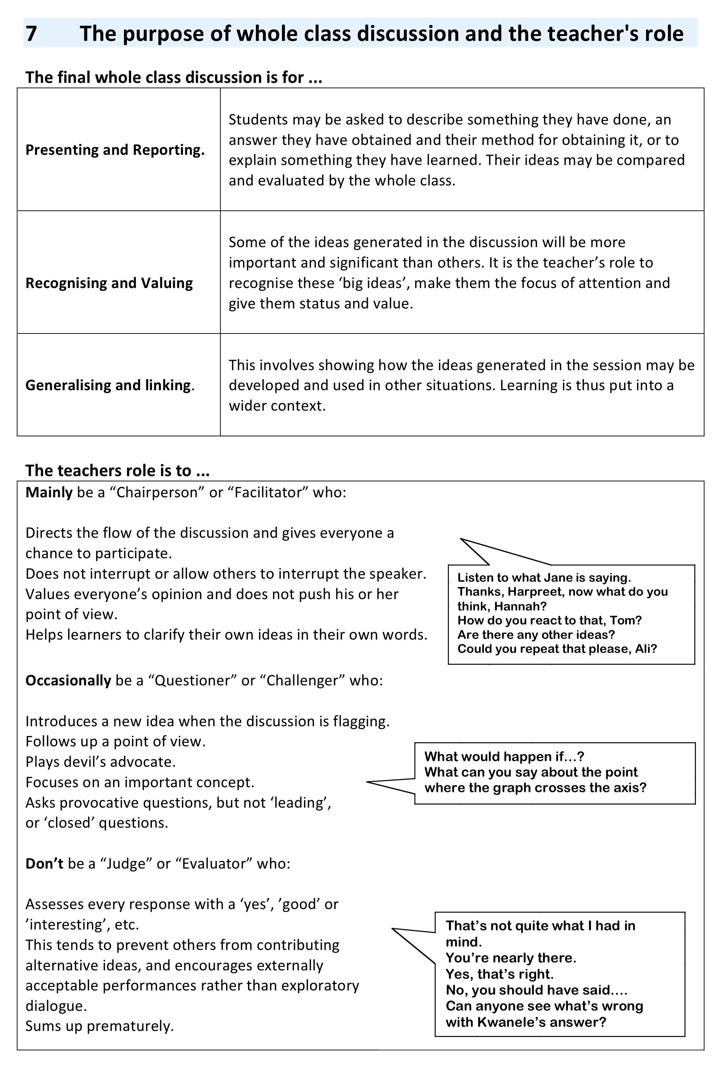

Activity F: Observe and analyse a Discussion lesson

Time needed: 20 minutes.
An 11 minute video clip is provided. This shows one class of secondary students engaging in a discussion lesson. Teachers may enjoy watching the lesson and discussing many of the issues raised in this professional development unit.

The video clip shows one teacher, Eve, teaching a class using the problem:

Estimate how many teachers there are in the UK.
The UK has a population of 60 million people.

Watch the video clip, and then consider the following issues:

- How does the teacher introduce the problem?
- Which 'ground rules' does she emphasise?
- What different approaches are being used by students?
- How does the teacher help students to discuss productively?
- Can you characterise the types of talk they are using? (Refer again to Handout 3)

The video clip shows the three phases of the lesson described in Activity E.

Handout 3. Characteristics of helpful and unhelpful talk

Activity G: Plan a lesson, teach it and reflect on the outcomes

Time needed:
- 15 minutes discussion before the lesson
- 1 hour for the lesson
- 15 minutes after the lesson

Plan a discussion lesson for your students.
As you do this, discuss the following issues:

- Which task will you use? It should have scope for discussion.
- How will you arrange the room?
- How will you group students?
- How will you introduce the purpose of discussion?
- How will you establish ground rules?

Some notes on these issues are given on Handout 9.

- How will you organise the phases of the session?
When will students be working individually?
When will they be in small groups?
When will there be a whole class discussion?
Refer back to Handouts 6 and 7 to support your planning.

Encourage teachers to record and transcribe some student-student discussions, if possible.
After teachers have taught the lesson, meet again and discuss the following questions.

Compare the different lessons that have been experienced.
How did you:
- Organise the room and introduce the task?
- Orchestrate and sustain phases of the work? (E.g. "Think, pair, share")
- Organise and share ideas as a whole class?
Give examples of helpful and unhelpful discussions that were evident.
Play any recorded extracts of student-student talk from your lesson and
discuss the type of talk this illustrates.

- Did students listen to and build on each others' reasoning?
- Can you think of occasions when your own intervention was helpful?
When was it unhelpful?
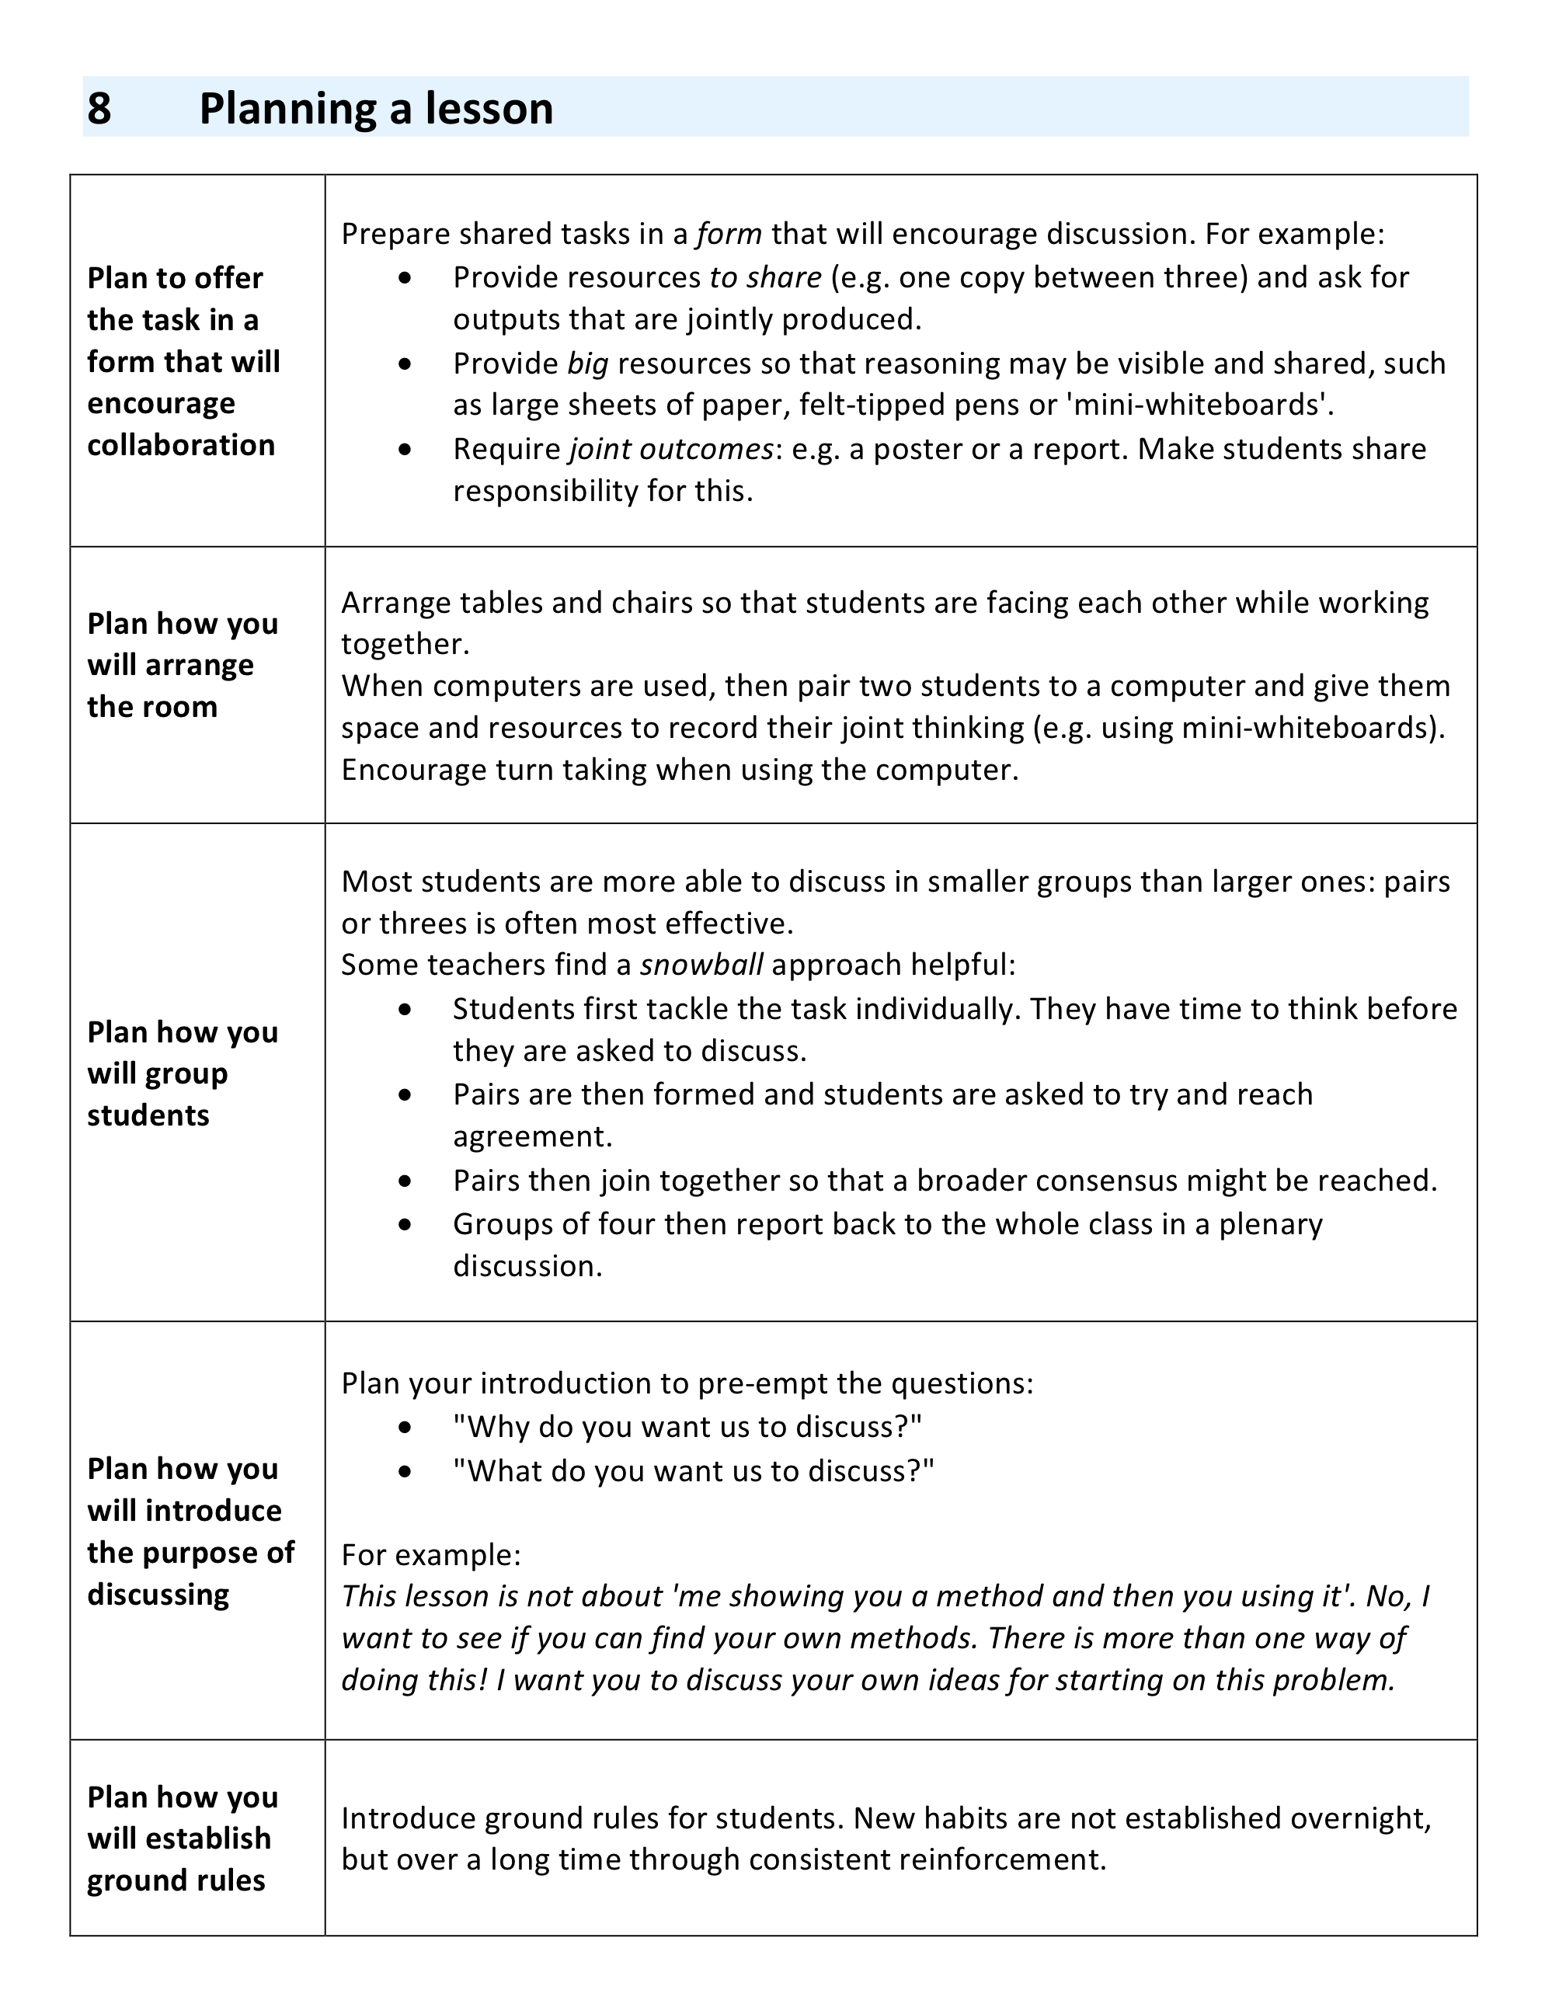

Suggested further reading
How can we be sure that the classroom encourages talk for learning? Here is what research shows.
Alexander R (2008) Towards Dialogic Teaching: rethinking classroom talk (Dialogos Cambridge
http://www.robinalexander.org.uk/docs/TDTform.pdf

What are the characteristics of talk for learning?
Mercer, N. (2000). Words and Minds. London: Routledge.

Improving learning in mathematics – through collaboration
Swan, M. Improving Learning in Mathematics, The Standards Unit. http://www.nationalstemcentre.org.uk/elibrary/collection/282/improving-learning-in-mathematics

A research study into the design of collaborative classroom activities
Swan, M. (2006). Collaborative Learning in Mathematics: A Challenge to our Beliefs and Practices. London: National Institute for Advanced and Continuing Education (NIACE); National Research and Development Centre for Adult Literacy and Numeracy (NRDC).

Making your interactive whiteboard really interactive.
Tanner H & Jones S (2007) How interactive is your whiteboard?, Mathematics Teaching #200, ATM, Derby
http://www.atm.org.uk/mt/archive/mt200files/ATM-MT200-37-41-mo.pdf

This article is about practice in a primary school but has a lot to say to secondary school teachers.
Williamson V (2007) Group and individual work, Mathematics Teaching #195, ATM, Derby http://www.atm.org.uk/mt/archive/mt195files/ATM-MT195-42-45-mo.pdf

References

Alexander, R. (2006). Towards Dialogic Teaching: Rethinking Classroom Talk (3 ed.). Thirsk: Dialogos.

Alexander, R. (2008). How can we be sure that the classroom encourages talk for learning? Here is what research shows. Cambridge: Dialogos.

Askew, M., & Wiliam, D. (1995). Recent Research in Mathematics Education 5-16. London: HMSO.

Mercer, N. (1995). The guided construction of knowledge. Clevedon, Philadelphia, Adelaide.

Mercer, N. (2000). Words and Minds. London: Routledge.

