Students working collaboratively

How can we foster scientific discussion?

Handouts for teachers

Contents

1 Experiencing a discussion 2
2 Analysing a discussion 3
3 Characteristics of helpful and unhelpful talk 5
4 Common obstacles to classroom discussion 6
5 Ground rules for students 7
6 The teacher’s role during small group discussion 8
7 The purpose of whole class discussion and the teacher's role 9
8 Planning a lesson 10

Acknowledgement:
This material is adapted for PRIMAS from two main sources:
Swan (2005) Improving Learning in Mathematics © Crown Copyright (UK) 2005, included by kind permission of the Learning and Skill Improvement Service (www.LSIS.org.uk);
Swan, M; Pead, D (2008). Professional development resources. Bowland Maths, © 2008-2010 Bowland Charitable Trust. Visit www.bowlandmaths.org.uk for more Bowland Maths materials.

1 Experiencing a discussion

Golf shot  How does the speed of the golf ball change as it flies through the air in this amazing golf shot ?  Sketch a speed v time graph to illustrate your answer. | 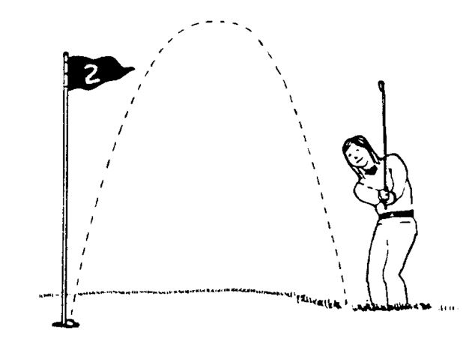
Teachers  About how many teachers are there in your country?  Try to make a reasonable estimate based on facts that you already know. | 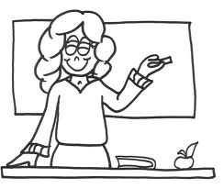
Which Sport?  Which sport could this graph represent? | 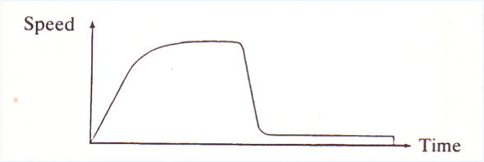
Particles  Which of the following arguments provides the best evidence that matter is made from particles?  - Air in a syringe can be squeezed  - The crystals of a pure substance have the same shape  - Water in a puddle disappears  - Paper can be torn into small pieces | 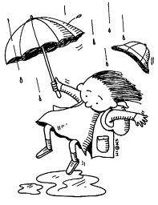  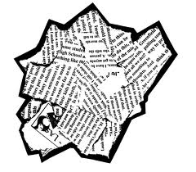

"Golf shot" and"Which sport?" are taken from The Language of Functions and Graphs, Shell Centre for Mathematical Education, University of Nottingham (1985). "Teachers" is taken from Swan, M; Pead, D (2008). Professional development resources. Bowland Maths Key Stage 3, Bowland Trust/ Department for Children, Schools and Families. Available online in the UK at: http://www.bowlandmaths.org.uk. "Particles" is taken from Language and literacy in science education, by Wellington and Osborne (Open University Press, 2001).

2 Analysing a discussion
Find the elephant  Two students are trying to find an elephant on a computer screen by typing in coordinates.  The computer gives feedback on how close they get.  They take consecutive turns to key in pairs of coordinates. | Lester: I can do it.  Sean: (still staring at the screen) No, not up, down.  Lester: It can't be.  Sean: It can.  Lester: I know where it is.  (Sean eventually takes his turn, but fails to find the elephant)  Lester: I told you it weren't over there.  (He then takes his turn, without success)  Sean: Eh, heh heh heh (laughing gleefully).  Lester: Which one just went on? I don't know  (says something unintelligible).  Sean: 1,2,3,4,5,6 (counting squares).  Lester: I know where it is.  Sean: I got the nearest.  Lester: (counting squares) 1,2,3,4,5, 6, 7, 8.  Sean: I got the nearest, 5.  Lester: So it has got to be (1, 8).  Lester: (2, 8).  Sean: Oh, suit yourself.
Rail prices  Four students are discussing the following problem:  In January, fares went up by 20%.  In August, they went down by 20%. Sue claims that:  “The fares are now back to what they were before the January increase”. Do you agree?  If not, what has she done wrong? | Harriet: That's wrong, because...they went up by 20%, say you had £100 that's 5, no 10.  Andy: Yes, £10 so its 90 quid, no 20% so that's £80. 20% of 100 is 80,... no 20.  Harriet: Five twenties are in a hundred.  Dan: Say the fare was 100 and it went up by 20%, that's 120.  Sara: Then it went back down, so that's the same.  Harriet: No, because 20% of 120 is more than 20% of 100. It will go down by more so it will be less. Are you with me?  Andy: Would it go down by more?  Harriet: Yes because 20% of 120 is more than 20% of 100.  Andy: What is 20% of 120?  Dan: 96...  Harriet: It will go down more so it will be less than 100.  Dan: It will go to 96.

The Find an elephant dialogue is taken from Mercer (1995, p. 100).
The Rail Prices dialogue is taken from Swan (2005, p. 28).

2 Analysing a discussion (continued)
Always sometimes or never true?  Two students are trying to sort some cards containing algebraic statements into categories: always true (these are identities), sometimes true (in which case they should solve the equation to find the values of the variable that make the statement true) or never true (these should be inequalities).  The statements are:  2n+3 = 3+2n  2t-3 = 3-2t  3+2y=5y  p+12 = s+12  4p > 9+p  n+5 is less than 20  2(x+3) = 2x+3 | Jane: Question 3 is sometimes true.  Sam: What 2n+3 = 3+2n? Sometimes true.  Jane: That’s what I put down.  Sam: 2t-3 = 3-2t. That’s more like that (previous question). I've never seen anything like this before.  Jane: Sometimes true.  Sam: It might be... That one is an add.  Jane: Take away, take away. Lets leave that one and go onto the next one.  Sam: 3+2y=5y  Jane: That’s true.  Sam: That’s true. Because if you add 2 you get 5y. It’s true.  Sam: p+12 = s+12. That's not true.  Jane: Never true.  Sam: Never heard of that before.  Sam: 4p is greater than 9+p.  Eh ? We don’t know what p is though. 9 is greater than 4 though isn't it.  Jane: I've got no clue for that one.  They leave it out.  Jane: n+5 is less than 20  Sam: Sometimes true. n could be anything. n could be 15. n+5 is 20, so sometimes true.  Jane: Yes.  Jane: 2(x+3) = 2x+3  Sam: That’s true. I think it is true.  Jane: It’s similar to that one on the board.  Sam: But that one has got brackets on and this one hasn't.  Jane: 2(3+s) = 6+2s  Sam: two times three is six. Add s.  Jane: That’s always true.

3 Characteristics of helpful and unhelpful talk
What types of talk engages students, develops understanding and promotes deeper thinking? Robin Alexander (2006) identified the following five principles of helpful classroom talk - which he terms dialogic.

Dialogic talk is:
- Collective: teachers and children address learning tasks together, as a group or as a class, rather than in isolation
- Reciprocal: teachers and children listen to each other, share ideas and consider alternative viewpoints
- Cumulative: teachers and children build on their own and each others' ideas and chain them into coherent lines of thinking and enquiry
- Supportive: children articulate their ideas freely, without fear of embarrassment over 'wrong' answers and they help each other to reach common understandings
- Purposeful: teachers plan and facilitate dialogic teaching with particular educational goals in view

Neil Mercer (1995, 2000) identifies the following three types of student-student talk. It is the third type, exploratory talk, that is most helpful for learning:

Cumulative talk | Speakers build positively, but uncritically on what each other has said. This is typically characterised by repetitions, confirmations and elaborations.
Disputational talk | This consists of disagreement and individualised decision making. It is characterised by short exchanges consisting of assertions and counter-assertions.
Exploratory talk | Speakers work on and elaborate each other’s reasoning in a collaborative, rather than competitive atmosphere. Exploratory talk enables reasoning to become audible and knowledge becomes publicly accountable.  It is characterised by critical and constructive exchanges.  Challenges are justified and alternative ideas are offered.

4 Common obstacles to classroom discussion
Time pressures | “ It’s a gallop to the main exam, we don't have time for discussion”  “ Students will waste time in social talk. They would rather talk about what is on TV than about science or maths.”
Control | “ What will other teachers think of the noise?”  “ How can I possibly monitor what is going on?”
Personal insecurity | “ What if they start asking questions I cannot answer?”  “ What if they stray off the point of the lesson?”
Views of students | “ My students cannot discuss.”  “ My students are too afraid of being seen to be wrong.”
Views of the subject | “ In Mathematics, answers are either right or wrong – there is nothing to discuss.”  “ In Science if they understand it there is nothing to discuss, and if they don’t, they are in no position to discuss anything. In fact they may even spread their own misconceptions.”
Views of learning | “ Mathematics/ Science is a subject where you listen and practise.”  “ Learning is a private activity.”

5 Ground rules for students

Here are some suggested 'ground rules' for students to use as they work in groups.
These could be displayed and reinforced over time.
Maybe you could involve you class in drawing up a similar list.

1. Give everyone in your group a chance to speak | "Lets take it in turns to say what we think".  "Claire, you haven't said anything yet."
2. Listen to what people say | "Don't interrupt - let Sam finish".  "I think Sam means that ...."
3. Check that everyone else listens | "What did Sue just say?."  "I just made a deliberate mistake - did you spot it?
4. Try to understand what is said | "I don't understand. Can you repeat that?"  "Can you show me what you mean?"
5. Build on what others have said | "I agree with that because ..."  "Yes and I also think that ...."
6. Demand good explanations | "Why do you say that?"  "Go on ... convinced me."
7. Challenge what is said | "That cannot be right, because..."  "This explanation isn't good enough yet."
8. Treat opinions with respect | "That is an interesting point."  "We all make mistakes!"
9. Share responsibility | "Let's make sure that we are all able to report this back to the whole class."
10. Reach agreement | "We've got the general idea, but we need to agree on how we will present it."

6 The teacher’s role during small group discussion

Make the purpose of the task clear
Explain what the task is and how they should work on it. Also, explain why they should work in this way. ‘Don’t rush, take your time. The answers are not the focus here. It’s the reasons for those answers that are important. You don’t have to finish, but you do have to be able to explain something to the rest of the class.’
Keep reinforcing the ‘ground rules’
Try to ensure that students remember the ground rules that were discussed at the beginning. Encourage students to develop a responsibility for each other’s understanding. ‘I will pick one of you to explain this to the whole class later – so make sure all of you understand it’.
Listen before intervening
When approaching a group, stand back and listen to the discussion before intervening. It is all too easy to interrupt a group with a predetermined agenda, diverting their attention from the ideas they are discussing. This is not only annoying and disruptive (for the group), it also prevents students from concentrating.
Join in, don’t judge
Try to join in as an equal member of the group rather than as an authority figure. When teachers adopt judgmental roles, students tend to try to ‘guess what’s in the teacher’s head’ rather than try to think for themselves: ‘Do you want us to say what we think, or what we think you want us to say?’
Ask students to describe, explain and interpret
The purpose of an intervention is to increase the depth of reflective thought. Challenge students to describe what they are doing (quite easy), to interpret something (‘can you say what that means?’) or to explain something (‘can you show us why you say that?).
Make students do the thinking
Many students are experts at making their teachers do the work! They know that if they ‘play dumb’ long enough, then the teacher will eventually take over. Try not to fall for this. If a student says that he or she cannot explain something, ask another student in the group to explain, or ask the student to choose some part of the problem that she can explain. Don’t let them off the hook! When a student asks the teacher a question, don’t answer it (at least straight away). Ask someone else in the group to do so.
Don’t be afraid of leaving discussions unresolved.
Some teachers like to resolve discussions before they leave the group. When the teacher leads the group to the answer, then leaves, the discussion has ended. Students are left with nothing to think about, or they go on to a different problem. It is often better to reawaken interest with a further interesting question that builds on the discussion and then leave the group to discuss it alone. Return some minutes later to find out what has been decided.

7 The purpose of whole class discussion and the teacher's role

The final whole class discussion is for ...
Presenting and Reporting. | Students may be asked to describe something they have done, an answer they have obtained and their method for obtaining it, or to explain something they have learned. Their ideas may be compared and evaluated by the whole class.
Recognising and Valuing | Some of the ideas generated in the discussion will be more important and significant than others. It is the teacher’s role to recognise these ‘big ideas’, make them the focus of attention and give them status and value.
Generalising and linking. | This involves showing how the ideas generated in the session may be developed and used in other situations. Learning is thus put into a wider context.

The teachers role is to ...
Mainly be a “Chairperson” or “Facilitator” who:

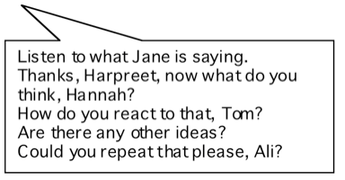
Directs the flow of the discussion and gives everyone a chance to participate.
Does not interrupt or allow others to interrupt the speaker.
Values everyone’s opinion and does not push his or her point of view.
Helps learners to clarify their own ideas in their own words.

Occasionally be a “Questioner” or “Challenger” who:

Introduces a new idea when the discussion is flagging.
Follows up a point of view.
Plays devil’s advocate.
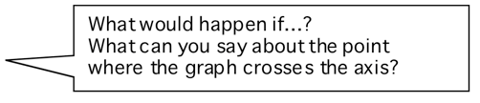
Focuses on an important concept.
Asks provocative questions, but not ‘leading’, or ‘closed’ questions.

Don’t be a “Judge” or “Evaluator” who:

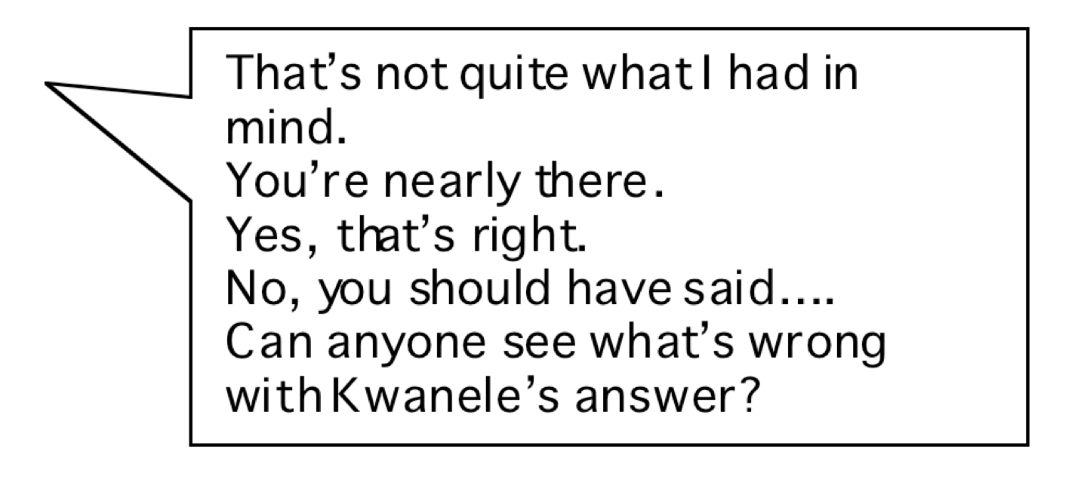
Assesses every response with a ‘yes’, ’good’ or ’interesting’, etc.
This tends to prevent others from contributing alternative ideas, and encourages externally acceptable performances rather than exploratory dialogue.
Sums up prematurely.

8 Planning a lesson
Plan to offer the task in a form that will encourage collaboration | Prepare shared tasks in a form that will encourage discussion. For example:  - Provide resources to share (e.g. one copy between three) and ask for outputs that are jointly produced.  - Provide big resources so that reasoning may be visible and shared, such as large sheets of paper, felt-tipped pens or 'mini-whiteboards'.  - Require joint outcomes: e.g. a poster or a report. Make students share responsibility for this.
Plan how you will arrange the room | Arrange tables and chairs so that students are facing each other while working together.  When computers are used, then pair two students to a computer and give them space and resources to record their joint thinking (e.g. using mini-whiteboards). Encourage turn taking when using the computer.
Plan how you will group students | Most students are more able to discuss in smaller groups than larger ones: pairs or threes is often most effective.  Some teachers find a snowball approach helpful:  - Students first tackle the task individually. They have time to think before they are asked to discuss.  - Pairs are then formed and students are asked to try and reach agreement.  - Pairs then join together so that a broader consensus might be reached.  - Groups of four then report back to the whole class in a plenary discussion.
Plan how you will introduce the purpose of discussing | Plan your introduction to pre-empt the questions:  - "Why do you want us to discuss?"  - "What do you want us to discuss?"  For example:  This lesson is not about 'me showing you a method and then you using it'. No, I want to see if you can find your own methods. There is more than one way of doing this! I want you to discuss your own ideas for starting on this problem.
Plan how you will establish ground rules | Introduce ground rules for students. New habits are not established overnight, but over a long time through consistent reinforcement.

Alexander, R. (2006). Towards Dialogic Teaching: Rethinking Classroom Talk (3 ed.). Thirsk: Dialogos.
Mercer, N. (1995). The guided construction of knowledge. Clevedon, Philadelphia, Adelaide. Mercer, N. (2000). Words and Minds. London: Routledge.

